

School of Computing and Mathematics

PRCO303

Final Stage Computing Project

BSc (Hons) Software Engineering

N.N.D.G. Liyanage

10707256

**Real Time Courier Tracking Mobile Application**

2021/2022

**Contents**

**Acknowledgment** 8

**Abstract** 9

**01. Introduction** 10

**02. Background and Objectives** 12

**2.1 Problem Identification** 12

**2.2 Current Process** 12

**2.3 Project Background** 13

**2.4 Project Aim** 14

**2.5 Business objectives** 14

**2.6 Project Objectives** 16

**2.7 Features of Courier Tracking Mobile Application** 17

**03. Legal, Social and Ethical Issues** 18

**04. Literature Review** 19

**4.1 Overview of courier service companies** 19

**05. Technical Review** 21

**06. Method of Approach** 23

**6.1 Agile Method** 23

**6.2 Test Driven Development** 24

**6.3 Tools Used** 24

**07. Architecture and Design** 25

**7.1 Use cases and Functional Requirements** 25

**7.1.1 Functional Requirements** 25

**7.1.2 Non-Functional Requirements** 28

**7.2 System Design** 29

**7.2.1 Research Design** 29

**7.2.2 Use Cases** 29

**7.3 System Architecture** 30

**7.3.1 Final Class Diagram** 30

**7.3.2 Activity Diagram** 30

**7.3.3 Collaborative Diagram** 30

**7.3.4 Sequence Diagram** 30

**7.4 User Interface Design** 31

**7.4.1 Software Design and Principles Used** 31

**7.5 System Analysis** 32

**7.5.1 Input Analysis** 32

**7.5.2 Process Analysis** 32

**7.5.3 Output Analysis** 32

**08. Development Technologies** 33

**8.1 Mobile Application** 33

**09. Project Management** 34

**9.1 Time Management** 34

**9.2 Control Plan** 34

**10. Testing** 35

**10.1 Unit Testing** 36

**10.2 Functional Testing** 36

**10.3 Usability Testing** 36

**11. Development** 37

**12. End Project Report** 38

**12.1 End Project Summary** 38

**12.2 Project Objectives Review** 38

**12.3 Changes Review** 39

**13. Project Post- Mortem** 40

**13.1 Objectives Attained** 40

**13.1.1 Developed a user-friendly interface** 40

**13.1.2 Development Database for storing all information** 40

**13.2 Development Process Evaluation** 40

**13.3 Technologies Evaluation** 41

**13.4 Developer Performance Evaluation** 41

**13.5 Future Enhancements** 42

**13.6 Challenges Facing Development** 43

**14. Conclusion** 44

**15. References** 45

**16. Appendices** 47

**16.1 User Guide** 47

**16.1.1 Web Application** 47

**16.1.2 Mobile Application** 47

**16.2 Project Proposal** 48

**16.3 PID** 52

**16.4 First Interim Report** 69

**16.5 Second Interim Report** 107

**16.6 Stage Plan** 169

**16.7 Supervisor Meetings** 169

# **Acknowledgment**

The completion of this project would not have been possible without the help of numerous parties that have helped and guided me throughout the project. First and foremost, I would thank and express my gratitude to my supervisor, Dr. Rasika Ranaweera, for the guidance I received in accomplishing the project's tasks. The meetings and the guidance were quite helpful in making certain decisions about how I should progress with the project and what I should add and what I should remove. His suggestions were wise and stimulating and encouraged me to achieve the best I could with every challenge that I faced and everything that was going on.

Secondly, I want to thank NSBM Green University and the University of Plymouth. The final year project is the outcome of everything I have learned throughout my degree program and the knowledge and experience that I gained at the university and the skills I managed to gain and enhance played a big role in getting the final project done. I would like to thank all the lecturers at the NSBM Green University and the University of Plymouth computing faculty for teaching me the concepts of Computer Science and Software Engineering and giving me the knowledge that was essential in all of my endeavors. I would also like to forward my sincere gratitude towards the instructors and the guest lecturers and professionals from the industry for spending their valuable time in providing us the industrial skills and practical technical knowledge which I have utilized in the final year projects.

Last but not least, I have to thank my closest friends and the team members with whom I worked for the rest of the group assignments. The final year project is individual coursework but that does not mean that one would be able to do it all by themselves. My closest friends provided me with suggestions and guidance when it comes to the technologies I used in this project and their pros and cons, and that information helped me in making decisions about what technologies I should use for the project. I want to forward special thanks to my family for providing me the opportunity of studying at the NSBM Green University without which none of these would have taken place.

# **Abstract**

E-commerce has grown exponentially over the years. Growth has been reflected in strong consumer demand and a growing number of different products available online. This creates a transportation problem and increases the need for an efficient courier service to support growing markets. It is very important for the courier service provider that the delivery of the parcel is done as soon as possible. One of the most important and important courier business processes are the delivery of parcels. This is where effective service delivery will be paramount. An efficient system needs to be built to facilitate interaction between the courier service provider and the buyer to accurately determine the complete package delivery route. In this proposed project, a real-time Android and iOS mobile tracking app will be developed. A mobile app that helps mail delivery staff find their way to deliver parcels to a customer's door. The app will direct courier staff to obtain courier data such as addresses and contact information and then navigate to selected customer addresses. It will select the best route to the address and inform customers before it arrives so that they are ready to receive the package. This parcel delivery tracking will provide the basis for an effective courier service system.

Recent research shows that the public has expressed moderate satisfaction with the current system and there is a clear need to improve the current way of distributing goods and services through postal services. This research paper explores the possibilities of using the system on Android-iOS-based smartphones to make it easier and more accessible for mail delivery services and more efficient. Researchers have designed a questionnaire and distributed it to users of the messenger service. Respondents' responses indicate a clear need to use a tracking app based on the android and iOS operating system platforms.

The project objectives and scope has been explained in detail and the background of the project has been stated. Diagrams have been used to explain the system architecture, data flows, and communication. Screenshots of parts of codes, applications, and their functionalities are included.

The report consists of a technology review that reviews the technologies that have been used in the development of the system and the reasoning behind those. It describes the path that was taken in selecting the technologies and the technologies that were tried, dropped, and adopted. The challenges faced throughout the project and how they affected the outcome have been explained in detail.

Keywords: Courier service, Real Time Courier tracking, Mobile app, Customers, React Native, Android, iOS

# **01. Introduction**

In ancient times, all transportation had to be done by humans. These people were not able to move to other regions without extensive training. The training involved familiarizing ourselves with the network of roads and traffic conditions in the area. The advent of the internet has caused changes in many industries, and this includes all courier tracking systems in the world. As the goods and products, the company makes increase, the burden on the transportation department also increases. This creates a huge need for such software to be available and used by many industries. Today such software is used to increase the accuracy, speed, and efficiency of their transportation. Companies that need courier tracking software have a high production value and usually make many products. The company also suffers from the task of organizing products into phases. There are tools within the courier tracking system that make this easy. Some tools send courier space whenever a client or company requests it. The software also provides automated submissions, delivery function filters, reminders, and real-time analytics solutions built into it. They also come with plugins to manage internal eCommerce delivery and integration that help track sender in real-time.

The needs and wants of people in today's world are also increasing. So, they need more resources and try to work in less time. In our country, we can import goods, but it takes a lot of time and there is an opportunity to miss the product. The right information in the right place makes the decision-making process more efficient. Therefore, identifying current and future needs becomes a basic requirement for any dynamic information system. The courier management system is one of the most respected and growing mail services for all customers. It is software that is used to manage courier services efficiently and effectively.

The importance of tracking shipping is a defining factor in today’s manufacturing companies and is very helpful in managing efficient transport networks. Problems related to export coordination have reduced the overall performance of global industries in the modern urbanization era. The difficulty of tracking shipping has been a thorn in the side of the transport chain from source to location as it uses transparency among customer peers. The tracking system works with the destination and informs the customer of the destination. The tracking system provides a transparent product environment that combines trust between the seller-customer relationship. This system may provide a solution for mapping the tracking process from dealing with this complex problem. A common practice for all of these tracking systems is usually confined to the client in order to access tracking information instead of tracking sent by hand questions such as telephone, e-mail, fax, or expensive hardware. Available tracking systems have a narrow path in the transport chain. Customers use the information of ordered goods by phone or email. Therefore, we have selected GPS tracking systems with google maps service that can be imported from the delivery point and sent to the user. When a user requests the location of their product, a notification is sent to the delivery agent who can transfer their location via our mobile APP. The APP is built on the basic use of geolocation services. The active location of the delivery agent is sent to the user who requested the location. Therefore, the cheapest option in the small-scale transport industry is to provide a tracking of goods. Includes transparency between industry services and users. As a cheaper option, it eases the burden on the financial sector of the industry and provides a competitive edge to the industry sector.

"Real Time Courier Tracking Mobile Application" is designed to avoid problems with the training manual system. This software helps to eliminate and, in some cases, reduces the complexity of the existing program. In addition, the program is designed to meet the specific needs of the company in terms of smoothing and efficiency. The application has been scaled down to avoid errors when entering data. It also gives an error message if you enter invalid data. The user does not need official information to use this application. Therefore, it seems to be easy to use. As mentioned above, the Courier Tracking System can lead to a seamless, secure, reliable, and fast management system. It can help the user to focus on other tasks rather than focusing on keeping records. So, it will help the organization to make better use of resources.

Every organization, large or small, has challenges in winning and managing tracking, shipping, customer, and delivery information. Address. Each courier tracking system has different courier requirements, so we create staff management systems that fit your management needs. This is designed to help plan strategies and will help ensure that your organization has the right level of information and details of your future goals. Also, for busy managers who are always on the move, our systems come with remote access features that allow you to manage your employees anytime, anywhere. These programs eventually allow you to better manage resources.

# **02. Background and Objectives**

## **2.1 Problem Identification**

When shipping their products using any courier service, people want to know if their item will be delivered to their destination, if not, when it will be delivered, and where it is now. Taking all this information by hand is a very difficult and time-consuming process. Manage all these tasks in terms of management, which includes a variety of processes and documentation. The motive for the project is to get a high-end business environment, a customer needs good service. So, in order to make more profit and get more business space, their managers need to have a way to solve all these problems in a timely manner. Its managers can receive instant orders and provide their customers with a receipt and all product details at a reasonable price. Thus, you save time and complete the process of drawing a line.

## **2.2 Current Process**

In the proposed courier management system, all work is automatic, and time should not be wasted. In the proposed system, all work is automated. If someone wants to send a courier, they can go to the panel and send a request to the courier company and the courier team will contact you.

In the proposed courier management system, there is no need to waste our time following any procedure or action and all work is done easily without taking too much time.

## **2.3 Project Background**

Courier service is an organization that specializes in the delivery of packages, cash, documents, or information. Courier services usually boast of faster delivery times than any other form of document delivery, and many services in today's world rely on it. The concept of mail delivery and mail delivery was almost universal, with governors using the courier as a means of informing new laws and regulations in their respective countries. In the current era of international business, emerging technologies such as machinery and the internet have provided little profit in some areas, but courier service has become a pillar of business.

A real-time courier tracking system is an important factor in providing customer service to the shipping business. There is a growing need from industry companies to monitor and manage shipping from start to finish. In today's state of mass production, manufacturing companies are looking for the right tools / equipment to monitor their distribution deployments in a real-time environment. Therefore, the design and development of proven and reliable tracking devices that qualify for service in one or more transport network networks is a priority. Today, companies transmit important tracking information to their customers by email, text, phone, and fax. This important provision of information exchange is often unreliable and not based on real-time location, considered a great need. Manufacturing companies. Utilizing state-of-the-art tracking and tracking technology through distribution networks can meet the essential requirements of tracking provision.

Shipping tracking system can be defined as a solution that helps to identify the delivery location in a real-time environment. A good tracking solution is one that identifies the shipping area by answering questions such as Where is the current shipping location? What are the internal / external export policy? All of these questions can be answered correctly using the appropriate tracking devices. However, providing reliable and effective tracking information to customers is a challenging issue for industrial enterprises. Currently, there are many tracking devices on the market such as GPRS tracker, TRK Newsteotelemetry, AIS system, Techno Soft Humistick, RFID technology, however, there is a lack of integrated information flow. For example, TRK Newsteotelemetry can only provide shipping location, GPRS tracker can provide acceleration data (vibration, vibration, etc.) but both devices cannot provide transmission conditions (humidity, temperature, etc.). Similarly, Techno Soft Humistick can only provide information on ship temperature, humidity, dew point, etc. but not the current location, acceleration, etc. A combination of technologies that should simultaneously pursue different information that needs to be developed and vision to satisfy the customer. requirements. The integrated version of the tool / device can support an area where more information can be tracked from a single source or a single location. This integrated tool / approach contributes to industry standards regarding the potential competitive advantage of service providers (LSPs) and printers. The progress that has been made for this purpose alone can emphasize the importance of being able to find a place to send to customers during transport, and thus contribute to the planning and monitoring of their normal operations. Delivery of goods in a timely and realistic manner increases the productivity of companies by reducing the delays and operational complexity that can result from such delays.

## **2.4 Project Aim**

Its purpose is to automate the existing manual system with the help of computer equipment and complete computer software, to meet their needs, and to maintain their important data/information for a long time with easy access and capture. Basically, the project outlines how to manage better performance and better customer service.

## **2.5 Business objectives**

* No Problem Online Booking: Clients will want to book their download and transfer data in full quantity with this help. Clients alike can analyze the level of transfer of internet transfers from their new location to the target. So, they did not worry about the cost.
* Real-Time Tracking: In the past, firms will talk to Courier expert organizations to determine the situation in bulk. However, they can perform this action using the requested application by checking the default send marker or using the in-app GPS. Similarly, clients of your dispatch shipping application will want to track their packages continuously.
* Push Notifications: If drivers experience problems during the trip, the app will notify you immediately. Additionally, by sending push notifications, you can keep your customers up to date on all aspects of your delivery services, such as order recovery, download, process, dispatch, and delivery, and so on. Customers will feel greatly appreciated if they are kept up to date.
* Reduced Papers: Each item you provide comes with a host of texts that are difficult to manage. The application submission application, then, significantly saves the administrative function by storing each piece of hidden object and tracking it until it is transferred. Likewise, the portable app robs everything while at the same time getting a good deal of fix.
* Multiple payment methods: Users in today's generation prefer safer, easier, and faster payment methods. Make sure the standard payment gateway is integrated during the book delivery application development phase. This will allow your users to perform tasks using plastic cards, online payments, net banking, and other methods. You can also monitor and control everything you do online, eliminating the fear of late or failed payments.
* Proof of Delivery: It also makes sense to confirm the status of the transfer or suspicion of Pod Proof of Delivery. This feature can often be found on the Order Details screen as it combines details (eSignature, image, code) into a specific application. There are probably a few ways to get confirmation that a request has been successfully forwarded and approved by a client:

1. eSignature is a customer.
2. Scan QR code; code is generated by the client application.

* Route-Route Improvement: As a guide, it is similar to a standard application map where clients can build a smooth course between two focuses. Receipt and disposal sites can be physically accessed by the messenger or set naturally by the app as per hidden request. Also, the feature is a complete requirement to promote a glossary posting framework. It keeps the co-operative's professional co-operatives continuously updated somewhere in your dispatch. the organization of the draft delivery specialist will really want to indicate the number of packages to be delivered each day in a practical way that can be conveyed by the guide in the address and distance request. As such, they can without taking long to check the driver's distance to the landing area or immediate assistance due to the critical situation.

## **2.6 Project Objectives**

Courier Tracking System Project Report Project objective in courier tracking system: The main purpose of a project in a courier tracking system is to manage courier information, tracking, tracking number, customer, and address information. Controls all information about courier, delivery, address, and courier. The project is built at the end of the administration and therefore only the administrator has guaranteed the access. The project aims to create an application system to reduce manual labor by courier handling, tracking, delivery, and tracking number. Tracks all information by tracking number, customer, and address. The functionality provided by Real Time Courier Tracking Mobile Application is as follows:

* Provides search based on a variety of resources. Courier, tracking number, customer, address, etc.
* The courier tracking system manages customer information, address details, and online courier delivery information.
* It monitors all information such as tracking, distribution, customer, etc.
* Manage tracking information
* The courier displays information and explanations about the tracking number
* Increasing efficiency of courier management, tracking
* Responsible for customer information and performance monitoring.
* Manage courier information
* Improved editing, collection, and review of records, allowing for efficient management of courier data resources.
* Manage customer details
* Attach all records to the address.

## **2.7 Features of Courier Tracking Mobile Application**

* Just like in any other app, it all starts with a login. Among all possible login options (like social, password less, email, etc.) I recommended sticking to the phone number or email and password login.
* Courier tracking mobile application is based on app, from which user can easily manage Tracking details, and Customer details.
* Admin user will be able to track all information of Courier, Tracking etc.
* Search module has been implemented to search courier, delivery, office.
* Admin has rights to edit, add, delete, and update records of customer, delivery, and office.
* The courier service provider will be able to show the numbers of parcels to be delivered per day in a convenient way that can be delivered by a map in the order of address and distance.
* After the logging app the customer must create an account a QR code is sent to the customer by courier service after filling the details. After the customer receiving the parcel the courier service provider must scan the QR code. Then a message sent to the courier service after every successful delivery.
* I hope to be implementing push notification feature when you develop a courier tracking system. Its main purpose is to keep courier service providers updated on the most important matters (New delivery orders, Changes in current orders, Status updates). It helps couriers never miss and timely react to anything important.
* This app allows the customer to pay the delivery fee cash or online payment methods.
* This set of features is the very special part of the courier tracking mobile application. From here a courier can access an active order.

1. Oder Number
2. Oder Description
3. Name of the recipient
4. The recipient’s mobile phone number
5. Estimated delivery time
6. Payment details
7. Pick-up location
8. Drop-up location
9. Notes

# **03. Legal, Social and Ethical Issues**

* **Privacy**

GPS systems that transmit the location of individuals violate a person's right to privacy. These systems provide information about a person's location without their consent. All drivers should feel safe in their car so that their current location is transferred to someone else so that they can choose to deal with the information in the way they wish. This information can be sold to companies or used by law enforcement officials to verify a person's whereabouts at a particular time.

* **Take control**

Many GPS systems are a way of helping people find what they need to track. For example, people confined to a house wear ankle strap with GPS to inform them of the curriculum in order to find the law. Alzheimer's patients use GPS to ensure that these patients do not roam. Employers can add GPS systems to taxis, buses, and company vehicles to monitor the car's location but provide a guide who monitors all vehicle movements.

* **The hackers**

GPS-generated data can be stored on a computer. Even the best computer security programs can be compromised. This can lead to criminals accessing personal information. The information provided by GPS can tell criminals your schedules or places you frequently visit. Works with other GPS vehicles and full vehicle functionality. For example, if a hacker accesses a car's GPS, it can shut down the engine at any time.

* **Data ID**

GPS satellites are designed by the government to track troops. These satellites are used to provide GPS information to pilots and third parties. The question arises as to who owns the data generated by the system. Does the person own GPS unit information? Or the government that created the satellite, or the third party that collects data? If you have government information, it gives the government the opportunity to monitor your movements without permission and perhaps without permission or reason.

# **04. Literature Review**

This chapter, especially the fourth chapter of this work, discusses text review. If the courier tracking mobile app for real-time courier service is efficient and easy to use, there are a few things to consider when upgrading. Book reviews include an overview of courier service companies, e-commerce, postal services, and savings products.

## **4.1 Overview of courier service companies**

According to Nick Mathiason, a sender is a person or company hired to deliver messages, packages, and mail. Letters can be categorized into standard mail programs with features such as speed, security, tracking, signature, skills, customization, and dedicated delivery times, which are the options for most everyday postal services. As a premium service, couriers are generally more efficient in emails than regular mail services, and their use is usually limited to packages, one or more of these features being considered important enough to ensure cost. Different courier services apply to all scales. In certain regional cities or towns, regions, national and international services. World: Largest Companies Courier Aramex, DHL, FedEx, TNT N.V, and UPS. These provide services worldwide, usually in institutional and speech format.

Runners and doves were used to send messages back in time. Then the horse softened, and its use was immediately accepted by the sender. Before the arrival of courier services, couriers traveled many miles to their destination. To this day, there are marathons that are directly connected to the paths of true messengers of history. In the cities, there are usually cyclists or motorcycle couriers, but in order to continue the delivery of supplies over the Internet, this may often involve trucks, trains, and airplanes.

Over time, the need for new types of agent delegates has increased. With close monitoring of rising fuel prices and manufacturing-focused companies, this new type of All-in-one courier has been developed to "consider business". Companies have more employees and less time to leave the office. Since the beginning of the millennium, there has been a remarkable growth in self-help books for owners, who work mainly at home in the Soul car. The advantage of working with a suspended one-day book company is that it is able to offer better prices to their customers. Self-employed delegates come from a variety of backgrounds, Individuals from the unskilled to the highly trained traders. Motorcyclists still exist, but they are often congested, especially in London and surrounding areas (and other major cities), as they are cheaper to drive in traffic jams.

Most fast-shipping companies are regional; Small businesses can provide additional supply chain management, archive storage, courier centers, out-of-mail postal services, and integrated air freight forwarding services.

Beginning in the mid-1980's, bicycle couriers began to convert motorcycle messengers to larger cities, making them cheaper in short-distance delivery. Increased costs, including insurance and fuel costs, have reduced competition for motorcycle riders. Outside many urban areas

One-day delegates across the country now use small vans to deliver. Under the current financial situation, corporate businesses often check courier costs and move from books on the same day to a cheaper solution the next day. This messenger specializes in bringing important or sensitive packages to the local area; And / or due to time and temperature issues such as body parts or large replacement tools or components needed for daily operation. While most companies use courier services, some industries rely on shippers on a daily basis. Biomedical labs require samples to be tested and tested, manufacturing industries need components to keep their plants running smoothly, financial institutions transfer large amounts of documents daily between branches and processing centers, litigation firms and drug distributors too strict to use confidential signature documents must be provided. on time. Drug transport agents to hospitals and nursing homes. Courier companies even use two-day delivery services. If an error is found, the courier company closes the gaps and ensures the package is delivered on time. Courier terms of service vary from country to country, city to city and even company to company. Contracts that govern the relationship between each courier and the company are subject to applicable domestic laws. In some places mail carriers are independent contractors who pay commissions and who do not receive benefits such as health insurance. In some areas, they are ordinary employees who enjoy all the benefits of a courier company.

# **05. Technical Review**

This chapter describe all technologies and concepts implemented in this project. Today, there are many different development processes and the programming languages used for them Languages have different capabilities. In the software development industry, those languages are used for specificities Development processes, and they are largely compatible with software based on specific functionality Development process.

**React Native**



React Native is an open-source software UI developed by Meta Platforms, Inc. Used to enable developers to use Framework to build applications for Android, Android TV, iOS, macOS, tvOS, Web, Windows, and UWP with native platform capabilities. At the 2015 React.js conference, Facebook unveiled its new React Native framework. The framework changes the way mobile apps are designed. What React Native was released, supported only by iOS but has been supported ever since Android has been added and is still growing. Facebook is starting to become an open-source, and this is their preferred method of React Native. Although not a source Still fully open, Facebook is trying to achieve this and is thinking about the community It will contribute to improving the framework. The main purpose of React Native is simple, the developer should at least not know or need to spend unnecessary time making the mobile app. Two apps need to be upgraded to support both iOS and Android. Because different forums have different looks, emotions, and energy, there can be no use Homogeneous across all operating systems. However different because of the graphical interface, the development may be based on the same language but there are picturesIt can be provided differently depending on the target location and should be real local components.

**React**



Response, sometimes called React.js, is a JavaScript framework created by Facebook It was also released as an open source in 2013 to help the developing community build links. Facebook was looking for a framework that could solve its problems with complexity User links with data changed over time. The reaction provides a "view" category. Model Development Model (MVC) and as a providing framework One can hope that the V in MVC responds only on the client side. However, it may be the provision of the server side creates a coherent connection between the two of you Sides. Tom Ochino, an engineer at Facebook, said, "Reactivity encompasses a critical API. By publication. The real power of feedback is in the way that allows you to code. "The style of the publishing program defines what to do but not how to do it, as a result with a low code, the binding editing style explains how it is done anyway.

**Node.js**



Node. js is most commonly used for events that use unrestricted servers due to their single-chain nature. Used for traditional websites and post-end API services but designed with real-time, push-based architecture in mind.

# **06. Method of Approach**

## **6.1 Agile Method**

Agile is a repetitive approach to project management and software development that enables teams to bring value to their clients quickly and efficiently. Instead of betting on everything from launching the "Big Bang", the fast-paced team is working on a small but practical, proactive approach to project design, planning and development that has been implemented and implemented. This methodology has the ability to access a scene in a flexible mechanism, open to change. Instead of the previously popular waterfall model having long-drawn release cycles, fast technology offers the usual short sprint release cycles.

The reason Agile is best suited for this project is because it supports development In short iterative steps. Unlike the waterfall model, the entire stage is not considered a single event. Dare to facilitate scope setting, add features, and improve. Diligent, persistent Development as shown in the figure (). As I had to deal with, it was important to have such an approach new technology, and several prototypes and integrations had to be implemented.



Figure 01: Agile Methodology

## **6.2 Test Driven Development**

Test-Driving Development (TDD) is a software development approach that tests each case The function is created and tested first, so if the test returns a negative return, a new code is written to pass Check makes the code simple and error-free. This allows you to create high quality and maintainable code in the long run, the TDD approach has the advantage of overcoming the negatives. The main benefit I gained from implementing this approach was that it helped me to understand what the code should do when testing each functionality before moving on to it.

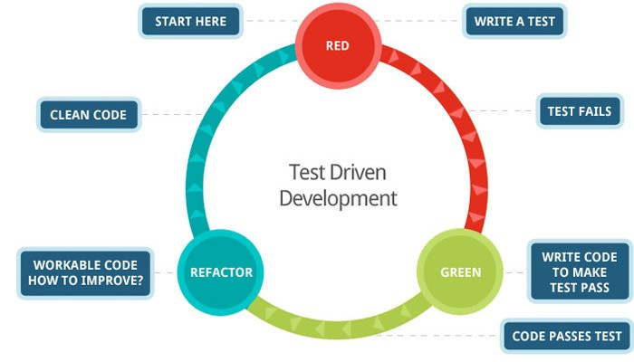

Figure 2: Test Driven Development

## **6.3 Tools Used**

* Mobile Application – React Native, Node js
* Web Application – React
* Database – Mongodb
* phone number validate with react-number-format npm package
* nodemailer npm package
* Axion pm package
* Alert Message Display – Sweet alert 2
* Brycrpt package

# **07. Architecture and Design**

## **7.1 Use cases and Functional Requirements**

### **7.1.1 Functional Requirements**

Functional requirements are generally defined as the specifications required for a system Achieving its goal. Functions performed by the system. The following is the activation Requirements are divided into three sections as Core, Desirable and Optional. The basic functions should be the most important and current needs. Without them, the system would stall the task and project do not meet its requirements and completion. Requirements Contains a functionality that gives the user additional options, but if they were not present Project, the system will still be running. Alternative needs are elements of functionality Due to constraints (time, cost, resources, etc.) the final project submitted may not appear. They are self-contained requirements under future improvements to the project.

**Tracking**

Customer orders are an integral part of the shipping company's business. These orders drive the business. With courier tracking software you can order in several ways. If you are using a courier service that uses advanced tracking software, you can place an order as follows:

**Dispatcher Consumer request**

In these ways, users can place three types of orders: Individual Customers, Business, and Corporate Activists (Posting Users). The software also allows you to monitor orders. Here are some suggestions that might help:

**Order status is updated in real-time**

Courier tracking software development often uses real-time technology. Orders can be reviewed in real-time forums and notify everyone involved in the process. The order status can be as follows.

**Driver acceptance**

* The driver's arrival to find a place
* Sending Driver
* The driver arrives to disembark
* Make a POD
* Review some orders
* Complete the order

**Order Management**

Users who use Dispatch to place orders, customers who monitor orders with applications, and businesses that use the API to send orders to your courier company will not see it. However, they can manage the entire order process. Each of these three types of users has different order management options. For example, once an order is placed, customers cannot cancel it. But the operator can update the order status from Dispatcher at any time.

**Communication**

As a result, courier tracking software should provide a complete and dynamic communication solution for all parties involved in the distribution process. As a result, software designed to manage business operations is required to make connections between components of each system. Typically, a communication module is installed that can randomly specify events to be sent to customers from time to time.Users can choose from the following channels:

* SMS
* Email
* Notice

The message may contain the following information:

* Follow-up link
* Order an invoice
* Driver's phone number
* Vehicle information
* Order price

Through communication, everyone involved in the order can receive messages about all events during the order process. The following people may be recipients:

* Individual customers
* Business customers
* Pickup links
* Leave contacts

**Driver**

Courier tracking software allows the customer to view the order status, and caller location and share the tracking link. In addition, it is possible to communicate directly with the driver via the communication module. Posting a playlist is the best way for customers who do not have a client application installed. In this case, you can send the link via SMS to follow the order process as it progresses.

**ETA**

ETAs, or Limited Time Travel, is an important option to ensure customer satisfaction. The feature measures this time and indicates when the driver arrives at the download and drop-off point. Map features show limited arrival time and allow you to organize your activities accordingly. Giving the customer ETA is vital.

**POD**

Almost all courier tracking software requires a POD to verify that a customer has received a shipment. Drivers collect enough documentation during the process to secure delivery. You can take pictures and write comments for more text using the powerful messenger tracking software to get a customer's signature on a computer.

### **7.1.2 Non-Functional Requirements**

* Documentation - There should be a Documentation of the System.
* Feedback – Provide appropriate feedback to the user.
* Performance – Should promptly respond to user actions.
* Security – Keep out unauthorized Users.
* Validation – User inputs should be validated before moving on to the next action.
* Privacy – Data should not be shared with another party

**That is there**

This system is available at any time of the day or night, but any order has been placed in the past Pm Delivery will not take place that day at 4:00 EST. That order will be included in the program, too the sender will be notified to pick it up at the beginning of the next business day. In Spot Courier Services is closed on Sundays, but any time after 4:00 pm EST, ships It can still be edited. If any maintenance is deemed necessary, notice will be sent here At least 24 hours before repair. If repairs are needed, it is done later End of business day.

**Ability to use**

This process requires a little effort to implement and understand. Using the SQL Server Database, Information entered into a web client is stored and updated on the website. If you order Ready to send, receive information and print a receipt. User sees nothing These actions, therefore, do not require them to understand how to use the website or to recognize the characters.

**Security**

Our database is always backed up to most external drives and cloud services, ensuring that data loss does not occur. Also, we have included a number of security measures Our domain is prone to both viruses and data theft. We use PayPal as our preferred method online Payments, but also a high credit card service.

## **7.2 System Design**

System design is the process of defining buildings, modules, meeting places, and data. A plan to meet specific needs. The system design can be seen as an application Product development system theory. There is some conflict with system discipline Analysis, Systems Architecture and System Engineering.

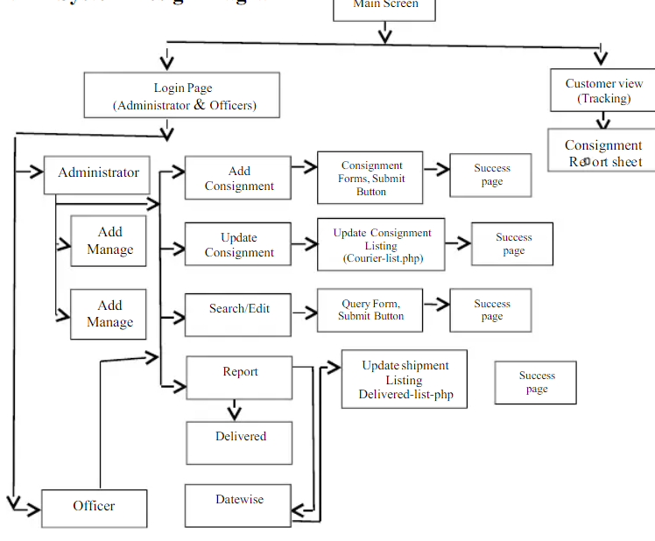

Figure: System Design Diagram

### **7.2.1 Research Design**

The research plan describes the process that the researcher will take to improve roads Provide guidance on various steps for problem solving and research. This study Satisfaction is worth explaining as it exists because it uses a detailed research design During reading without supervision. Given to the researcher Opportunity to gain a deeper understanding of the topic being studied.

### **7.2.2 Use Cases**

#### **7.2.2.1 Final Use Case Diagram**

#### **7.2.2.2 ER Diagram**

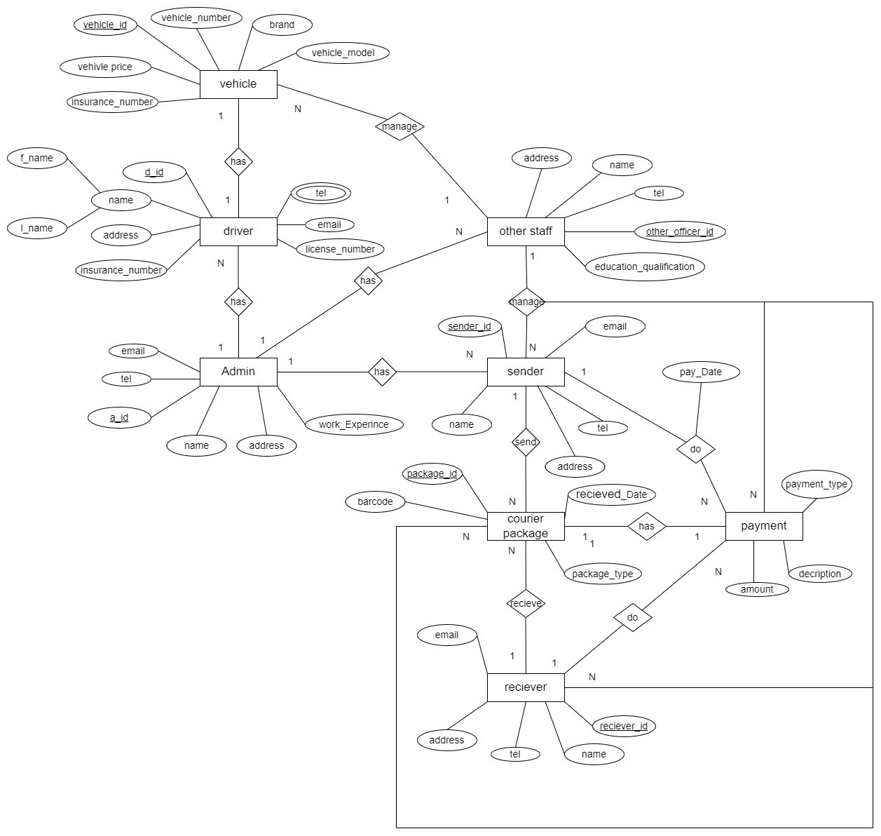

## **7.3 System Architecture**

Provides a complete overview of the system framework and framework System and function. This diagram shows the system interactions between each module and forums to be used in each component of the system. From the framework, several components or modules need to be developed. Make a backup copy Services such as package and user information management, internet management, and more Software delivery is upgraded as a cloud space software. The framework is a platform It integrates all components to facilitate system operation. It will happen Manage requests and responses from system administrator, messaging service provider Customer requests. Android and iOS mobile apps that will upgrade to Mail once Customer service.

### **7.3.1 Final Class Diagram**

### **7.3.2 Activity Diagram**

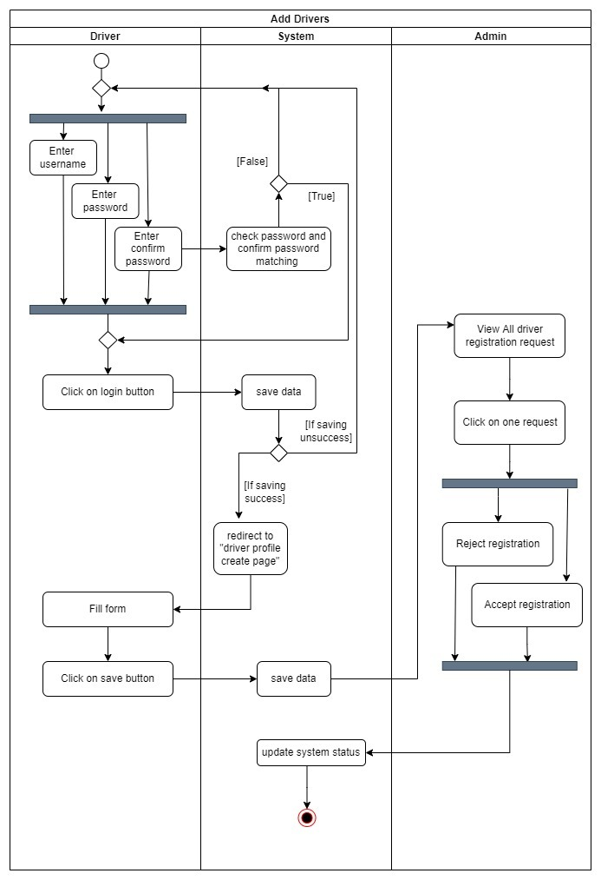

Figure: Activity Diagram for Add drivers

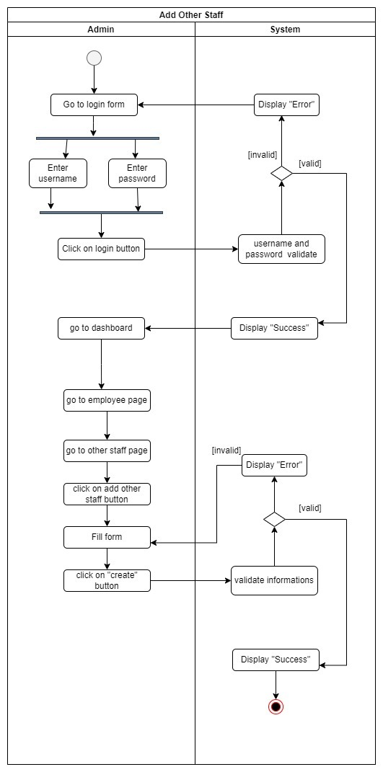

Figure: Activity Diagram for Add other staff

### **7.3.3 Collaborative Diagram**

### **7.3.4 Sequence Diagram**

**

## **7.4 User Interface Design**

An abstract design of the interface was created before the project was developed. The main focus is on the background work of the core activity. Finally, system requirements as it was completed, I focused on the designs and color schemes, layouts related to the front end. Because it is also a crucial part in the eyes of customers. Poorly defined interfaces can also lead to disappointment No matter how good the functionality is, if it is not user friendly on the outside, it keeps customers by doing what they are supposed to do.

### **7.4.1 Software Design and Principles Used**

The policies here provide the means needed to handle complexity and reduce opportunities Wrong. The saying goes "software should be open for extension but closed for modification". Those the main purpose of the key is to ensure that the code is easy to understand without losing it Understanding of its performance. There are design guidelines for multiple, clear production with these principles Code and documents. When considering design principles, SOLID has thought about and applied design principles Do the project to the best of my ability.

**S** - Single Liability Principle (SRP) - This principle states that a class must have only one cause change. The classes here are designed in such a way that one class has a single purpose.

**O** - Open / closed principle - previously repeated, open for extension but closed for modification.

**L** - Liskov Substitution Principle - Can perform tasks that use pointers or references for elementary classes Use objects in derivative classes.

**I** - Interface Separation Principle - Users can view the features they should use.

**D** - Dependency inverse principle (DIP) - High level modules do not depend on lower-level modules, but both depend on abstractions.

## **7.5 System Analysis**

During project work, data collection is done in a variety of ways. Magazines, journals, articles, e-books, and the Internet were often used as sources for collecting and collecting data needed for a project. The case study also collected useful information for system development. The software development tools used in designing this project are a step up. The ascending and descending method (also known as step-by-step design or concept of reduction) is a system division to understand sub-systems in their construction. On the way to the bottom, it is designed to view the entire system, which is clear but does not explain the small first-level plan. Each sub-system is then filtered in detail, probably at multiple levels of the sub-system, until complete specificity is reduced to a basic feature.

It should be done to analyze the existing system. In this study, we will analyze the courier service system that should have access to the input data and see how the system achieves its purpose. This will help identify an existing system problem and suggest a new system to improve the existing book service system.

The existing system of a courier service company is manually made. Documents to be sent are filed and a payment receipt is issued. These packages are sorted by destination, city, or province. Arrangements were made to take them to their destination. Upon arrival, the documents will be delivered to the owners and a manual report will be prepared for each delivery. Sometimes customers come to the office to request a parcel and a search is done in person so that the customer can find the parcel.

### **7.5.1 Input Analysis**

Data analysis and limitations were based on identifying the basic needs and structure needed for the project. The information collected was analyzed and reorganized so that sub-systems and modules could be successfully acquired. This data analysis and reconfiguration allows the system to insert data into the input form.

### **7.5.2 Process Analysis**

The collected information was modified to make it more accessible to the system. Processing was primarily on parcel records.

### **7.5.3 Output Analysis**

System output the program is produced by system input.

# **08. Development Technologies**

Before the project development phase began, an investigation was carried out to choose the most suitable technologies as best suited. In the end, the technologies chosen were the best but were unfamiliar and time was allocated to learning specific aspects of these technologies, building on the knowledge already available. The technologies chosen were,

## **8.1 Mobile Application**

Android and iOS were the chosen platform for the mobile application. The application was developed using React Native and Node.js. Android was chosen as the

the preferred platform for the reasons given below.

* Cost-free to use.
* Device Availability – It is important for a developer to have the device in hand, in order to understand how a real-world user would interact, rather than testing user experience on an emulator.
* Documentation – In regard to Androids and iOS compatibility and working areas with React Native and React.

# **09. Project Management**

GitHub is divided into two parts: git and hub. Access control, as well as range collaborative tasks, such as simple task management tools and all the tasks you manage everything is included in the service. Maintains a record of multiple improvements made by GitHub each version of the source code project is available in a variety of programming languages. As a result, the word "git" refers to a version control system, a factor that helps programmers keep it observe continuous revisions to their code. Once I lost all my data due to damage to my hard drive and had to restart the project scratching. So, I used GitHub from the beginning because I knew the dangers of losing data. GitHub versions of this project were used for the control system. Since the file is hosted on GitHub rather than maintaining locally, data does not disappear if local hardware fails. Throughout the system growth, two sections have been used. A development branch was used to monitor the current development work, and the code of the development branch was pushed to the master after reviewing the branch and finding that it operates as planned. Main branch maintains a copy of the system's activation, system certified and validated iterations still in operation.

## **9.1 Time Management**

A supervisory meeting was scheduled to be held every Friday for the first 15 weeks. In time for the first few weeks, oral reports informed our supervisors and supervisors about our progress. Ensured that the project was adequately managed. He was able to advise and suggest to us Research areas when needed. However, they were not expected to assist us in any other course of action Regarding the development of the project. In addition to the above, in any case, maintained a work diary to keep records of tasks They are completed, post-feedback, and so on. This helped in the necessary understanding Helped to make necessary improvements in the areas of growth and to plan for the future.

## **9.2 Control Plan**

Control Plan is still applied to the project using the following techniques

* Weekly Highlighted Performance reports
* Communication plan
* Risk management
* Quality management

# **10. Testing**

Testing is a crucial part of the development of any project, as it brings out the flaws and errors that need to be cleaned up before delivery. A thorough inspection of the system will ensure reliability, safety, usability, and stability. I have used a variety of methods, using a user's vision, experimentation, and ensuring that all functions conform to their standard functionality.

* Mobile Application - React Native, Node js
* Web Application - React
* Database - MongoDB

I created this project using the above techniques and concepts and tested it on several in the final stages. Computers to detect application errors and misconduct. After identifying those issues Resolve those issues using resources and test the application on those computers again. Testing was an integral part of the development process. Project testing included developer testing and User testing. The developer test consists primarily of verifying that different parts of the code are working and secondary application testing to ensure that they are not broken. On the other hand, try to test the user Ensure that the application provides a decent user experience and provides the desired results based on them His research. Some test cases are identified and tested, where the results are valid and are compared to the expected ones. The result. If the program has errors in the expected results, it will be analyzed to determine any errors in the program. This test cycle is repeated until all issues are resolved. Then there will be the evaluation Held to strengthen and improve the system to provide the best user experience.

## **10.1 Unit Testing**

Unit testing is the process of writing tests and automating to ensure that the functions you expect for your code are executed as desired. A unit is the smallest component. In-system and, as mentioned earlier, test-driven development takes place with this stage as each unit is subjected to TDD. Using unit tests, the code can be rearranged. This, in turn, revolves around the Agile Method, because the nature of the fast approach allows it to make any changes at this stage.

## **10.2 Functional Testing**

By definition, this test methodology is based on what needs to be accomplished by the application being tested. It has been tested based on requirements and specifications performance. This ensures the quality of the software, including testing failed routes and borderline instances. These were the tests. This is done periodically after each sprint to ensure that the activation is activated as specified.

## **10.3 Usability Testing**

The objectives of the utility test are different, but they include,

* Identify product design issues.
* Identify opportunities for improvement.
* Learn about the preferences of the target users.

Utility testing is the standard tool used to assess usability. Here users are asked to check Software by completing a set of tasks. Users are encouraged to give their feedback and think aloud. Upon completion, users will be directed to a survey asking for their experience. The notes collected from the overall survey were used to further enhance usability.

# **11. Development**

To fully understand the software development process, we need to look at the following steps:

**Needs Analysis**: How does a company operate internally? What software features are needed to improve the efficiency and effectiveness of these processes? Who uses this program, and what features are needed? What kind of data is needed? Answering these questions is the basis for developing a courier management system.

**Design:** After defining the requirements, you will need to build a number of pages in the software. The UI / UX design shows the final look of the software and images.

**Implementation:** In this case the engineering team is responsible for software development. The work is done professionally, and the features obtained during the step analysis process and the image details collected during the design phase are listed here.

**Testing and Production:** Once the original version has been installed, it should be tested internally. Once a sufficient amount of testing has been completed and successfully completed, the customer can produce a plan and apply it in real life.

# **12. End Project Report**

## **12.1 End Project Summary**

On an overall basis, the project was a success, as all main requirements were able to be met on time. The applications covered the core functionality and most of the desired functions.

## **12.2 Project Objectives Review**

**To analyze user requirements for the application**

Here, user functionality was analyzed, and information was extracted by researching the previously defined current solutions. Also, the analysis of articles that highlight the depth of the features, of a highly virtualized courier system would have, given me an understanding of implementation.

**To analyze potential development technologies to use.**

This objective was met by conducting extensive research in the primary stages, in regard to the best development technologies. Certain factors considered here are cost, scalability, security, documentation, etc. This stage is as important as development process, even more so.

**Design the interface of the Application**

In the primary stages of development, how to develop user-friendly interfaces that follow the HCI principles was analyzed. Based on how most of the focus was given to the main functionality, minor changes were made as to front end development.

**The Development Process**

Firstly, the focus was to develop core functionality before deciding on the desired. According to a sprint plan, as given before I made sure that within the time frame procured, the core requirements were met. Most of the desired features were then later, implemented at the end stages of the project development life cycle.

## **12.3 Changes Review**

The technology chosen to develop the entire system took me a while, as it was a new field of study for me Requirements for fulfilling certain needs and less for others are marked as ‘done’ More time than expected, balancing with time limits. In any case, there was no turning back the schedule is already set. It helped that I started learning quickly and its features The hand too.

# **13. Project Post- Mortem**

## **13.1 Objectives Attained**

At the beginning of the project, I set some goals that I should achieve by the end of the system design, I was finally able to accomplish many of the goals I had set for myself.

### **13.1.1 Developed a user-friendly interface**

The program includes an easy-to-use interface so customers can easily access a variety of settings. The ingredients are simple and there is an option to easily go to the top of the entry page. User can Easy and manageable access to home, menus, bookings, services, contacts, staff homepage Portions such as shipping, ordering, and testing.

### **13.1.2 Development Database for storing all information**

This application includes a website with multiple login names. Saving information on a website Users in the user table, stores information in the package in the system settings table Package Table, Package Track Table Verification of Package Song Table and Branch Table branches.

## **13.2 Development Process Evaluation**

An agile approach was taken to make sure the project was contained between constraints. But still since I had very little knowledge over most technologies used, it was extremely difficult to develop a detailed plan in the development schedule. Considering this, I spared time for learning the technologies to a certain level and then continued with my plan to develop, which made me be a head of time by sprint 4. Agile as mentioned before was the right approach to software development because of the flexibility it offers. Changes to the requirements could be implemented at any area of the project for an example and feedback can be the gained from the users again. Weekly sprints were used to allow me to focus on completing tasks while being open to changes as mentioned, while making sure that each week, there was something completed.

## **13.3 Technologies Evaluation**

The development methods used are correct and, therefore, no Major problems arose during the development. Despite all the technology used There were not many scriptures, there was enough information that I could take little by little and I could apply I had no idea. The decision to use MongoDB as a website and website was an uninterrupted process. MongoDB provides android, iOS, react and web development. Allows the developer to access the website an important feature of the mongoDB rendering is the ability to work quickly without the need for any sensitivity.

## **13.4 Developer Performance Evaluation**

Throughout the project I set personal deadlines for myself with safety zones in order to complete noted tasks. Aiming to work for more than 35 hours a week, there were times where I lagged behind due to other commitments being managed. For example, other projects to be developed. But any hours missed were covered up by working through the following week, overtime. This ensured that I claimed my goals and completed the tasks necessary. At the start of my project there was a doubt, that there might be restrictions, due to my lack of knowledge but because it’s an area that I love learning about, I used my passion to drive my motivation and study more and complete more. I took my time reading and learning while implementing while jotting down necessary documentation that I would need. As a result, my knowledge base was broadened, and I managed to accomplish what I set out to do.

## **13.5 Future Enhancements**

Future projects:

* The work to be done with the future release of this program is outlined below Part.
* Add more functionality to the system, such as having user barcodes to make the task easier.
* Improve user interaction by adding interactive features for users. Giving transactions once Management Promotion
* Post the details on the home page. Provide week / day home cooking
* Payment Options: Add different payment options like PayPal, cash, gift cards. Give Way
* To save payment details for future use.

## **13.6 Challenges Facing Development**

* Integrating a better and improved phone structure
* Unauthorized access and user not trusted.
* Learning a new language, you can write
* Deadlines - Complete the study before the project duration becomes a major challenge due to the complexity of the project That I chose. It takes a long time to learn the basics of React Native and Node js. Is under development A mobile app usually takes a long time. Is the system UI completely done? But there are some functions Such as activities to be completed for a completed project.
* Difficulties in finding new resources - When I was doing this project, the main problem was the difficulty of finding new resources. There are a lot the limited number of tutorials for React Native and Courier Tracking Mobile Application in React Native is a challenge. Find suitable material tutorials for enhanced knowledge. Requires a mobile application development and a web application Professional knowledge of the software.
* Covid-19 epidemic - The Covid-19 epidemic has had the greatest impact on the project. I could not because of the lockdown Physically meet my supervisor.

# **14. Conclusion**

In summary, the world is rapidly evolving and moving towards technological excellence. Technology is not a fixed or permanent field, but a field that is constantly changing as new trends emerge. As patterns change and evolve, the time has come for us to change as well. The use of courier online management systems is very important to respond and speed up assets and make the task easier. As a result, the system of courier companies will be simpler, responsible for all their services.

Having an effective distribution tracking system not only ensures business growth Creates a strong customer base for life. Time for everything to be online. People avoid it Go to the shops for their daily needs and choose the same online method instead. This It's time to change the much-needed courier services and online shopping. With fast with the growth of online shopping comes the need for accurate and robust mail delivery system. In addition, a courier system without a proper tracker is useless. A tracking system It is essential to get maximum customer satisfaction. Having one is very important Proper service delivery tracking system for developing a service delivery system a competitive market. Proper tracking system will ensure proper handling of parcels Vessels. A project called 'Courier Management Service' was developed as a delegation Services and guidance If you're doing business in this digital age, you need to be familiar Online tracker. When everything is online these years, you should have an advanced one Distribution system that includes the installation of trackers so that customers can access it in real time Distribution-related information and updates. The system was tested, and the system The performance was found to be acceptable. All necessary outputs are built. Was the system It was found to be easy to use with a customer support message.

# **15. References**

1. CodeCanyon. (n.d.). No results found. [online] Available at: https://codecanyon.net/category/mobile?term=courier%20delivery.
2. ResearchGate. (n.d.). (PDF) Development of android-based apps for courier service management. [online] Available at:https://www.researchgate.net/publication/339802344_Development_of_androidbased_apps_for_courier_service_management [Accessed 23 Jan. 2022].
3. Stormotion Blog. (2020). How to Develop a Courier Management System: Top Things to Consider. [online] Available at: https://stormotion.io/blog/how-to-develop-courier-management-system/ [Accessed 23 Jan. 2022].
4. www.deliforce.io. (n.d.). How Does A Courier And Package Tracking System Work? | Deliforce. [online] Available at: https://www.deliforce.io/blog/courier-parcel-package-tracking-system [Accessed 23 Jan. 2022].
5. Bunger AC, Hanson RF, Doogan NJ, Powell BJ, Cao Y, Dunn J. Can learning collaboratives support implementation by rewiring professional networks? Adm Policy Ment Health. 2016
6. Neta G, Glasgow RE, Carpenter CR, Grimshaw JM, Rabin BA, Fernandez ME, Brownson RC. A framework for enhancing the value of research for dissemination and implementation. Am J Public Health. 2015.
7. Nadeem E, Olin S, Hoagwood KE, Horwitz SM. Understanding the components of quality improvement collaboratives: a systematic literature review. Milbank Q. 2013 Gulc, A. (2017). Courier service quality from the clients’ perspective. Engineering Management in Production and Services, 9(1), 36–45. https://doi.org/10.1515/emj-2017-0004
8. Mohd, A., Rashid, R. A., Abdul Hamid, A. H. F., Sarijari, M. A., Rahim, M. R. B. A., Sayuti, H., & Abdul Rashid, M. R. (2019). Development of android-based apps for courier service management. Indonesian Journal of Electrical Engineering and Computer Science, 15(2), 1027–1036.
9. <https://doi.org/10.11591/ijeecs.v15.i2.pp1027-1036> Okemiri, H., Henry, O., Nwogbaga, N. E., & Nwebonyi, F. N. (2017). Critical Review Of Courier Service
10. Management System With Empasis To Its Relevance If Adopted In Nigeria Queuing Theory View project Smart home control system View project Critical Review Of Courier Service Management System With Empasis To Its Relevance If Adopted In Nigeria. In Journal of Multidisciplinary Engineering Science and Technology (JMEST) (Vol. 4). [www.jmest.orgJMESTN423516887738](http://www.jmest.orgJMESTN423516887738)
11. Anon, (n.d.). introduction to courier management system | Projectworlds. [online] Available at: https://projectworlds.in/tag/introduction-to-courier-management-system/ [Accessed 16 Nov. 2021].
12. Bhardwaj, V. and Garg, Mrs.M. (2018). Development of a Web Content Management System in PHP. International Journal of Trend in Scientific Research and Development, Volume2(Issue-3), pp.1454–1456.Ejdys, J. and Gulc, A. (2020). Trust in Courier Services and Its Anteced(Courier Management
13. System Title of the Project-(1)-Courier Management System Introduction to Purpose System (Courier Management System), n.d.; Efficient Courier Tracking System Project, n.d.; Ejdys & Gulc, 2020; Gulc, 2017; Okemiri et al., 2017)ents as a Determinant of Perceived Service Quality and Future Intention to Use Courier Service. Sustainability, 12(21), p.9088.
14. Eneanya, A.N. (2018). Performance management system and public service delivery in Nigeria: Impacts, problems, challenges and prospects. Africa’s Public Service Delivery and Performance Review, 6(1).
15. Keep, J. and Johnson, H. (1997). Generating requirements in a courier despatch management system. ACM SIGCHI Bulletin, 29(1), pp.51–53.
16. pdfcoffee.com. (n.d.). Project Report of Courier Tracking System. [online] Available at: https://pdfcoffee.com/project-report-of-courier-tracking-system-pdf-free.html.Priebe, L. (2009). Could Your Library Courier Benefit from a Courier Management System? Collaborative Librarianship, 1(2), pp.72–72.
17. Riyanto, S., Ariyanto, E. and Lukertina, L. (2019). WORK LIFE BALANCE AND ITS INFLUENCE ON EMPLOYEE ENGAGEMENT “Y” GENERATION IN COURIER SERVICE INDUSTRY. International Review of Management and Marketing, 9(6), pp.25–31.
18. Team Invonto (2020). Mobile App Development Process: A Step-by-Step Guide [2020]. [online] Invonto. Available at: https://www.invonto.com/insights/mobile-app-developmentprocess/

# **16. Appendices**

## **16.1 User Guide**

### **16.1.1 Web Application**

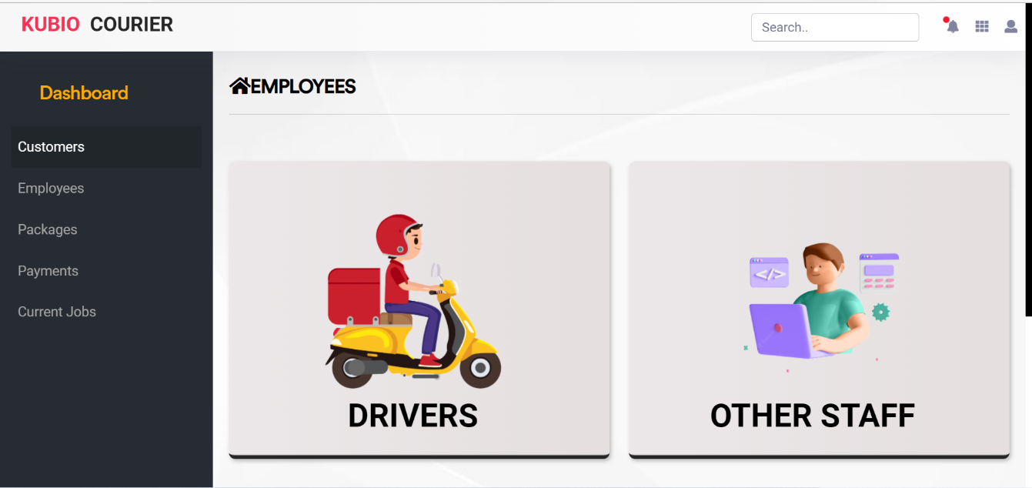

This is a Courier Tracking Web Application Dashboard. The dashboard can also be viewed as the title / homepage of your admin panel. They usually visualize important data about your distribution system. The good look of this screen depends on the needs of your business. However, it usually includes data such as: Current and recent delivery order conditions: pending, ongoing, delivery, cancellation, etc.

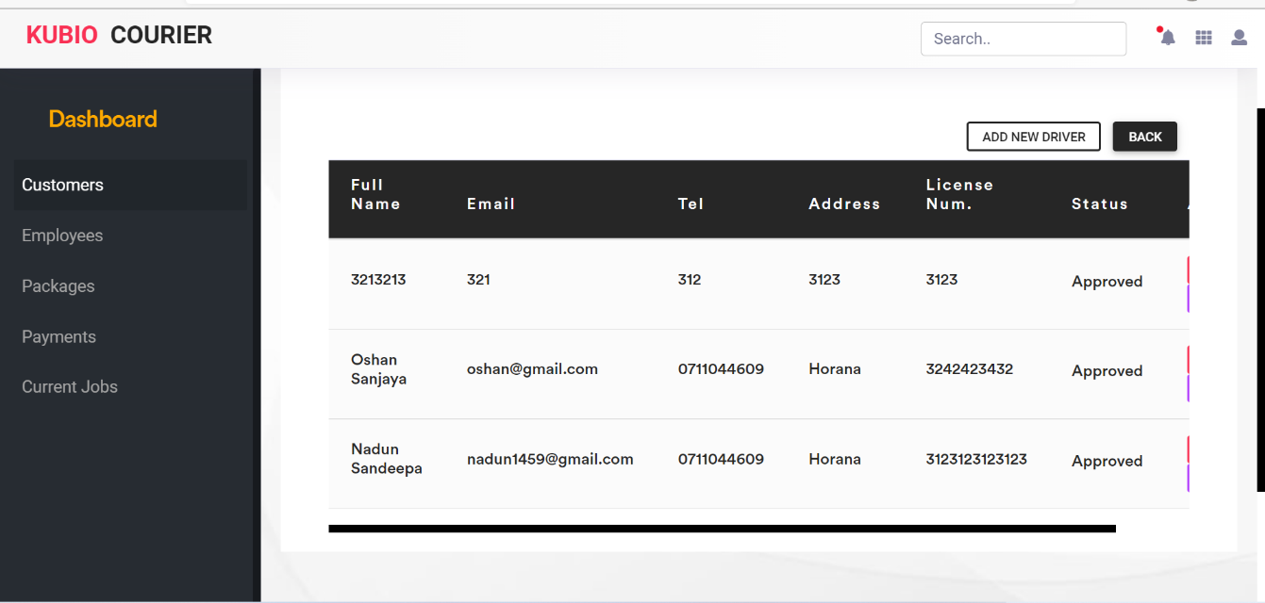

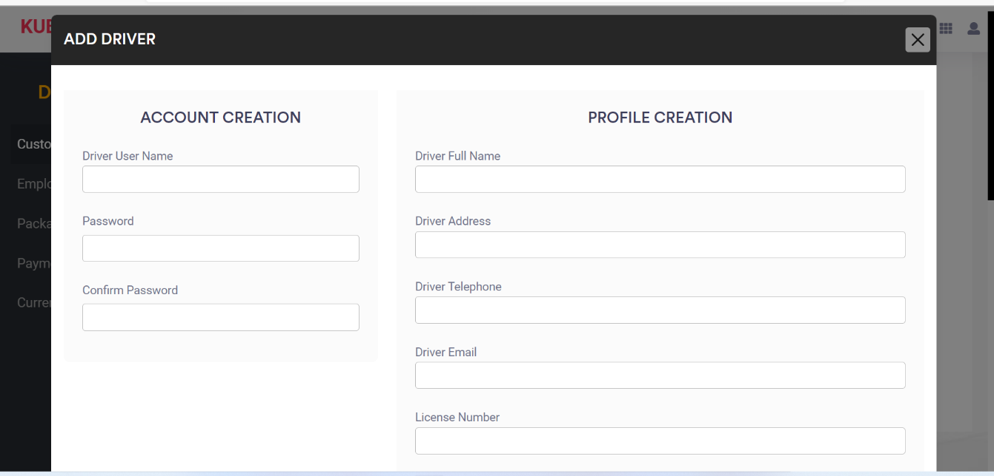

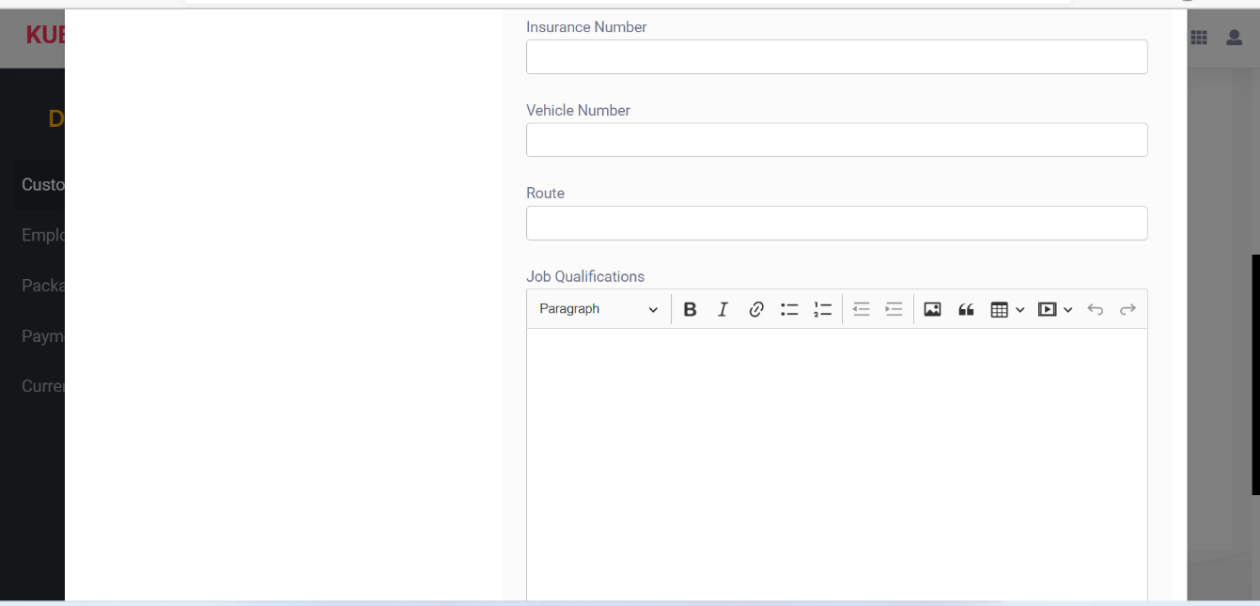

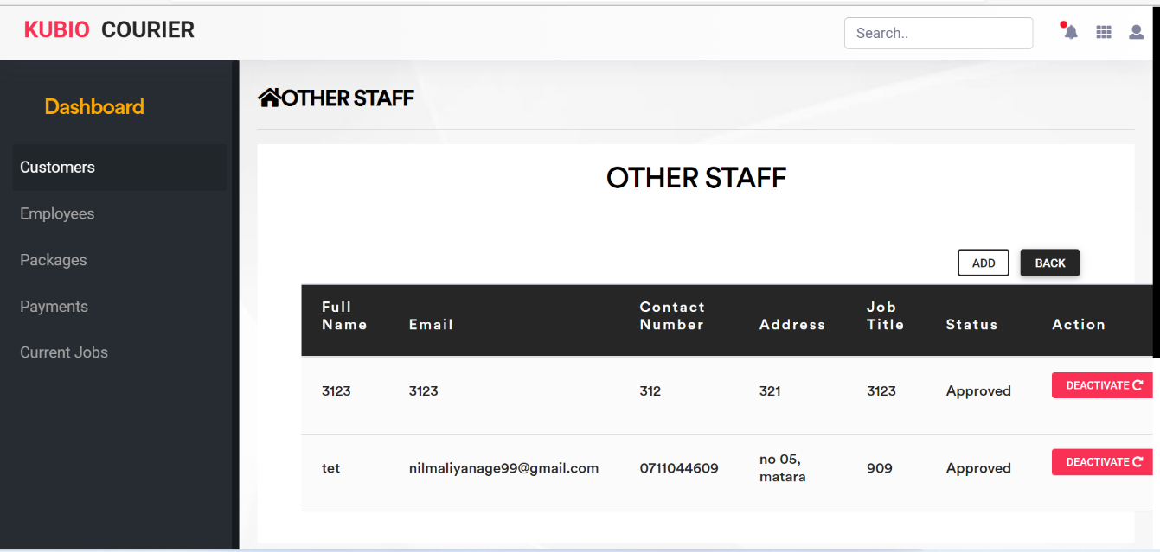

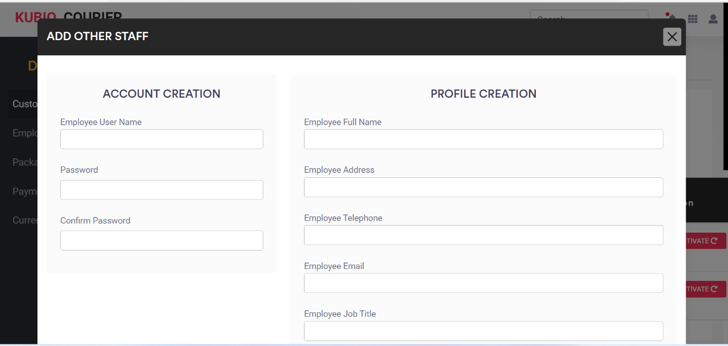

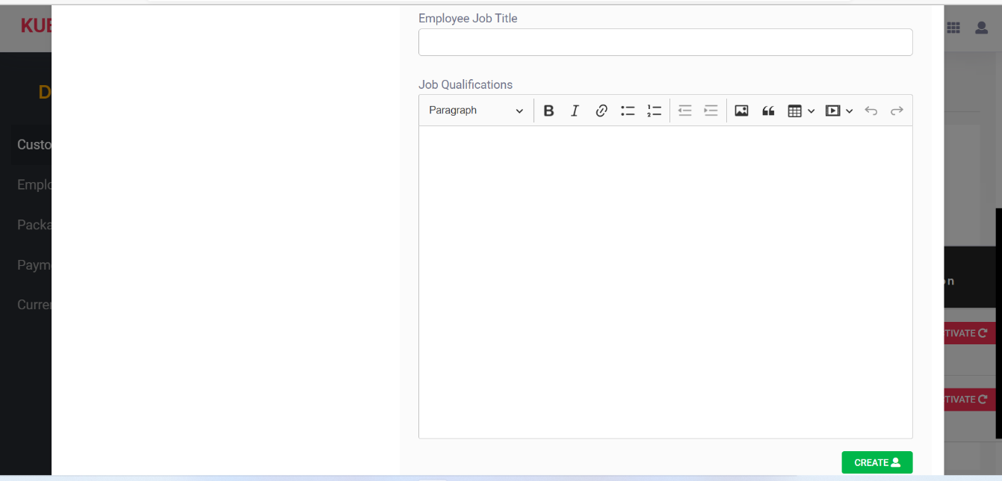

### **16.1.2 Mobile Application**

## **16.2 Project Proposal**

**Real Time Courier Tracking Mobile Application**

**Proposer**

N.N.D.G. Liyanage [10707256]

**Proposed supervisor**

Dr. Rasika Ranaweera

**Problem statement**

My proposal for the final year project is a Real Time Courier Tracking Mobile Application to improve connectivity between courier service provider and customer.

Using courier service for delivery is expanding business service in Sri Lanka. Courier services are being used widely by the people in Sri Lanka.

So, using and app for courier service industry can be a boost. So, by using an app the following problems can be eradicated easily.

* The first problem is difficulty in finding the location of customer and courier service and vice versa.
* There is no correct idea of the time between the goods are handed over to the courier service and to the customer. That mean wastage of time and the courier service provider can’t manage the delivery of goods within working hours.
* The third problem is the customer has no correct idea whether delivery charges are paid or not. Until courier service provider meets the customer.
* The fourth problem is the people in remote areas are unaware of the closest courier service center.

**Project description**

Real time courier tracking mobile application is an android and iOS based mobile application. I have developed this project in React native and Node.js. The main purpose of react is to be fast, scalable, and simple. I will choose to build tracking API with Google API.

I hope to develop this app to use by courier service, courier service provider and the customer. The main objective of developing mobile application on the courier tracking system facilities’ both the customer and the courier service. With the increase of using courier service the demand of a simple and easier methods for courier industry has been increased. Because of these I would like to propose my project to develop an app on courier tracking system. I hope this app would help all to minimize the problems arising with the use of courier service.

In this project there are various types of modules available to manage courier, delivery and customer. Courier module can manage courier, Tracking module is normally developed for managing tracking, Customer module manages customer operations , Delivery module has been implemented to manage delivery.

Modules of the Courier Tracking System

* Courier Module: All the operations related to courier, is managed by this module.
* Tracking Module: Tracking module is used to manage the tracking.
* Customer Module: It has been developed for managing customer.
* Delivery Module: It manages the delivery.
* Office Module: Office operations will be managed by office module.

Features of Courier Tracking Mobile Application

* Just like in any other app, it all starts with a login. Among all possible login options (like social, password less , email, etc.) I recommended sticking to the phone number or email and password login.
* Courier tracking mobile application is based on app, from which user can easily manage Tracking details, and Customer details.
* Admin user will be able to track all information of Courier, Tracking etc.
* Search module has been implemented to search courier, delivery, office.
* Admin has rights to edit, add, delete, and update records of customer, delivery, and office.
* The courier service provider will be able to show the numbers of parcels to be delivered per day in a convenient way that can be delivered by a map in the order of address and distance.
* After the logging app the customer must create an account a QR code is sent to the customer by courier service after filling the details. After the customer receiving the parcel the courier service provider must scan the QR code. Then a message sent to the courier service after every successful delivery.
* I hope to be implementing push notification feature when you develop a courier tracking system. Its main purpose is to keep courier service providers updated on the most important matters (New delivery orders, Changes in current orders, Status updates). It helps couriers never miss and timely react to anything important.
* This app allows the customer to pay the delivery fee cash or online payment methods.
* This set of features is the very special part of the courier tracking mobile application. From here a courier can access an active order.
* Oder Number
* Oder Description
* Name of the recipient
* The recipient’s mobile phone number
* Estimated delivery time
* Payment details
* Pick-up location
* Drop-up location
* Notes

**Project keywords**

React Native, Node.js, Firebase (Languages) QR Reader, Push Notification (Technology)

, Android, iOS, Google API (Tracking system).

**Requirements**

I have to learn about React Native and database connection thoroughly.

**Finance**

Cost for internet facilities and for required software.

**External organizations**

None

**Other staff**

None

## **16.3 PID**



School of Computing and Mathematics

PRCO303

Final Stage Computing Project

BSc (Hons) Software Engineering

N.N.D.G. Liyanage

10707256

**Real Time Courier Tracking Mobile Application**

2020/2022

Contents

1. Introduction 4

1.1 About Us 4

1.2 Introduction 5

1.3 Background & Motivation 6

2. Business Case 6

2.1 Business Need 6

*2.1.1* *Underlaying Problem 7*

2.2 Business Objectives 7

3. Project Objectives 9

4. Chapter 4: Initial Scope 10

5. Method of Approach 12

6. Project Plan 13

6.1 Control 13

6.2 Communication plan 13

7. Initial Risk List 17

8.Initial Quality Plan 20

9.References 21

Introduction

**About Us**

E-commerce has grown exponentially over the years. Growth has been reflected in strong consumer demand and a growing number of different products available online. This creates a transportation problem and increases the need for an efficient courier service to support growing markets. It is very important for the courier service provider that the delivery of the parcel is done as soon as possible. One of the most important and important courier business processes is the delivery of parcels. This is where effective service delivery will be paramount. An efficient system needs to be built to facilitate interaction between the courier service provider and the buyer to accurately determine the complete package delivery route. In this proposed project, a real-time Android and iOS mobile tracking app will be developed. A mobile app that helps mail delivery staff find their way to deliver parcels to a customer's door. The app will direct courier staff to obtain courier data such as addresses and contact information and then navigate to selected customer addresses. It will select the best route to the address and inform customers before it arrives so that they are ready to receive the package. This parcel delivery tracking will provide the basis for an effective courier service system. (Courier Tracking System Project, n.d.; Okemiri et al., 2017)

**Introduction**

These days, e-commerce stores have been growing as a result of changes in consumer behaviour as more consumers choose to shop online. The latest figures show that Sri Lanka has 6 million online shoppers, comprising 29 percent of the population, and 35 percent of mobile users shopping online. The growth of online shopping requires the modernization of parcel delivery services, especially for day-to-day delivery. In Sri Lanka, the number of courier service companies has been increased to support the need for parcels.

In the Courier Tracking Mobile app, parcels must arrive on time in place to satisfy customers. To ensure prompt delivery of packages to customers, it is necessary to find the fastest route with the least amount of traffic from the delivery point to the destination customer. At the same time, customers should be notified during continuous delivery or on time.

Responsive communication between the two organizations will improve the efficiency of the messenger service and customer satisfaction. The purpose of the mobile app is to develop an Android and iOS mobile system that can help build a more intelligent package delivery system by integrating the use of current communication technologies such as Google API, QR Reader, Push Notifications, and Android-iOS Tools. It will help to track the mobile app to intelligently manage the parcel delivery process and deliver the parcels in a timely manner to the customers.

In developing the application, a delegation tracking system was discussed. However, the system courier service provider will be able to indicate the number of parcels to be delivered per day in a simple way that can be delivered on a map in order of address and distance. The proposed sender tracking mobile app can be easily used to provide better user information to consumers to track and collaborate with a delivery service provider to avoid unnecessary hassles. (Mohd et al., 2019)

**Background & Motivation**

One of the main reasons I'd like to take on the proposed project is to learn about and become acquainted with new trends. Another reason is that the project holds an interesting plot for which critical thinking is necessary. Information in relation to the applications needed to build the project is scarce. As likely as it is to have its risks, it is also an innovative approach to the defined problems.

Business Case

**Business Need**

Currently, the package or courier tracking process involves the process of packaging local packages and packages separately during screening and delivery. Although the main problems of local mail delivery services are late delivery and goods delivered in an unacceptable condition, Competitive Prices, Poor Customer Service, and General Service Issues.

The concept of required delivery is an ongoing trend that is popular among customers around the world. Customers are initially looking forward to successful delivery, and if your business can supply them in the same way, you may have some loyal customers for the rest of your life. Organizations striving for excellence must come up with strategies that will improve the overall performance of the business. An effective tracking system helps an organization to regain its normal performance, improve customer experience, and remove additional steps while allowing them to operate faster and more efficiently. It is always important to have a strong commitment to delivery managers, customers, and business operators. The technological advancement of tracking systems enables us to provide professional delivery to our customers, improve performance management, and, ultimately, delight our customers. This not only helps to give customers a better sense of delivery but also helps the growth and development of the organization. Having an effective courier tracking system not only ensures business growth but also creates a strong customer base for a lifetime. (Mohd et al., 2019)

**Underlaying Problem**

As a result of globalization, businesses are rapidly expanding, and the book industry is growing at its best. The demand for fast, efficient, and trackable delivery is growing, and competition is fierce when it comes to delivery. Such situations present many challenges to the book industry. especially for those entering the market and even those experiencing the transition from conventional to modern services. The big question is how they can play shoulder to shoulder with great bullies, effective technology and brand ownership.

Other problems with local mail delivery services are late delivery and goods delivered in an unacceptable condition, competitive prices, poor customer service, and general service issues. (Gulc, 2017)

**Business Objectives**

* **No Problem Online Booking**: Clients will want to book their download and transfer data in full quantity with this help. Clients alike can analyze the level of transfer of internet transfers from their new location to the target. So, they did not worry about the cost.
* **Real-Time Tracking**: In the past, firms will talk to Courier expert organizations to determine the situation in bulk. However, they can perform this action using the requested application by checking the default send marker or using the in-app GPS. Similarly, clients of your dispatch shipping application will want to track their packages continuously.
* **Push Notifications**: If drivers experience problems during the trip, the app will notify you immediately. Additionally, by sending push notifications, you can keep your customers up to date on all aspects of your delivery services, such as order recovery, download, process, dispatch, and delivery, and so on. Customers will feel greatly appreciated if they are kept up to date.
* **Reduced Papers**: Each item you provide comes with a host of texts that are difficult to manage. The application submission application, then, significantly saves the administrative function by storing each piece of hidden object and tracking it until it is transferred. Likewise, the portable app robs everything while at the same time getting a good deal of fix.
* **Multiple payment methods**: Users in today's generation prefer safer, easier, and faster payment methods. Make sure the standard payment gateway is integrated during the book delivery application development phase. This will allow your users to perform tasks using plastic cards, online payments, net banking, and other methods. You can also monitor and control everything you do online, eliminating the fear of late or failed payments.
* **Proof of Delivery**: It also makes sense to confirm the status of the transfer or suspicion of Pod Proof of Delivery. This feature can often be found on the Order Details screen as it combines details (eSignature, image, code) into a specific application. There are probably a few ways to get confirmation that a request has been successfully forwarded and approved by a client:
  + 1. eSignature is a customer.
    2. Scan QR code; code is generated by the client application.
* **Route-Route Improvement**: As a guide, it is similar to a standard application map where clients can build a smooth course between two focuses. Receipt and disposal sites can be physically accessed by the messenger or set naturally by the app as per hidden request. Also, the feature is a complete requirement to promote a glossary posting framework. It keeps the co-operative's professional co-operatives continuously updated somewhere in your dispatch. , the organization of the draft delivery specialist will really want to indicate the number of packages to be delivered each day in a practical way that can be conveyed by the guide in the address and distance request. As such, they can without taking long to check the driver's distance to the landing area or immediate assistance due to the critical situation.

Project Objectives

1. Project development consists of several phases with the aim of providing a comprehensive courier tracking service that will increase the efficiency of courier service in terms of cost and customer information. An application server integrated with the database system was upgraded to support the Internet management system.

2. The navigation function of the app is based on Google Maps, while the notification or notification function will be sent using the SMS (Short Message System) service. All of these functions are integrated into the customer package package database in the management system

1. The principal objective of the project on courier tracking systems is to deal with the subtleties of courier tracking, tracking number, customer, and address. It deals with all the data about couriers, delivery, addresses, and couriers. The undertaking is completely worked at the authoritative end, and along these lines, just the director has ensured the entrance. The goal of the task is to put together an application program that will reduce the amount of manual work involved in dealing with the courier, tracking, delivery, and tracking number. It tracks every one of the insights regarding the tracking number, customer, and address.
2. Analyze the customer, the location of the parcel, the date and time of delivery, the current location of the courier service provider on a map, and so on.
3. To analyze the convenience of the courier service providers' analysis of the number of parcels to be delivered in a working hour, customer details and special messages, and the number of parcels to be delivered in the easiest way.
4. Analyzing how to get track of the delivery service provider's current location to map out the location of the customer's location.

Chapter 4: Initial Scope

The starting point for my project is a study of simple courier service companies based in Sri Lanka and identifying patterns for customers and the cooperation of postal service providers.

Although the scope and functionality of a product may vary depending on the business model and specification, there are certain basic features that every package delivery tracking application should have. Here are some of them.

With the customer tracking app:

* QR reader
* Customer profile, including address and personal information, preferences, orders, payment data, etc.
* Optional: Add a personal package (compact only) package tracking system with map view.
* Package management in real time: ability to change location address, recipient or delivery time, etc.
* In-program chat: the ability to communicate by courier or ask for help from sponsors.
* GPS-enabled tracking system with map view.
* Real-time tracking: Real-time tracking is one of the most important features of a parcel delivery service. This feature is common in the admin panel, driver app, and client application. In the client app, the user can track the location and status of their package in real time. This tracking feature plays a major role in improving customer satisfaction as it gives users the assurance that their package is delivered. Similarly, this feature also helps the controller to match the nearest driver available to deliver the package. Additionally, it supports multiple routes that allow the user to add multiple addresses to the list.
* Payment gateway integration: Payment gateway is another important feature that you should include in your desired mail delivery application. Payment gates such as wallets and credit / debit cards, bank transfers must be integrated with the system. This payment gateway offers the user many payment options such as COD, card, and wallet. Not only this, with this feature, users also get a digital bill receipt with all the important information like time and date of delivery, order ID, item description, shipping cost, etc.
* Administrator chat: This feature allows the administrator to chat with the user and the delivery person to improve service quality and customer satisfaction. This feature helps to maintain continuous communication with both delivery guys and customers.
* App notifications: App notifications help users to get live updates of their delivery status directly from the app. These app notifications provide users with important information such as the current delivery phase, the estimated delivery time, and changes to the delivery timeline if available. Not only this, but users also get contact details of the driver and the control panel with these notifications. Push notifications are also an important means of communication between stakeholders. App notifications are used to inform customers about various offers and promotions. This plays an important role in customer retention.
* courier reviews and updates: This feature allows the customer to rate the service and write a review based on their experience. Ratings and reviews are important features as they help you evaluate your services.

Through the courier app:

1. Login (using information provided by the administrator)

2. Courier account, which includes personal information, user rating, in-app wallet, etc.

3. List of available orders sorted by location, overtime, package size, etc. Alternatively, the system can use the same algorithm and automatically assign the order to the nearest messenger with the option to accept / reject the order.

4. Delivery status management - manually or automatically 5. Customer delivery status verification (eg, signature or scanning QR code generated by the customer application)

5. In-message messaging: the ability to communicate with the customer and discuss details of the time / place of delivery.

6. Completed order history

After feasibility study, the design, development, and implementation process will follow the steps listed below.

Stage A: Administrators application that provides a grid report on the flexibility of messenger information and connects that to the website, and then uploads some data from the UI to the UI.

Customer's destiny according to the mark found in the real world.

Stage B: Tracking the current location of the postal service provider and showing it on a map.

Category C: Managing the app in a way that the customer can work with on arrival.

Additional features that could be used as future implementation would be system utilization across all platforms and having a more detailed and easier-to-use GUI. Maintaining a database here will be easier as it is online and in one place. An app on the client side, the app will be used by the public about the manager while it is private.

Method of Approach

The improvement of the undertaking while primarily zeroing in on a more established form of a model, the waterfall, will likewise follow the coordinated methodology in plan and execution. Intending to utilize an overabundance to appraise assignments

I need to finish and know about it; I can guarantee a useful stand-up and review. The waterfall model will empower to give me the bit-by-bit process all through the improvement of the task. The improvement will utilize a steady methodology zeroing in on the route and information the executives of the association. Beginning from Stage An as referenced in the past and finishing it with the last.

Possible technologies used would include,

* React Native and NODE.JS
* Firebase as the Centralized Database
* Tracking system as the Google API
* Figma for UI development
* An app navigation function based on the Google Maps or Navbar bar

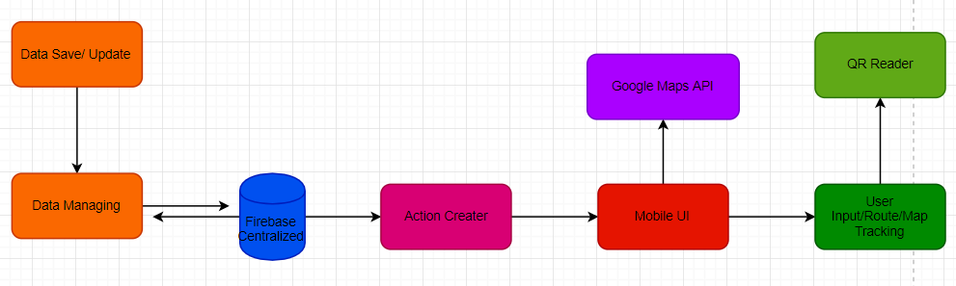

Figure 1. A diagram that can explain your project

Project Plan

**Control Plan**

* Using different methodologies, I will be using a Jira based control plan.
* Highlight Reports with the use of sprint reviews at the end of each Stage (A, B, C).

(Would include reviews on the stage and its completion)

* Weekly review meetings with my project Supervisor (Dr Rasika Ranaweera) to review progress and plan for thereafter
* Risk management (see section 7)
* Communication plan (see section 6.2)
* Quality Plan (see section 8)
* Exception reports and plans if necessary

**Communication plan**

In addition to the interim director's meetings as required, scheduled review / response meetings will be held at the end of each phase to discuss the Final Phase report, the next Phase plan, and to review any technical submissions produced during the stage. Response meetings will also be held following the submission of two interim reports.

|  |  |  |  |  |
| --- | --- | --- | --- | --- |
| **Stage** | **Est.Start date** | **Est.End date** | **Deadline** | **Deliverable** |
| 1.Initiation | 01/11/2021 | 15/11/2021 | 17/11/2021 | P.I.D |
| 2.Investigation and Requirements | 01/09/2021 | 10/11/2021 |  | Analysis of similar projects, analysis of current process in convenient stores, analysis of the step by step build of the applications. |





Initial Risk List

What can go wrong and what management strategies are you adopting now to deal with these.

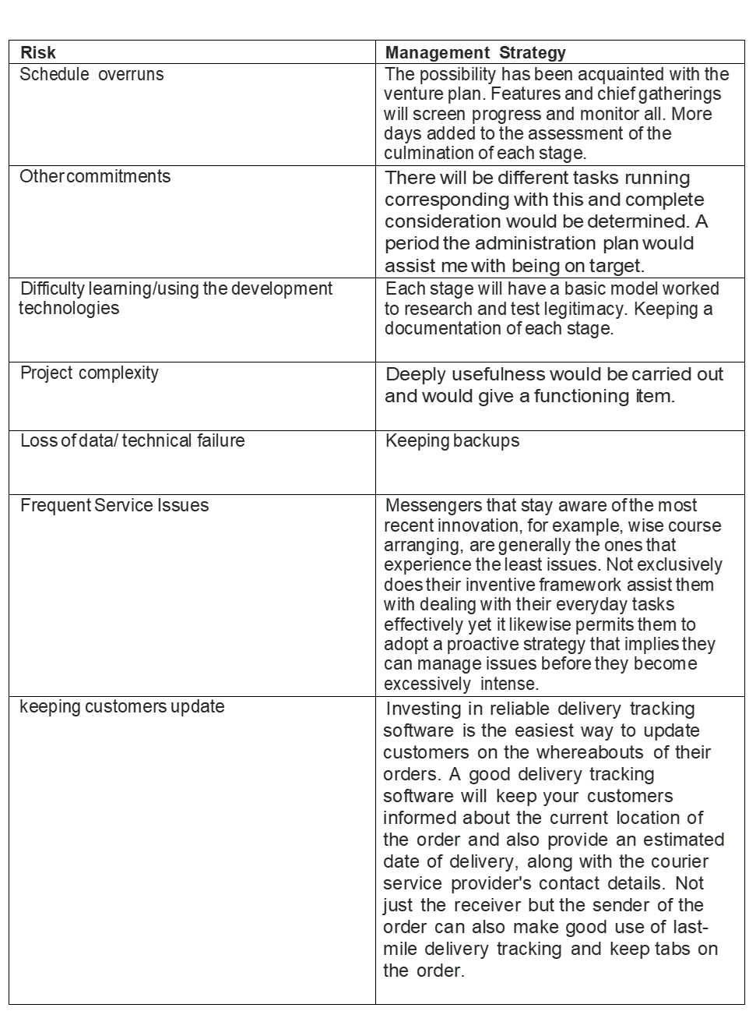

8.Initial Quality Plan



9.References

*Efficient Courier Tracking System Project*. (n.d.).

Gulc, A. (2017). Courier service quality from the clients’ perspective. *Engineering Management in Production and Services*, *9*(1), 36–45. https://doi.org/10.1515/emj-2017-0004

Mohd, A., Rashid, R. A., Abdul Hamid, A. H. F., Sarijari, M. A., Rahim, M. R. B. A., Sayuti, H., & Abdul Rashid, M. R. (2019). Development of android-based apps for courier service management. *Indonesian Journal of Electrical Engineering and Computer Science*, *15*(2), 1027–1036. https://doi.org/10.11591/ijeecs.v15.i2.pp1027-1036

Okemiri, H., Henry, O., Nwogbaga, N. E., & Nwebonyi, F. N. (2017). Critical Review Of Courier Service Management System With Empasis To Its Relevance If Adopted In Nigeria Queuing Theory View project Smart home control system View project Critical Review Of Courier Service Management System With Empasis To Its Relevance If Adopted In Nigeria. In *Journal of Multidisciplinary Engineering Science and Technology (JMEST)* (Vol. 4). www.jmest.orgJMESTN423516887738

 pdfcoffee.com. (n.d.). *Project Report of Courier Tracking System*. [online] Available at: https://pdfcoffee.com/project-report-of-courier-tracking-system-pdf-free.html.

‌ (Anon, n.d.)

(pdfcoffee.com, n.d.)*Efficient Courier Tracking System Project*. (n.d.).

Gulc, A. (2017). Courier service quality from the clients’ perspective. *Engineering Management in Production and Services*, *9*(1), 36–45. https://doi.org/10.1515/emj-2017-0004

Mohd, A., Rashid, R. A., Abdul Hamid, A. H. F., Sarijari, M. A., Rahim, M. R. B. A., Sayuti, H., & Abdul Rashid, M. R. (2019). Development of android-based apps for courier service management. *Indonesian Journal of Electrical Engineering and Computer Science*, *15*(2), 1027–1036. https://doi.org/10.11591/ijeecs.v15.i2.pp1027-1036

Okemiri, H., Henry, O., Nwogbaga, N. E., & Nwebonyi, F. N. (2017). Critical Review Of Courier Service Management System With Empasis To Its Relevance If Adopted In Nigeria Queuing Theory View project Smart home control system View project Critical Review Of Courier Service Management System With Empasis To Its Relevance If Adopted In Nigeria. In *Journal of Multidisciplinary Engineering Science and Technology (JMEST)* (Vol. 4). www.jmest.orgJMESTN423516887738

TryCartwheel.com. 2021. *Cartwheel On-demand Delivery Management Software*. [online] Available at: <https://trycartwheel.com/?network=g&placement=&adposition=&utm_term=courier%20tracking%20software&utm_campaign=delivery_world&utm_source=google&utm_medium=cpc&utm_content=549881954131&hsa_acc=5257596931&hsa_cam=11669439785&hsa_grp=114814538378&hsa_ad=549881954131&hsa_src=g&hsa_tgt=kwd-6113732314&hsa_kw=courier%20tracking%20software&hsa_mt=e&hsa_net=adwords&hsa_ver=3&gclid=Cj0KCQiAys2MBhDOARIsAFf1D1dIRClaM48V7EAhhE_KvkHzygYgp1AM0SxW9sBvFFLtQ7Iu63EaVAkaAoGOEALw_wcB> [Accessed 16 November 2021].

## **16.4 First Interim Report**



School of Computing and Mathematics

PRCO303

Final Stage Computing Project

BSc (Hons) Software Engineering

**N.N.D.G. Liyanage**

**10707256**

**Real Time Courier Tracking Mobile Application**

2020/2022

Contents

1.Introduction 4

1.1 Abstract 4

1.2 Introduction 5

1.3 The Process So Far… 5

1.4 Project Objectives 6

2. System Architecture 7

2.1 Project Core 7

2.2 Project flow diagram 8

3.Tasks Undertaken and Outcomes 9

4. Product Produced and Product Quality 11

4.1 Project Implementation 12

5. Risk Management 13

5.1 Risks to be Materialized 13

5.2 Existing risks and how to resolve them. 14

5.3 Risk Assessment of the risks yet to materialize 15

5.4 Risks that have materialized and responses 16

6. Schedule 17

7. Resources Used 18

8. Learning Undertaken 19

8.1 Student Learning Undertaken 19

8.2 Studies required 19

9. Feedback 20

9.1 Supervisors Guidance 20

10. Screenshots 22

11. References 37

12. Appendices 38

12.1 Project Proposal 38

12.2 Project Initiation Document (PID) 42

# 1.Introduction

## 1.1 Abstract

These days, e-commerce stores have been growing as a result of changes in consumer behaviour as more consumers choose to shop online. The latest figures show that Sri Lanka has 6 million online shoppers, comprising 29 percent of the population, and 35 percent of online mobile users. The growth of online shopping requires the modernization of parcel delivery services, especially daily deliveries. In Sri Lanka, the number of courier companies has been increased to support the demand for parcels. In the Courier Tracking Mobile app, parcels must arrive on time to satisfy customers. To ensure fast delivery of packages to customers, it is necessary to find the fastest route with the least amount of traffic from the delivery point to the destination customer. At the same time, customers should be notified during continuous delivery or on time. Responsive communication between the two organizations will improve the efficiency of the messenger service and customer satisfaction. The goal of the mobile app is to improve the Android and iOS mobile system that can help build a more intelligent package delivery system by integrating the use of current communication technologies such as Google API, QR Reader, Push Notifications, and Android-iOS tools. It will help to track the mobile app to intelligently manage the parcel delivery process and deliver parcels on time to customers. In developing the application, a delegation tracking system was discussed. However, the system courier service provider will be able to indicate the number of parcels to be delivered per day in a simple way that can be delivered to the map in order of address and distance. The proposed sender tracking app can be easily used to provide better user information for consumers to track and interact with the delivery service provider to avoid unnecessary problems.

## 1.2 Introduction

In ancient times, all transportation had to be done by humans. These people were not able to move to other regions without extensive training. The training involved familiarizing ourselves with the network of roads and traffic conditions in the area. The advent of the internet has caused changes in many industries, and this includes all courier tracking systems in the world. As the goods and products, the company makes increase, the burden on the transportation department also increases. This creates a huge need for such software to be available and used by many industries. Today such software is used to increase the accuracy, speed, and efficiency of their transportation. Companies that need courier tracking software have a high production value and usually make many products. The company also suffers from the task of organizing products into phases. There are tools within the courier tracking system that make this easy. There are tools that send courier space whenever a client or company requests it. The software also provides automated submissions, delivery function filters, reminders, and real-time analytics solutions built into it. They also come with plugins to manage internal eCommerce delivery and integration that help track sender in real time.

## 1.3 The Process So Far…

Remember the above, my final year project Real-Time Courier Tracking Mobile Application. E-commerce has grown exponentially over the years. Growth has been reflected in the strong demand for consumers and the growing number of different products available online. This creates a transportation problem and increases the need for an efficient courier service to support growing markets. It is very important for the courier service provider that the delivery of the parcel is done as soon as possible. One of the most important and important processes of the courier business is the delivery of parcels. This is where effective service delivery will be a priority. An efficient system needs to be built to facilitate interaction between the courier service provider and the buyer to accurately determine the complete package delivery route.

I decided to use React Native as I thought it would be quick to get a beta version of the App Store. And the idea of ​​releasing the same app on Google Play also plays a role. It's amazing how easy it was, and I as one engineer can easily support 2 platform applications and daily ship updates. I have chosen to create a tracking API with Node.js. To keep the Node.js API running smoothly, I have supported many processors using the PM2 process manager, and I am still amazed at how well it works

## 1.4 Project Objectives

* Project development consists of several phases with the aim of providing a comprehensive courier tracking service that will enhance the efficiency of courier service in terms of cost and customer experience. An application server integrated with the database system was upgraded to support the Internet management system.
* App roaming function is based on Google Maps, while notification or notification function will be sent using the SMS (Short Message System) service. All of these functions are integrated into the customer package website in the management system.
* The principal objective of the project on courier tracking systems is to deal with the subtleties of courier tracking, tracking number, customer, and address. It deals with all the data about couriers, delivery, addresses, and couriers. The undertaking is completely worked at the authoritative end, and along these lines, just the director has ensured the entrance. The goal of the task is to put together an application program that will reduce the amount of manual work involved in dealing with the courier, tracking, delivery, and tracking number. It tracks every one of the insights regarding the tracking number, customer, and address.
* Analyse the customer, the location of the parcel, the date and time of delivery, the current location of the courier service provider on a map, and so on.
* To analyse the convenience of the courier service providers' analysis of the number of parcels to be delivered in a working hour, customer details and special messages, and the number of parcels to be delivered in the easiest way.
* Analysing how to get track of the delivery service provider's current location to map out the location of the customer's location

# 2. System Architecture

System framework and frameworks provide a complete overview of the system and functionality of the application. This diagram shows the system connection between each module and the forums to be used in each component of the system.

From the framework, several components or modules should be developed. Backup copy services such as packages and user information management, routing management, and software provision will be developed as Software in the cloud space. A framework is a platform where all the components will come together and be able to simplify the operation of the system. It will be able to manage requests and responses from the system administrator, messenger service provider, and customer request. The Android and IOS mobile app should be upgraded to a postal and customer service.

## 2.1 Project Core

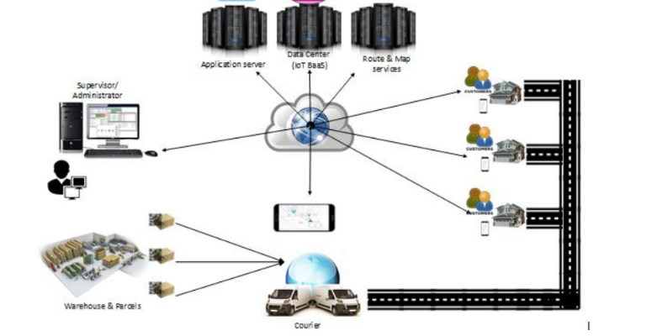

Figure 1: The framework of the system development

## 2.2 Project flow diagram

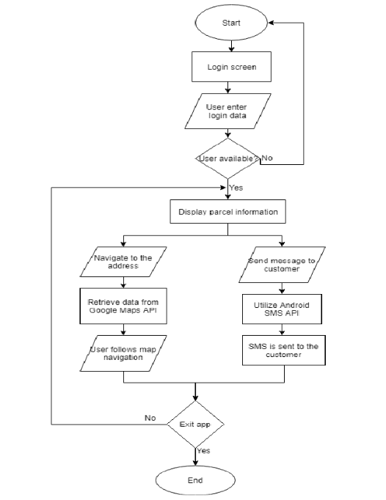

Figure 2: Flowchart of the Android-based Application

# 3.Tasks Undertaken and Outcomes

As explained in previous sections, the main components of the system are the entire system control of Android and IOS based mobile apps and package tracking. The real-time mail tracking app will provide package service and customer information management. It will be integrated with a mobile application that will be used by courier service staff responsible for delivering packages to customers.

* **Navigation and Route Development**

You will not be able to make courier logistics software without the navigation feature.

As a rule of thumb, it looks like a standard in-app map where users can build a line between two points. Download and download locations can be manually entered by courier or automatically set up in the app according to order details.

In addition, this feature is required to upgrade a courier tracking system. It keeps your managers up to date with the exact location of your messengers. Therefore, they can easily check the driver's distance to the destination or provide emergency assistance in an emergency.

* **Product QR Code Generation**

Especially if you are using QR codes as part of a marketing campaign, using QR Code Tracking lets you understand whether this campaign has been successful or not. It also shows patterns so you can customize current campaigns and improve future campaigns.

Dynamic QR codes are traceable, which means that once completed, their usage records will be tracked. This includes information such as the scan location, the scan number, when the scan was performed, and the operating system of the device used. The great advantage of Dynamic QR codes is that they can be programmed at any time. This, of course, is very beneficial in the event of any errors in the linked information. In addition, if you plan to make changes to QR Code campaigns while it is in operation, it is highly recommended to use Power QR Codes to make any necessary changes.

* **Delivery tracking system**

Route tracking system uses GPS (Global Positioning System) to determine the exact location of the vehicle and the package. This is forwarded to delivery agents and delivery managers in real time. There is therefore no possibility that the package will be lost or lost. If for some bad reason any delay occurs, customers are sent the same notice. This eliminates the risk of such situations and increases the speed and efficiency of the transportation department.

* **Route optimization**

The software is provided with route upgrade services that use the latest technology to select the fastest route possible. This route has been selected and sent to delivery truck drivers. Drivers can make changes to the route if necessary. Drivers can also identify the delivery number and use the map function properly.

For a courier service provider, timely delivery is important, but even more important is the proper management of the delivery process. Fortunately, courier tracking software makes it as easy as pie. It helps the driver to understand the best route and carrier to understand the condition of the package.

Courier tracking software provides GPS tracking services via GPS (Global Positioning System). It automatically updates the driver of the vehicle about the best route available to save time and improve the delivery process. However, the driver can change lanes based on low reality. The software also shows the driver the total amount of goods they need to deliver.

Since the package delivery system is based on GPS, everything from package to delivery takes place in an integrated way. Therefore, there is no possibility that the package will be lost or misplaced. However, if the package is somehow delayed, the software notifies both the customer and the network company. Such speed increases the efficiency of the letter delivery partner and increases customer confidence.

# 4. Product Produced and Product Quality

Currently, the project is in the first phase where the mathematical model is used Similarly, GUI design is complete again implementation is underway. User Interface Design is about communication between user and computer. It pertains to everything from system startup or system login to final presentation of the inputs and outputs you want. The full flow of screens and messages is called dialogue.

The courier package or package tracking system starts with courier tracking or shipping software solutions. The software makes the delivery system smooth and seamless.

Modern software tracking software is cloud-based and can be accessed from any part of the world (depending on the company's performance). Software (or part thereof) can be accessed by the carrier, sender, and sender. It speeds up and simplifies the delivery process by making the delivery more manageable and manageable.

Without software delivery solutions, it is almost impossible for professional courier services to perform their functions on a large scale. The software controls the delivery part of the delivery system and keeps the customer and the messenger company on the same page.

In addition to allowing, you to track your orders or shipments, the software also makes payments much faster by reducing processing time. It also retains the information of the previous order and assists in the research process. Moreover, since the whole process is online, there is no damage to the environment.

Therefore, courier tracking or shipping solutions software enhances customer satisfaction and makes package tracking much smoother

|  |  |
| --- | --- |
| Quality check | Strategy |
| 1. Requirements to use | May be requirements checked and sure that are correct. |
| 2. Validation of the design | May be design checked against requirements. |
| 3. System validation | May be conducted within stages |

## 4.1 Project Implementation

Model View Controller or MVC as it is commonly known, is a web design software development software. The model view control pattern is made up of the following three components:

* Model-Very low level of pattern responsible for data storage.
* View - This is responsible for displaying all or part of the data to the user.
* Manage Code-Software that controls interaction between model and view.

MVC is popular as it separates the app from the user interface and supports anxiety separation. Here Controller detects all application requests and works with Model to adjust any data required by View. View and use a control data set to generate a final silent response.

# 5. Risk Management

## 5.1 Risks to be Materialized

In the Project initiation Document (PID), potential risk was identified. Some materialized and were mitigated with the solution mentioned in the risk management plan. Going forward, there could only be more. From all constraints risks are independent of all other constraints and is inevitable. And so, given below are a list of risks that can potentially occur in due time.

1. Time stabilization is tightened resulting in more deviations and unevenness in width.

This will lead to a decrease in blood sugar and cause inflammation. In a metal triangle, given

software and project management see how time can create fluctuations scope and resources. This, if not handled properly, could be detrimental to the latter elimination. The product will be a failure or dissatisfaction, during client time acceptance phase.

Chances - 40%

Solution - research and perform unit tests by building component prototypes required. The time management schedule from here onwards will allow for construction planning and risk reduction in time.

2. Accumulating Projects - As the final semester of the final year draws to a close, we have other projects that need attention and development. Sometimes, our priorities are set it can deviate from this and can be good or bad unless there is time manager.

Chances - 40%

Solution - Sprints will allow me to monitor the progress of any project. Ongoing manager meetings can also compare if I am on the right track.

3. Feature creep- This is a common occurrence during the final stages of a project development, when we try to prioritize the 'fun to have' over 'the need to have it. This it is dangerous as it may fail the required performance requirement.

Chances - 30%

Solution - early preparation and performance research can provide me the confidence of moving forward rather than closing, reluctantly result

4. Certain technologies may be difficult to learn and apply at this stage – For e.g., Internal navigation documents are very small and require one to do so chat.

Chances - 40%

Solution - Analyse similar technologies, adapt, and improve, so that performance can be achieved. If this is going to happen in the future, always have a support system that will enable you to change routes but focus on the same way. This is where using the Agile approach helps. Agile as it goes it means you are open to change and flexible. At this point the project is everything changes, and alterations should be recorded.

As such, these are potential risks but only if appropriate diagnostic criteria it is considered, we can reduce and control risk already it is synthesized and can reduce the likelihood of accidents.

## 5.2 Existing risks and how to resolve them.

1. Minor documents to be reviewed to set internal performance

navigation to work.

Resolved - Reviews and analysis done on existing methods to determine how common they are Strong code recognition with strong code can be considered as personal identification

current location.

2. Feature Creep - on the management side, after working and working performance, there came a time when I felt like, some certain features should be added again as I clung to the rotating function of the union.

Resolved - You did more research on performance and passed almost every forum

given in unison with Vuforia.

3. Spatial projects are of high importance

Resolved - show me when and where I should work on some of my projects as well, I have done my best to complete some of the requirements related to this project, in morning hand.

## 5.3 Risk Assessment of the risks yet to materialize

|  |  |
| --- | --- |
| Risk probability | Risk Level Definition |
| High | 50% or > chance of happening |
| Medium or Significant | 30% - 49% chance of happening |
| Low | >30% chance of happening |

**Risk Assessment Matrix**

Low

Medium

High

L M H

|  |  |  |
| --- | --- | --- |
|  |  |  |
|  |  |  |
|  |  |  |

L

H

## 5.4 Risks that have materialized and responses

|  |  |
| --- | --- |
| Risk | Management strategy |
| 1. Overrun in the schedule | * A contingency has been added to the project plan. * Highlights from reports will serve as a regular monitoring schedule. * In the event of a more than one-week delay, an exception plan will be established and approved by the project supervisor. |
| 2. Lack of knowledge | Many issues will come because of not having complete understanding while developing. So, I'm hoping to learn additional knowledge to complete this project. |
| 3. Technology failure | Standard technologies will be used to deploy the system, and daily backups will be taken. |
| 4. Platform Up gradation | To maintain a continuous functioning environment, I aim not to upgrade my developing platforms. |
| 5. Time | Working with daily basis, that can I reduce the pressure about to this task. |
| 6. Unfamiliar in React Native development | Refer some tutorials related React.js, Native. |
| 7. Bugs | Refer stack overflow or google and fix those bugs. |
| 8. Difficulty learning | A very simple system prototype will be developed. |
| 9. Technology limitation and Failure | The system will be deployed using standard technologies, and system backups will be taken daily. |

# 6. Schedule

The current plan was undertaken to accustomed to time management of project completion.

|  |  |  |
| --- | --- | --- |
| Stage | Deadline | Deliverables |
| Sprint 1  Constructive planning and Scheduling.  Further research and implementation of resources.  UI design and login page development |  | Interim report Part 1  Video on progress. |
| Sprint 2  Further research and unit testing of functions.  Debugging and Maintenance  Instantiating Databases and checking platform viability. | 27/01/2022 | Requirement Progression |
| Sprint 3  Back – End Development Part 2(final)  Detailed design according to H.C. I | 17/02/2022  20/02/2022 | Interim Report Part 2 |
| Sprint 4  Hosting and connections Integration testing Debugging and Maintenance | 25/02/2022 |  |
| Sprint 5  System testing  Corrective maintenance | 27/02/2022 | Maintenance Report |
| Sprint 6  Debugging and Error correction  Final System testing | 05/03/2022 | The Software Application |
| Assemble and complete final report | 20/03/2022 | User manual  Final Report |

# 7. Resources Used

* React Native for mobile application development
* React Native and NODE.JS
* Firebase as the Centralized Database
* Tracking system as the Google API
* Adobe xd for UI development
* An app navigation function based on the Google Maps or Navbar bar
* Data gathering - Used React native.io gathered more components for implementation in the User mobile application.

# 8. Learning Undertaken

* Code properly
* Connect to the proper network using better technique
* Install suitable tools and components
* Check connectivity
* Configure the threat detection tools and software’s
* By using the node.js how to create the mobile applications
* How to use pre-created node modules.
* How to use advanced features of the react-native
* Finalize the project (physically)
* Finalize the documents and user guide
* Knowledge of new software components and applications.

## 8.1 Student Learning Undertaken

React Native is a popular JavaScript-based mobile application framework that allows you to create iOS and Android mobile apps. The framework allows you to create an application for different platforms using the same codebase.

Before the P.I.D was deployed, I personally had to train myself with a traditional response for two good months to identify most of its resources. More basic JavaScript information is required to interact with different applications. Become a medium programming language that works in a virtual studio near a firebase. Further research was conducted in the area of ​​tracking systems.

## 8.2 Studies required

This research comes with future implications, as into how the rest of the components will be integrated. Agile Planning has paved the way for uncertain change to be welcomed, especially in the concern of the main function which is data loading for customer review. There were two options to go with. Depending on which becomes experimentally successful it will be implemented but for the experimental stage to be conducted, research on both possibilities needs to be conducted. Hosting of data on the cloud is open to the client through an inbuilt QR scanner and tracking courier parcel. These options both will take research and as documentation on such is also very limited prototyping and researching of similar implementations and improvisations will be done.

# 9. Feedback

## 9.1 Supervisors Guidance

The support received from the supervisor is very helpful in order to perform background research on various techniques such as Abstract Real-time Courier tracking and also for the implementation. Regular meetings with the supervisor have happened and the guidance received from the supervisor meetings lead this project to this much distance.

**Meeting Minute 1:**

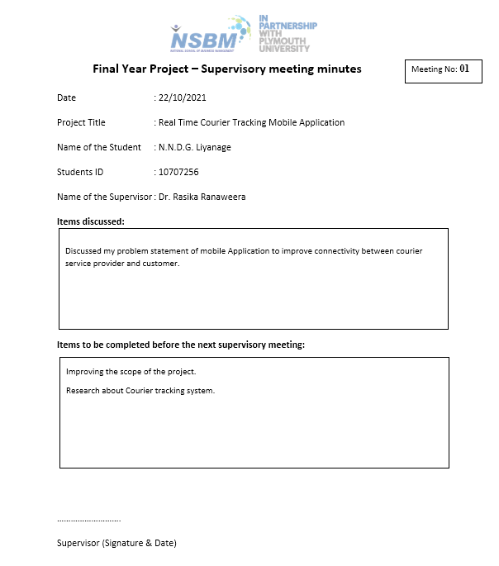

**Meeting Minute 2:**

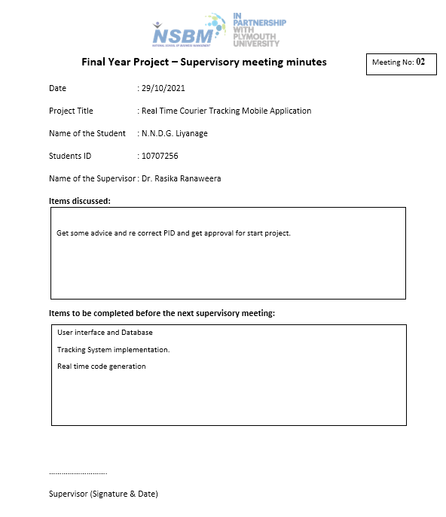

# 10. Screenshots

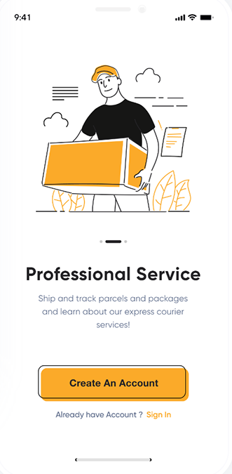

This is a welcome page. So first, you already created this account using a username and password. If you do not have an account, you want to sing. Many companies are also taking advantage of the opportunity to change the delivery environment as they develop software for courier services. Thus, your customers will receive real-time status updates on their post orders.

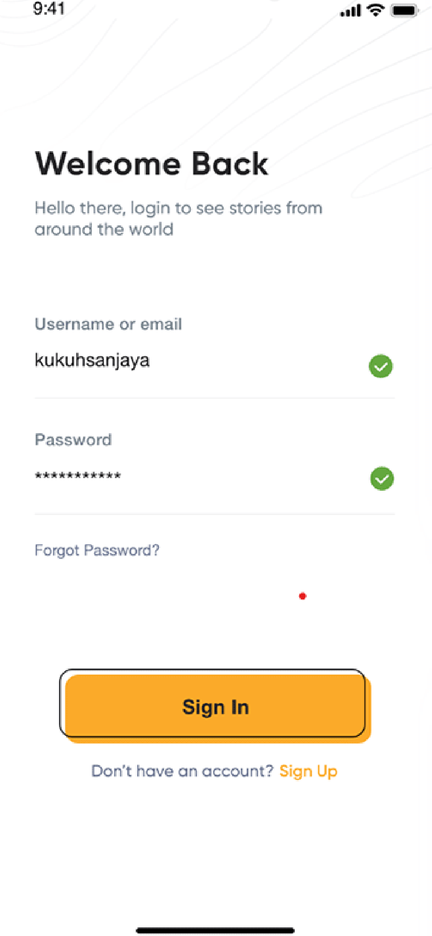

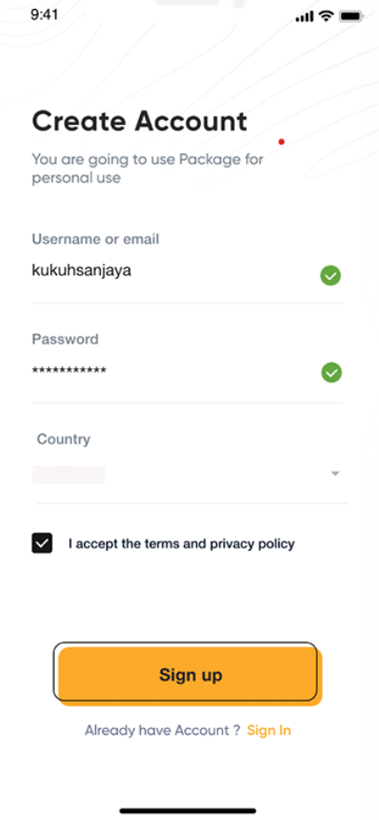

As agents, your managers and supervisors should first register. The default registration option "Username or email + and password" should work fine here. However, to prevent unwanted invaders from entering the entire courier management system, we also recommend that you use additional security layers.

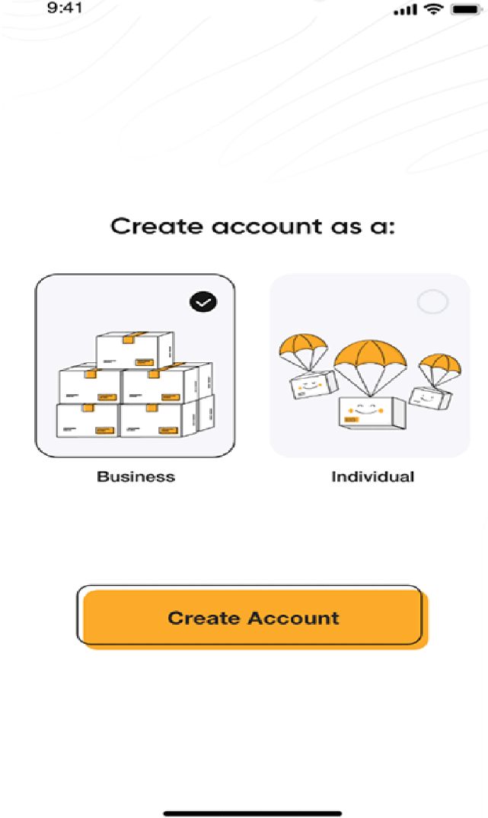

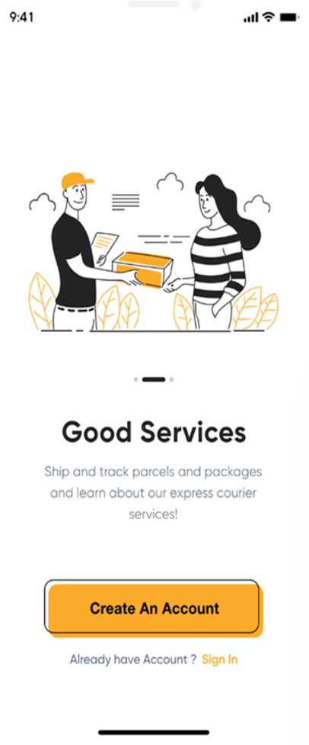

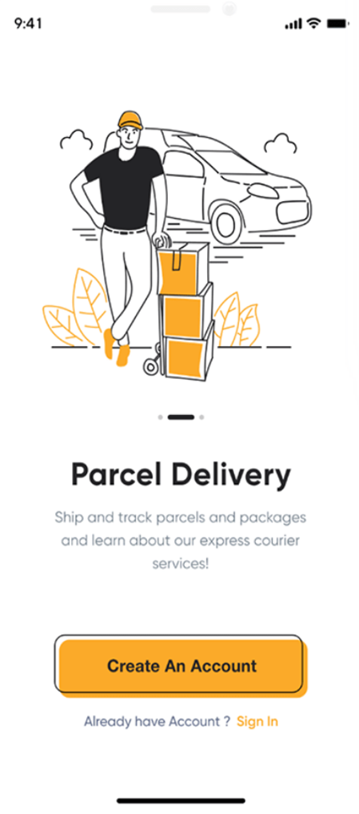

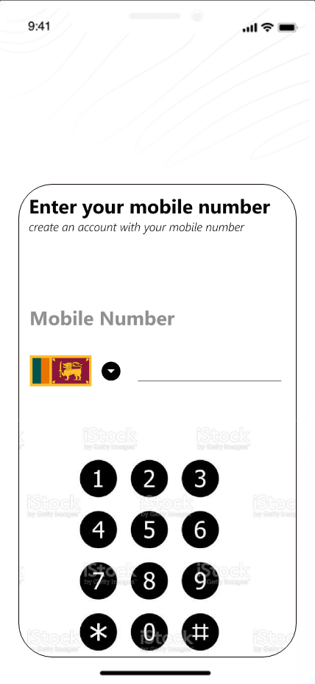

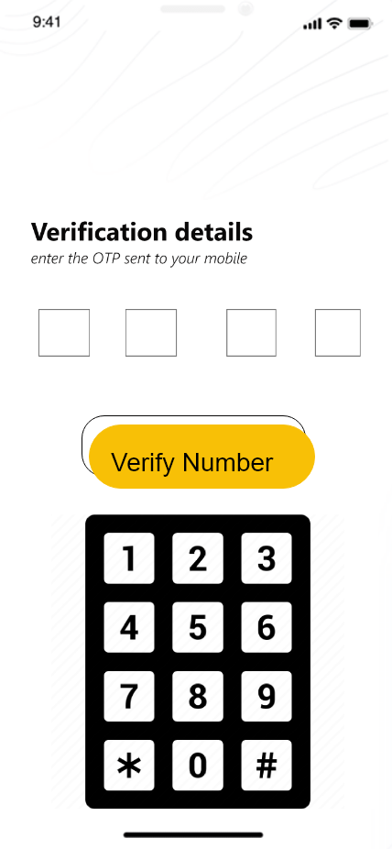

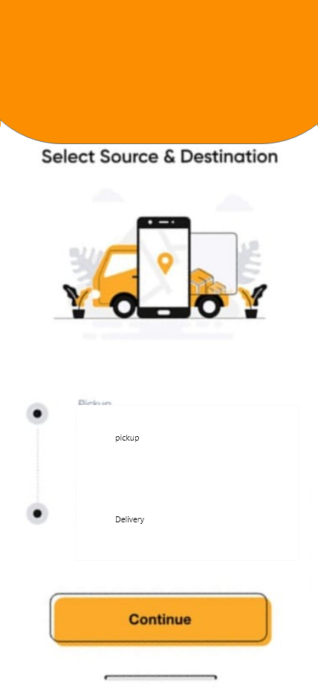

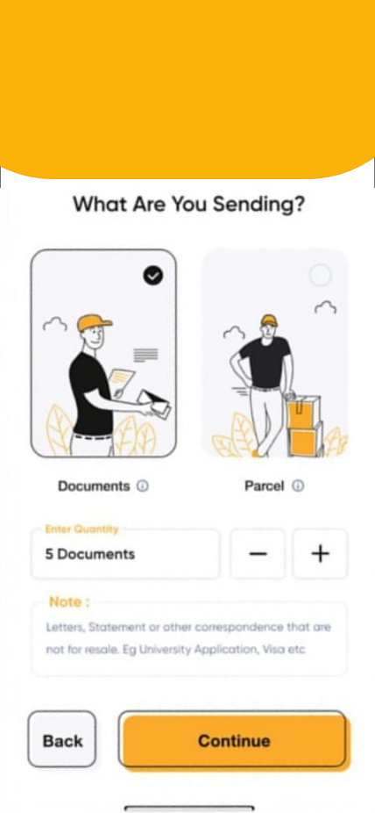

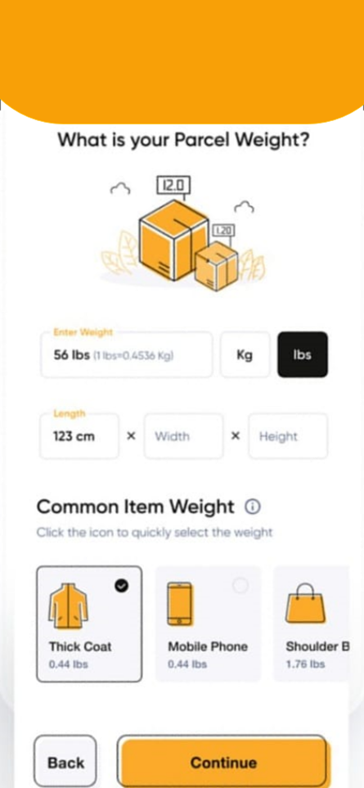

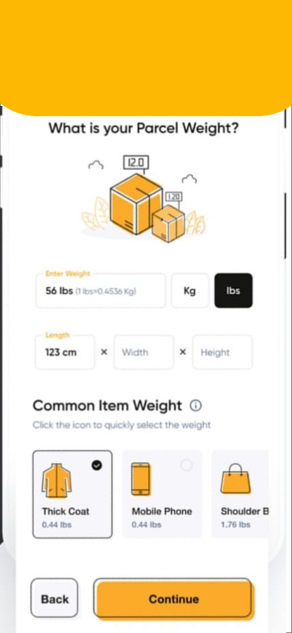

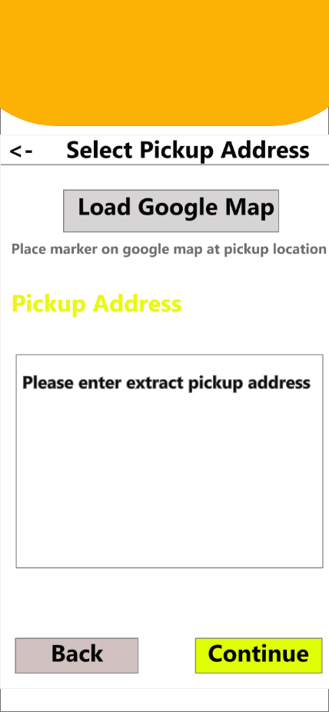

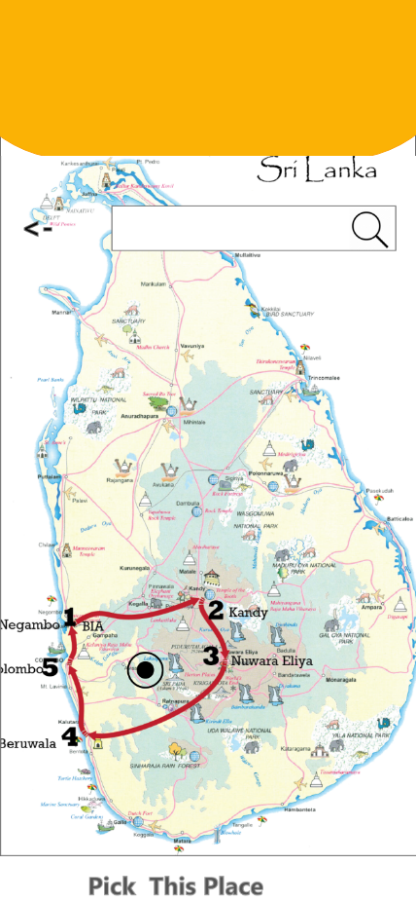

This feature is required if the company has its own collection of delivery vehicles. In this case, it is best to build a courier management software capable of handling these vehicles. On the other hand, it will be easier to keep everything clear and in control, as you will be able to check the number, status, and details of your vehicles and bikes at any time. On the other hand, the system will remind you of unresolved technical issues, standard car tests, and more. Your supervisors should also be able to assign the car a specific vehicle and track its performance and location of the vehicle.

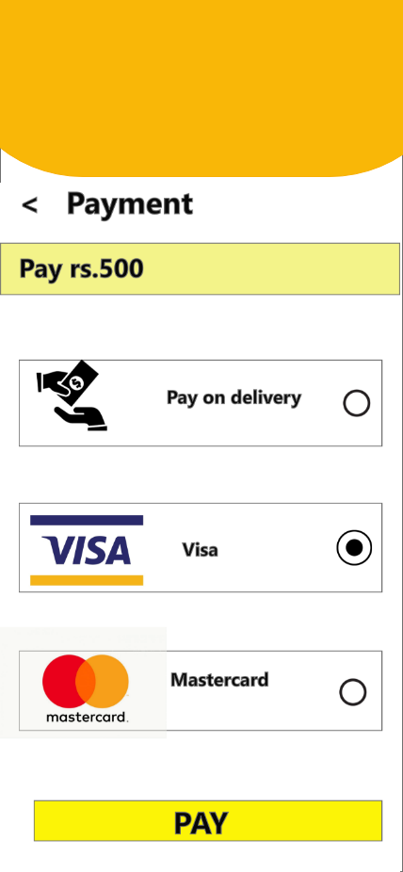

*(This User interfaces here may change in the future)

# 11. References

CodeCanyon. (n.d.). *No results found*. [online] Available at: <https://codecanyon.net/category/mobile?term=courier%20delivery>.

ResearchGate. (n.d.). *(PDF) Development of android-based apps for courier service management*. [online] Available at: <https://www.researchgate.net/publication/339802344_Development_of_android-based_apps_for_courier_service_management> [Accessed 23 Jan. 2022].

Stormotion Blog. (2020). *How to Develop a Courier Management System: Top Things to Consider*. [online] Available at: <https://stormotion.io/blog/how-to-develop-courier-management-system/> [Accessed 23 Jan. 2022].

www.deliforce.io. (n.d.). *How Does A Courier And Package Tracking System Work? | Deliforce*. [online] Available at: <https://www.deliforce.io/blog/courier-parcel-package-tracking-system> [Accessed 23 Jan. 2022].

Bunger AC, Hanson RF, Doogan NJ, Powell BJ, Cao Y, Dunn J. Can learning collaboratives support implementation by rewiring professional networks? Adm Policy Ment Health. 2016

Neta G, Glasgow RE, Carpenter CR, Grimshaw JM, Rabin BA, Fernandez ME, Brownson RC. A framework for enhancing the value of research for dissemination and implementation. Am J Public Health. 2015.

Nadeem E, Olin S, Hoagwood KE, Horwitz SM. Understanding the components of quality improvement collaboratives: a systematic literature review. Milbank Q. 2013 Gulc, A. (2017). Courier service quality from the clients’ perspective. *Engineering Management in Production and Services*, *9*(1), 36–45. https://doi.org/10.1515/emj-2017-0004

Mohd, A., Rashid, R. A., Abdul Hamid, A. H. F., Sarijari, M. A., Rahim, M. R. B. A., Sayuti, H., & Abdul Rashid, M. R. (2019). Development of android-based apps for courier service management. *Indonesian Journal of Electrical Engineering and Computer Science*, *15*(2), 1027–1036. https://doi.org/10.11591/ijeecs.v15.i2.pp1027-1036

Okemiri, H., Henry, O., Nwogbaga, N. E., & Nwebonyi, F. N. (2017). Critical Review Of Courier Service Management System With Empasis To Its Relevance If Adopted In Nigeria Queuing Theory View project Smart home control system View project Critical Review Of Courier Service Management System With Empasis To Its Relevance If Adopted In Nigeria. In *Journal of Multidisciplinary Engineering Science and Technology (JMEST)* (Vol. 4). www.jmest.orgJMESTN423516887738

## **16.5 Second Interim Report**



School of Computing and Mathematics

PRCO303 Final Stage Computing Project

BSc (Hons) Software Engineering

**N.N.D.G. Liyanage**

**10707256**

**Real Time Courier Tracking Mobile Application**

2020/2022

**Contents**

**01. INTRODUCTION** **5**

**1.1 ABSTRACT** **5**

**1.2 INTRODUCTION** **6**

**1.3 LITERATURE REVIEW** **7**

**1.4 THE PROCESS SO FAR** **8**

**1.5 INTRODUCTION OF THE PROCESS TO BE** **11**

**02. SYSTEM ARCHITECTURE** **13**

**2.1 ER DIAGRAM** **14**

**2.2 CLASS DIAGRAM** **15**

**2.3 USE CASE DIAGRAM** **16**

**2.4 ACTIVITY DIAGRAM** **17**

**2.5 COMPONENT DIAGRAM** **18**

**2.6 DATA FLOW DIAGRAM LEVEL 0** **19**

**2.7 DATA FLOW DIAGRAM LEVEL 1** **20**

**2.8 DATA FLOW DIAGRAM LEVEL 2** **21**

**03. TASKS UNDERTAKEN AND OUTCOMES** **22**

**3.1 RESEARCHED TOPICS FOR MORE DEPTH INTO THE STUDY** **22**

**3.1.1 EDIT YOUR IDEA** 22

**3.1.2 CHOOSE THE RIGHT BUSINESS MODEL** 22

**3.1.3 CLARIFY THE GOALS AND NEEDS OF YOUR BUSINESS** 22

**3.1.4 FIND THE RIGHT RANGE OF FEATURES** 22

**3.2 ADMINISTRATION** **23**

**3.2.1 AUTHENTICATION OF LOGGING INTO THE SYSTEM** 23

**3.2.2 NAVIGATION AND ROUTE DEVELOPMENT** 23

**3.2.3 PRODUCT QR CODE GENERATION** 24

**3.2.4 PAYMENT GATEWAY INTEGRATION** 24

**3.2.5 ADMINISTRATOR CHAT** 24

**3.2.6 APP NOTIFICATIONS** 24

**3.3 DATA SECURITY** **25**

**3.4 APPLICATION DEVELOPMENT** **25**

**04. PRODUCTS PRODUCED AND ITS QUALITY** **26**

**4.1 QUALITY PLAN AND CONTROL** **27**

**4.1.1 QUALITY PLAN TABLE** 27

**4.1.2 VERIFICATION** 28

**4.1.3 VALIDATION** 28

**05. RISK MANAGEMENT** **31**

**5.1 RISKS MANIFESTED AND OVERCOME** **32**

**5.2 RISK ASSESSMENT MATRIX** **33**

**06. SCHEDULES** **34**

**6.1 PROJECT PLAN FOR THE LAST PHASE** **34**

**6.2 CONTROL PLAN** **35**

**6.3 COMMUNICATION PLAN** **35**

**6.3.1 SUPERVISOR MEETING MINUTES** 36

**07. RESOURCES USED** **38**

**7.1 METHODOLOGIES USED IN DEVELOPMENT** **38**

**7.1.1. USING THE AGILE METHOD** 39

**7.1.2. USING PHASES OF THE WATERFALLS MODEL** 39

**7.2 TECHNOLOGIES** **40**

**7.3 EXTERNAL RESOURCES** **40**

**08. LEARNING UNDERTAKEN** **41**

**09. FUTURE IMPLEMENTATION** **57**

**10. SUMMARY** **57**

**11. REFERENCES** **58**

**12. APPENDICES** **59**

**12.1 QUESTIONNAIRE** **59**

**12.2 PROJECT PROPOSAL** **62**

**12.3 PROJECT INITIATION DOCUMENT (PID)** **67**

**12.4 INTERIM 1 REPORT** **83**

**01. Introduction**

**1.1 Abstract**

These days, e-commerce stores are growing as a result of changes in consumer behavior as more consumers choose to shop online. The latest figures show that Sri Lanka has 6 million online consumers, comprising 29 percent of the population and 35 percent of Internet mobile users. The development of online shopping requires the modernization of parcel delivery services, especially daily deliveries. In Sri Lanka, the number of courier companies has increased to support the demand for parcels. In the Courier Tracking Mobile app, parcels must arrive on time to satisfy customers. To ensure fast delivery of packages to customers, it is necessary to find the fastest route with the least traffic from the delivery point to the destination customer. At the same time, customers should be notified of ongoing or on-time delivery. Responsive communication between the two organizations will improve the efficiency and customer satisfaction of the messenger service. The goal of the mobile app is to upgrade the Android and iOS mobile system, which can help build a smarter package delivery system by integrating current communication technologies such as Google API, QR Reader, Push Notifications and Android-iOS tools. It helps to manage the package delivery process wisely and monitor the mobile app to deliver packages to customers on time. In developing the application, the agent tracking system was discussed. However, the number of parcels to be delivered per day to the system courier service provider can be provided on the map in a convenient way with address and distance order. The proposed Shipper Tracker app can be easily used to provide better user information for customers to track and interact with the delivery service provider to avoid unnecessary problems.

**1.2 Introduction**

In ancient times, all transportation had to be done by humans. These people were not able to move to other regions without extensive training. The training involved familiarizing ourselves with the network of roads and traffic conditions in the area. The advent of the internet has caused changes in many industries, and this includes all courier tracking systems in the world. As the goods and products, the company makes increase, the burden on the transportation department also increases. This creates a huge need for such software to be available and used by many industries. Today such software is used to increase the accuracy, speed, and efficiency of their transportation. Companies that need courier tracking software have a high production value and usually make many products. The company also suffers from the task of organizing products into phases. There are tools within the courier tracking system that make this easy. There are tools that send courier space whenever a client or company requests it. The software also provides automated submissions, delivery function filters, reminders, and real-time analytics solutions built into it. They also come with plugins to manage internal eCommerce delivery and integration that help track sender in real time.

The importance of tracking shipping is a defining factor in today’s manufacturing companies and is very helpful in managing efficient transport networks. Problems related to export coordination have reduced the overall performance of global industries in the modern urbanization era. The difficulty of tracking shipping has been a thorn in the side of the transport chain from source to location as it uses transparency among customer peers. The tracking system works with the destination and informs the customer of the destination. The tracking system provides a transparent product environment that combines trust between the seller-customer relationship. This system may provide a solution for mapping the tracking process from dealing with this complex problem. A common practice for all of these tracking systems is usually confined to the client in order to access tracking information instead of tracking sent by hand questions such as telephone, e-mail, fax, or expensive hardware. Available tracking systems have a narrow path in the transport chain. Customers use the information of ordered goods by phone or email. Therefore, we have selected GPS tracking systems with google maps service that can be imported from the delivery point and sent to the user. When a user requests the location of their product, a notification is sent to the delivery agent who can transfer their location via our mobile APP. The APP is built on the basic use of geolocation services. The active location of the delivery agent is sent to the user who requested the location. Therefore, the cheapest option in the small-scale transport industry is to provide a tracking of goods. Includes transparency between industry services and users. As a cheaper option, it eases the burden on the financial sector of the industry and provides a competitive edge to the industry sector.

**1.3 Literature Review**

Tracking the transport network has recently been considered an important factor in the management of a global supply chain. It has been identified by manufacturing companies as a pursuit of competitive advantage that recognizes the potential value of their transport network. There is no description of the global pursuit text and the accepted goods. In many cases, the pursuit of love is often accompanied by a so-called 'pursuit and pursuit'. The word track can be viewed as a one-time collection of current product location information or distribution materials. A tracking system, on the other hand, is the production and distribution of a product (s) and the maintenance and maintenance of the life cycle of its components. This tracking and tracing system is considered an industry standard for customer service. It also creates competitive advantage for transport service providers.

Individual industries have long recognized the need to track and transport logistics. Educational communities and affiliated organizations seek global development efforts to identify products and services. It focuses on identifying common process processes that have been developed so far and does not define any direct links to product tracking systems. The complexity of the material chains used in the global industry is a growing interest in its development controls. Due to the diversity of different products and the need to improve the ability to find products, more information about the items is needed. This tracking system is considered to be a very useful service in the management of industrial assets and to meet the needs of high customers. Company executives see this tracking program as a way to strengthen their market position by improving customer satisfaction and information processing technology (IT). The system covers the world of physical activity networks and provides more transparent and effective information in everchanging market conditions. However, most of the current publishing activities belong to one organization, so there is a lack of location tracking and tracking in many organizations. Many transport companies focus on short-term tracking and tracking, providing easy access to information and protection of identification codes and information frameworks. The development emphasizes the importance of having access to transport by designing and monitoring their performance by independent acquisition service providers such as Technologies and LOG. If the assets belong to the same company, the existing tracking systems are suitable for use and are not suitable for multi-company networks. These company-based tracking services use service-specific codes in shipping, thus increasing the difficulty of obtaining tracking information from potential customers.

**1.4 The process so far**

As mentioned above, my project last year was a mobile app tracking app. E-commerce has grown exponentially over the years. Growth is reflected in the strong demand for consumers and the growing number of different products available online. This creates a transportation problem and increases the need for an efficient courier service to support a growing market. It is very important to deliver the package to the courier service as soon as possible. Delivery of parcels is one of the most important and important processes in the book business. This is where the provision of effective services will be a priority. An effective system must be developed to facilitate interaction between the book service provider and the consumer in order to accurately determine the full package delivery route.

I decided to use React Native because I thought it would be quick to get a beta version of the App Store. The idea of uninstalling one app on Google Play also plays a role. It's amazing how easy it is, as one developer I can easily support 2 platform applications and daily ship updates. I have chosen to create a tracking API with Node.js. For the Node.js API to work properly, I have supported many processors using the PM2 Process Manager, and I am still amazed at how well it works.

Like any other app, it all starts with access. As you can guess, its main purpose is to let you identify all the guests separately. For all possible sign-in options (contact, no password, email, etc.), we recommend that you log in with a password attached to your phone number. Why is that? Because soon your drivers will need to enter their phone numbers. So, why not get a “reuse” right away? You also need to enable personal profile management, as delegates may need to add additional information. In addition to their cell phone numbers, they often ask for a profile picture, a name, and a driver's license.

This set of features is the basis of your courier management app. Its central feature is the Delivery Order screen. From here the sender can access the active order (or orders if you place less than one) and check all information:

* Order number - Automatically enabled system.
* Order description - Items included in the program.
* Name of recipient.
* Recipient phone number or call button.
* Limited delivery time.
* A place to relax - However, it is not necessary if you are distributing your products in one place or if every driver is firmly attached to a fixed location.
* A place to relax - You have the opportunity to show it on a map or just get it in writing.
* Payment details - Enter the payment type (card or cash), total amount and payment status (paid or not).
* Notes - It is left to the customer to provide additional information on the order or location to be downloaded.
* It also makes sense to use a delivery status guarantee or so-called Pod - Proof of Delivery. Typically, this feature can be accessed on the Order Details screen as we link data (e.g., eSignature, image, code) to specific orders.

There are several different ways to get confirmation that an order has been successfully delivered and received by a customer:

* Signature is a customer.
* Capture photo delivery.
* QR code scanning; code is generated by the client application.
* Code verification: Like a QR code, this code is also generated by the client application.

You can create courier tracking software from any of the mentioned options, so it really depends on you.

As a rule, it looks like a normal in-app map where users can build a line between two points. Download and download locations can be manually entered by courier or automatically set by the app based on the order details. In addition, this feature is important if you want to improve your courier tracking system. It always lets your managers know where your messengers are. Therefore, they will be able to easily check the driver's distance to the dump site or immediately assist in an emergency.

Communication is very important to senders. Sometimes it is not possible to complete the distribution without reaching the affected parties. In addition, it should work both ways and empower your distribution men to connect with their clients and a support agent. When companies develop a courier management system, they usually make a quick tap on the order description screen. It is helpful to contact the customer immediately to clarify certain details and inform them of future deliveries. By pressing a button your distribution men should be able to drive your support service in the same way. Alternatively, you can choose to provide a support number so that the sender can call it in person. In addition to calling, you can create in-app chat as a communication tool for your drivers.

Lastly, we also recommend enabling the Push Notifications feature when upgrading a courier tracking system. Its main purpose is to let your drivers know about the most important issues: new delivery orders, changes to existing orders, status updates, etc. It helps your agents not to miss important things and respond on time. The control panel can set the actual list of events that trigger app notifications. Here's what you need to know about this part of your messenger service management software

**1.5 Introduction of the process to be**

Real-time tracking is an important part of parcel delivery and courier service. This feature is common in the admin panel, in the driver app, and in the client application. In the server application, the user can track the location of his package even in real time. This tracking feature plays an important role in improving customer satisfaction because it assures users that we will deliver their packages. Similarly, this feature allows the controller to match the driver closest to the package. Additionally, it supports multiple methods that allow the user to add multiple addresses to the list. This feature allows the sender to select a distribution address and download the location with the correct ID.

A GPS-enabled system that can help you track real-time events. The distribution app includes a mobile app where he can get a small free delivery. When a request is received from a user who seeks the status of his product, the delivery employee immediately accepts the request and notifies the user and his or her location. The status is transmitted to the user by notifying the message style of the user's registered phone number. The generated link is very good so our idea is to reduce traffic and costs by making the tracking system simpler and easier. When the location and product ID are captured via GPS, the distributor can send messages to the monitoring center via the app. The operating system of the system has three basic levels. First, when the product leaves the warehouse and is transferred to the shipping company. Sales identification data is available from the bar code reader. At that point, product movements and arrival details are automatically registered in the same way. Sales and shipping information is also sent to the shipping company, and the GPS module receives a location message. This sales information and integrated GPS location information is sent in real time.

App notifications help users to get live updates of their direct distribution status in the app. These app notifications provide users with important information such as the current delivery phase, limited delivery time, and changes to the distribution timeline, if any. Not only this, but users also receive caller and sender contact information for these notifications. Push notifications are also an important means of communication between participants. Uses app notifications to inform customers about various offers and promotions. This plays an important role in customer retention.

A payment portfolio is another important feature that you need to incorporate into your book delivery application. High-quality wallets and credit / debit cards should be integrated with the payment gateway system. This payment gateway offers the user many payment options such as COD, card and wallet.

Especially if you use QR codes as part of a marketing campaign, you can understand whether this business is successful or not by using QR code tracking. It also shows patterns so you can customize current businesses and develop future businesses. Powerful QR codes can be obtained, which means that once completed, their usage records will be tracked. This includes information such as the scan location, the number of scans performed, and the operating system of the device used. The great advantage of Dynamic QR codes is that they can be programmed at any time. This is especially helpful if there is an error in the link information. In addition, if you intend to make changes to the QR code business when it is in operation, it is highly recommended that you use Energy QR codes to make any necessary changes.

**02. System Architecture**

System Framework and Framework provides a complete overview of the application system and functionality. This diagram shows the system connection between each module and the forums to be used in each component of the system.

From the framework, several components or modules must be developed. Backup services such as package and user information management, online management and software provisioning are developed as cloud space software. A framework is a platform that combines all the components to simplify the operation of the system. It will be able to manage requests and responses from system administrator, messenger service provider and customer requests. The Android and iOS mobile app needs to be upgraded to a mail and customer service.

**2.1 ER Diagram**

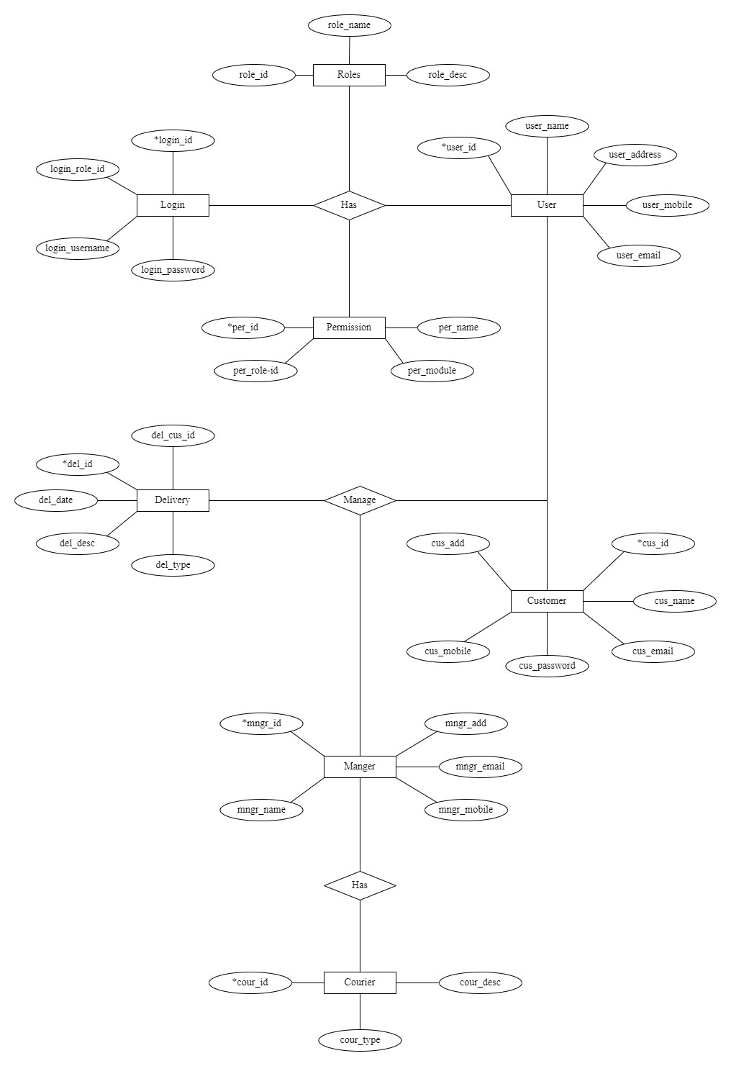

**2.2 Class Diagram**

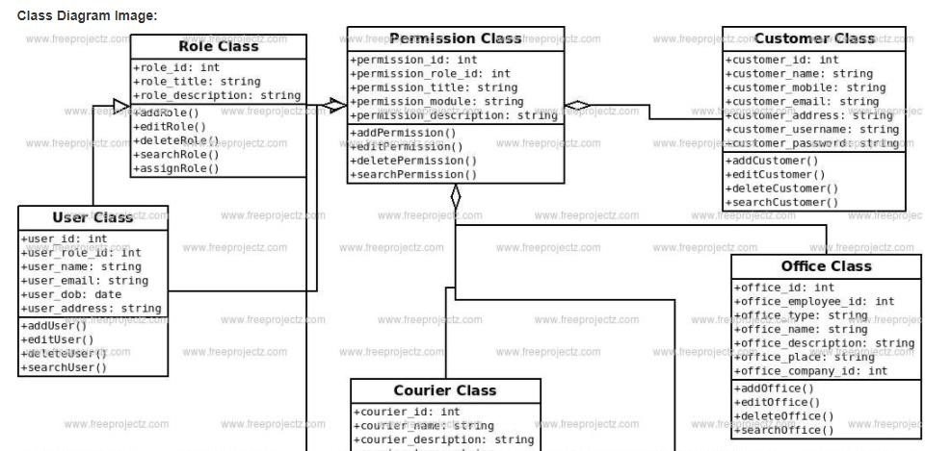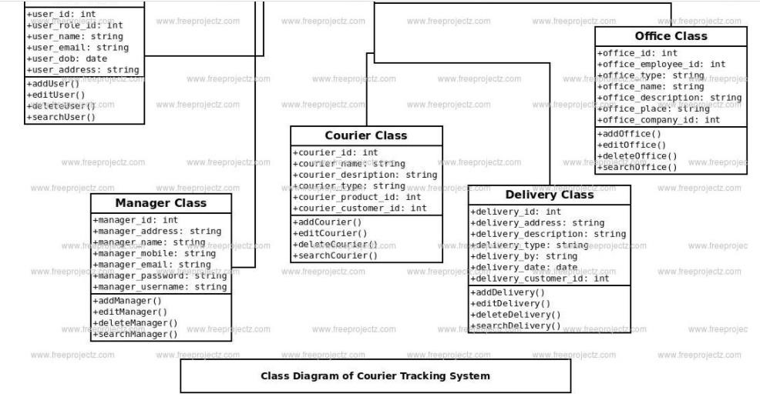

**2.3 Use Case Diagram**

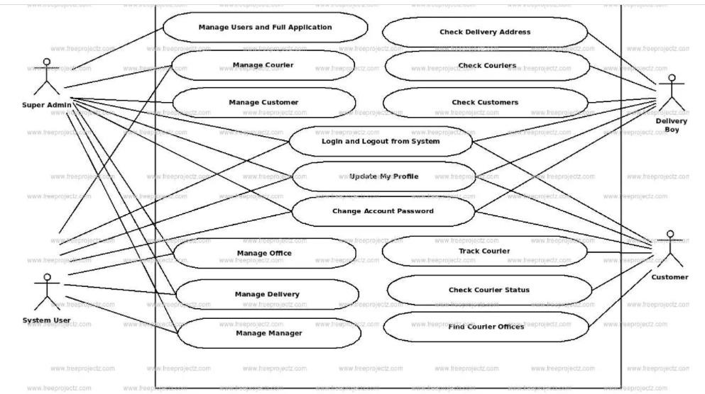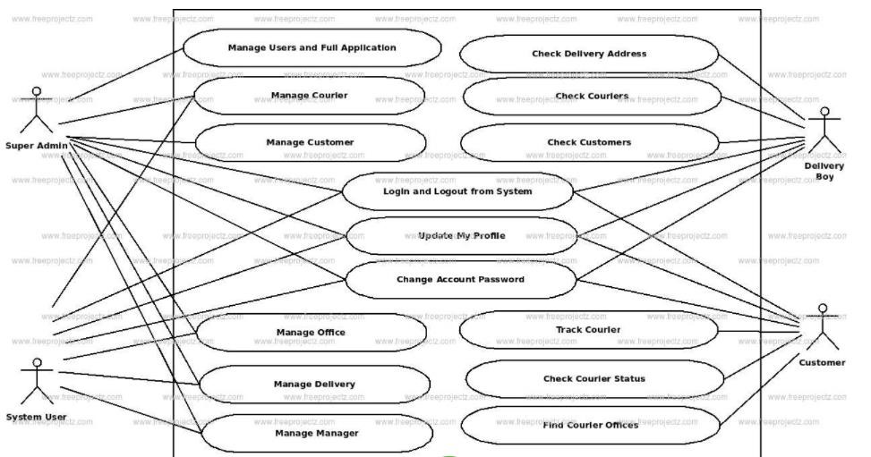

**2.4 Activity Diagram**

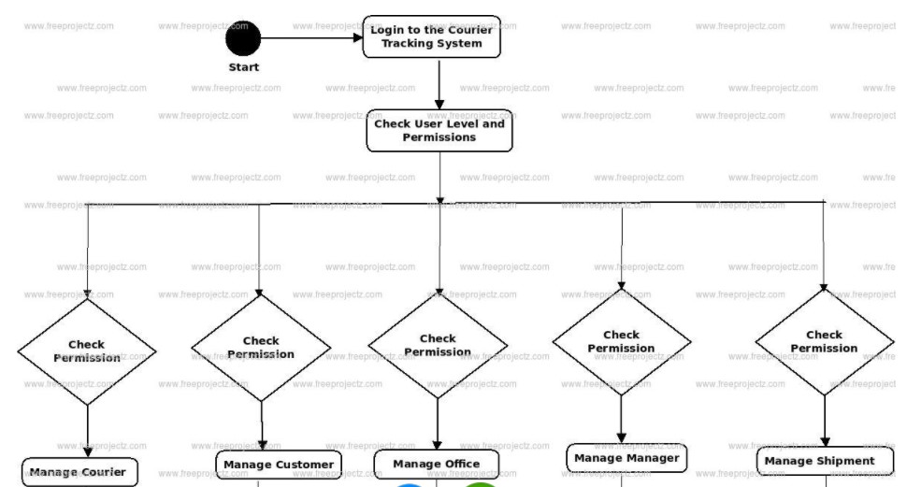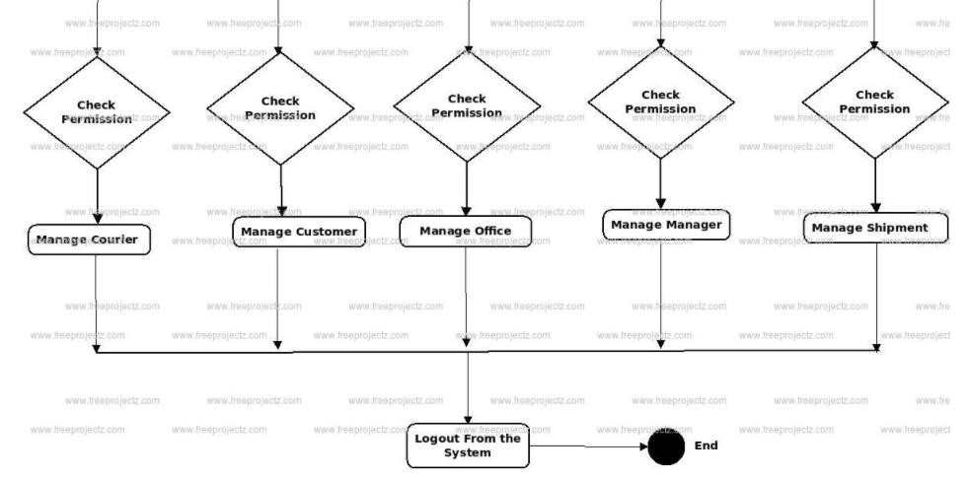

**2.5 Component Diagram**

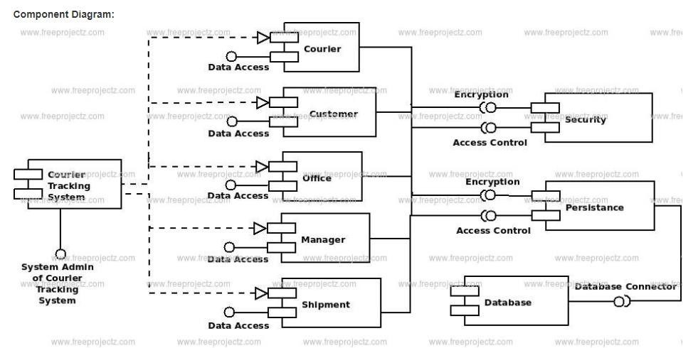

**2.6 Data Flow Diagram Level 0**

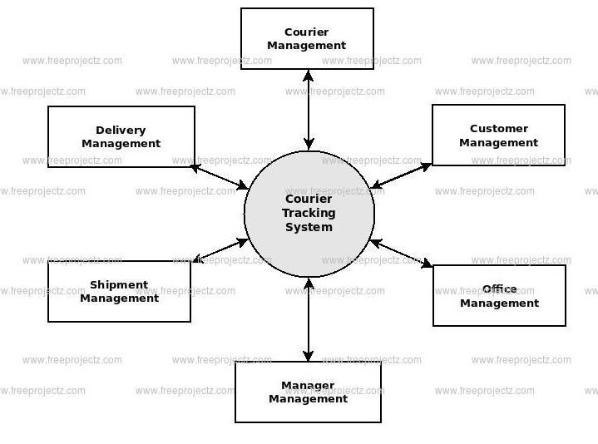

**2.7 Data Flow Diagram Level 1**

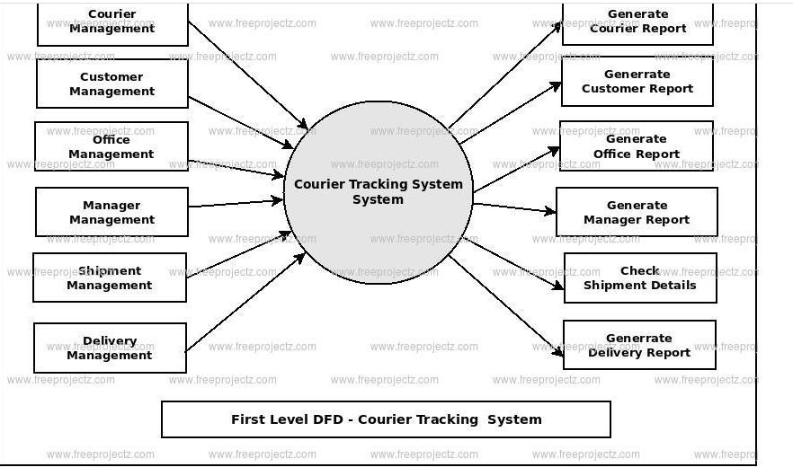

**2.8 Data Flow Diagram Level 2**

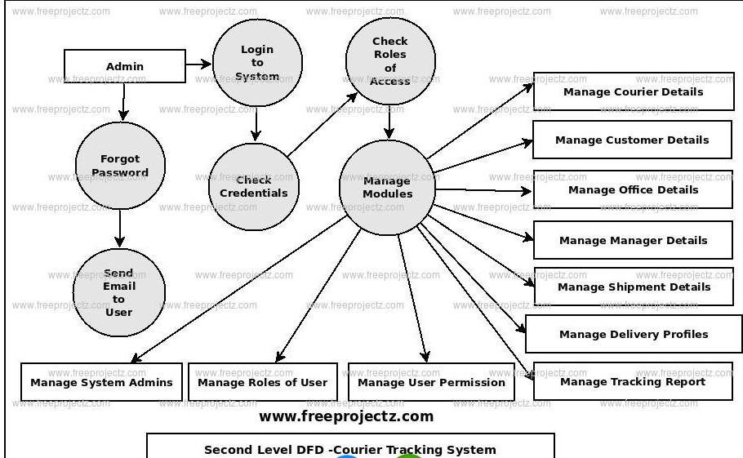

**03. Tasks Undertaken and Outcomes**

**3.1 Researched Topics for more Depth into the study**

**3.1.1 Edit your idea**

Before starting an application, the development step is the first step in writing a flowchart to better understand and imagine the flow of the process. Create questions such as Why courier app? How to improve? What is the future? All questions raised should have an answer or solution. Analyze each concept to avoid any obstacles to future app development.

**3.1.2 Choose the right business model**

The first step is to choose the most suitable business model. We have already mentioned the major business models used in the desired mail delivery business. You must choose whether you want a reputable reseller shipping request, postal service request, or a muchneeded parcel delivery application. To make the right choice, you need to look at a few things like your business specification, audience, long-term goals, resources available, and much more.

**3.1.3 Clarify the goals and needs of your business**

There is more to launching a much-needed courier service than building a mobile app. You need a clear understanding, opportunities, and requirements for your business model.

**3.1.4 Find the right range of features**

Once you have completed all the theoretical aspects, you can begin to work on the practical application of your concept. You can start by prioritizing your needs and documents. Here you can create performance specifications to set all your needs. The scope and functionality of your product may vary according to your specifications and business models. However, there are a few basic things you should have in order to send letters and parcels. Let's look at them.

**3.2 Administration**

**3.2.1 Authentication of logging into the system.**

It is of common knowledge, that employees are not permanent resources and change positions. But to avoid having the administrative application being used by unauthorized personnel, it’s an obvious point that the same credentials should not be used by everyone. A solution for this is to sign up and then sign in, but that only is to protect individual information and if you are a direct stakeholder. In this case, anyone can sign up. Using a component already available on Visual Studio, creating randomized passwords to a size specified helps solve the problem. A generated password is created, and it’s connected with the internal database that the platform offers. It’s also connected with the SMTP Server to send out a customized mail with the password to the relevant individual. The individual can then, log in and reset the password to his/her liking

**3.2.2 Navigation and Route Development**

You will not be able to make courier logistics software without the navigation feature. As a rule of thumb, it looks like a standard in-app map where users can build a line between two points. Download and download locations can be manually entered by courier or automatically set up in the app depending on order details. In addition, this feature is important if you want to improve the courier tracking system. It will always keep your managers informed of the exact location of your messengers. Therefore, they will be able to easily check the driver's distance to the dump site or assist immediately in an emergency. In addition, this feature provides the sender and customer with ETA. It can also improve User Information (UX) for customers. In some applications, customers can access this information in real time and see how their order is delivered on the map. This is how the delivery service works. Is it hard to build a courier tracking software like that? The good news is that you do not have to build from scratch. Instead, your developers should incorporate the existing Google Maps solution into your app. As it is a popular technology, the learning curve of your staff will always be short.

**3.2.3 Product QR Code Generation**

Especially if you are using QR codes as part of a marketing campaign, using QR Code Tracking lets you understand whether this campaign has been successful or not. It also shows patterns so you can customize current campaigns and improve future campaigns.

Dynamic QR codes are traceable, which means that once completed, their usage records will be tracked. This includes information such as the scan location, the scan number, when the scan was performed, and the operating system of the device used. The great advantage of Dynamic QR codes is that they can be programmed at any time. This, of course, is very beneficial in the event of any errors in the linked information. In addition, if you plan to make changes to QR Code campaigns while it is in operation, it is highly recommended to use Power QR Codes to make any necessary changes.

**3.2.4 Payment gateway integration**

Payment gateway is another important feature that you should include in your desired mail delivery application. Payment gates such as wallets and credit / debit cards, bank transfers must be integrated with the system. This payment gateway offers the user many payment options such as COD, card, and wallet. Not only this, with this feature, users also get a digital bill receipt with all the important information like time and date of delivery, order ID, item description, shipping cost, etc.

**3.2.5 Administrator chat**

This feature allows the administrator to chat with the user and the delivery person to improve service quality and customer satisfaction. This feature helps to maintain continuous communication with both delivery guys and customers.

**3.2.6 App notifications**

App notifications help users to get live updates of their delivery status directly from the app. These app notifications provide users with important information such as the current delivery phase, the estimated delivery time, and changes to the delivery timeline if available. Not only this, but users also get contact details of the driver and the control panel with these notifications. Push notifications are also an important means of communication between stakeholders. App notifications are used to inform customers about various offers and promotions. This plays an important role in customer retention.

**3.3 Data security**

By combining limited user rights, company executives can allow more employees to participate in delegate management. They can process deployments and update status only through authorized processes to make user data secure which is our main concern at this time.

**3.4 Application development**

Now that you have decided on the business model and key features, it is time to start building your letter shipping app.

To improve your application delivery required application will include UI / UX design, testing, and engineering. The only thing that can be different is the technical stack and tools you can choose from in your app.

* Needs Analysis: How does a company operate internally? What software features are needed to improve the efficiency and effectiveness of these processes? Who will use this program, and what features are needed? What kind of data is needed? Answering these questions forms the basis for developing a courier management system.

* Design: Following the requirements, most software pages will need to be designed. The UI / UX design shows the final appearance of the software and images

* Implementation: The teams of developers are responsible for software development at this stage. Work is done professionally, and features are downloaded during the requirements analysis step, and detailed information collected during the design phase is organized here

* Testing and Production: Once the original version is in use, it should be tested internally. After a sufficient amount of testing has been completed and completed, the customer can enter the program into production and use it in real life.

**04. Products produced and its Quality**

Currently, the project is in the first phase where the mathematical model is used Similarly, GUI design is complete again implementation is underway. User Interface Design is about communication between user and computer. It pertains to everything from system start-up or system login to final presentation of the inputs and outputs you want. The full flow of screens and messages is called dialogue. The courier package or package tracking system starts with courier tracking or shipping software solutions. The software makes the delivery system smooth and seamless.

Modern software tracking software is cloud-based and can be accessed from any part of the world (depending on the company's performance). Software (or part thereof) can be accessed by the carrier, sender, and sender. It speeds up and simplifies the delivery process by making the delivery more manageable and manageable. Without software delivery solutions, it is almost impossible for professional courier services to perform their functions on a large scale. The software controls the delivery part of the delivery system and keeps the customer and the messenger company on the same page. In addition to allowing, you to track your orders or shipments, the software also makes payments much faster by reducing processing time. It also retains the information of the previous order and assists in the research process. Moreover, since the whole process is online, there is no damage to the environment. Therefore, courier tracking or shipping solutions software enhances customer satisfaction and makes package tracking much smoother.

**4.1 Quality plan and control**

**4.1.1 Quality plan table**

|  |  |
| --- | --- |
| Quality check | Strategy |
| 1. Requirements to use | May be requirements checked and sure tha correct. |
| 2. Validation of the design | May be design checked against requiremen |
| 3. System validation | May be conducted within stages |

|  |  |
| --- | --- |
| Quality check | strategy |
| Validation and requirements | To be conducted after each stage and unit development. Ensuring the gathered requirements are function able by prototyping and continual unit testing and integration testing. |
| Validation of the system design | Using the HCI (Human Computer interaction) principles when designing to make it user friendly. Receiving feedback after user intervention. |
| Validation on design architecture | UMLs, DFDs would measure and synchronize data flow and functions |

**4.1.2 Verification**

When underlining Quality, there are two methods of ensuring that a product and the process worked on have been of high standards. Verification is one. It is the task of comparing and evaluating the specifications. By matching the requirements first gathered during the period of the feasibility study and comparing it to the functionalities I have adapted on, the requirement specification can be verified. “Am I doing it right?” that’s the question that needs positive clarification. Due to the constraints of handling other projects, less documentation and lack of time, to be ready with a successful output, I’ve implemented the Agile approach to planning and by breaking down the project process to a work break down structure, constant unit testing while having my documentation of the problem in hand has verified its purpose. Reviews and Questionnaires from third parties also help match cases with the scenario.

**4.1.3 Validation**

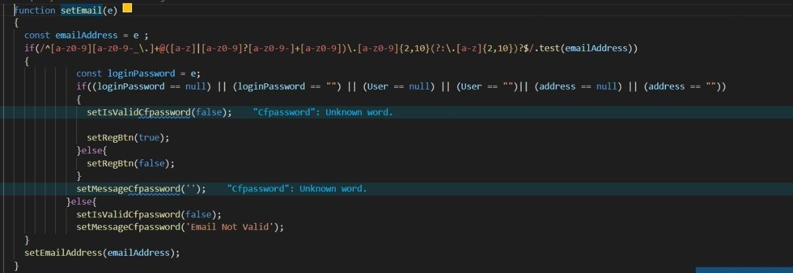

Email validation does not save junk data.

 phone number validate with react-number-format npm package.

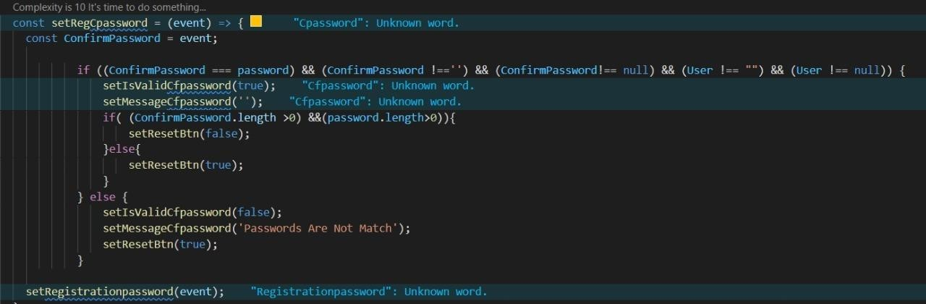

password and confirm password validation

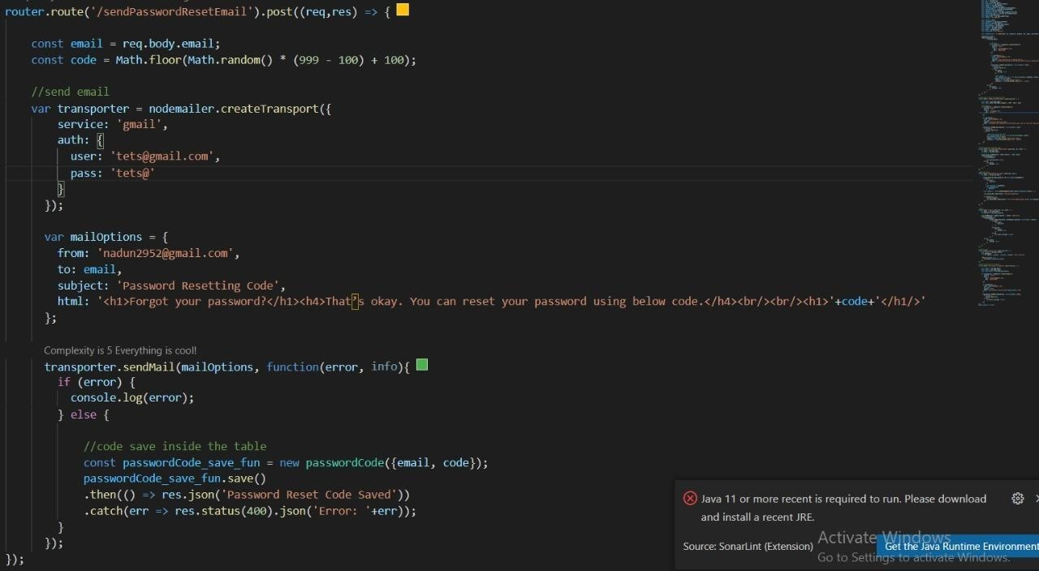

nodemailer npm package

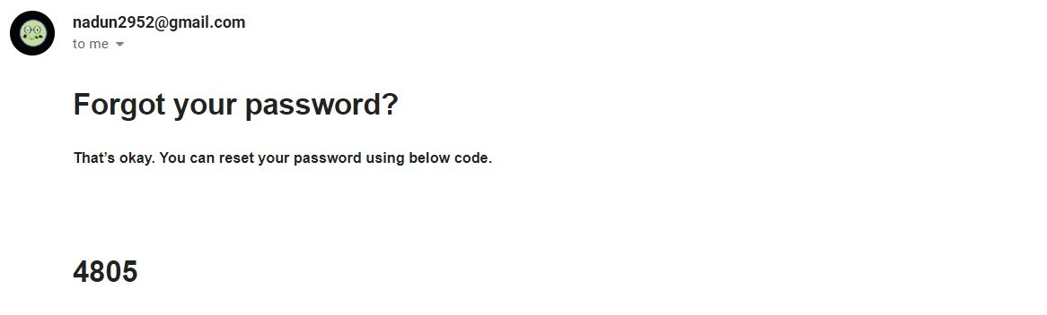

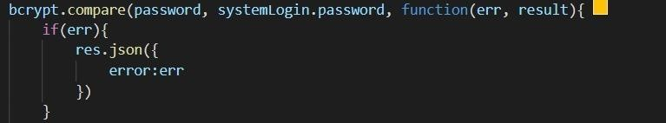 password encrypt with bcrypt js

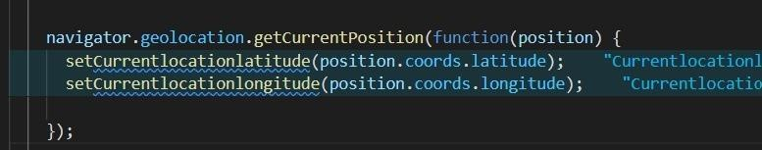 js track user's location

**05. Risk Management**

We provide risk management applications at all stages of transportation - from initial compliance with appropriate packaging and labeling, to road safety procedures, tracking and tracking, and our immediate response to delays or loss of traffic.

At Parcel, we protect the delivery of our high-risk customers by monitoring shipping patterns and losses by the network company, by delivering advance warnings that may be affected by potential losses, and by using controls in these situations.

Our effective process of anticipating potential problems in an effort to avoid risk is very effective in reducing losses. We also provide specific instructions and guidance to our customers regarding shipping safety and educate our customers on shipping materials, packaging requirements and appropriate labeling.

**Loss Control - Tracking and Tracking**

We track and track your shipping using smart software that searches confusing and different from shipping and shipping. Although delivery delays occur (such as weatherrelated delays, machine delays), we carefully monitor the delays and liaise with network companies until safe delivery. Our risk management team is quick and responsive to minimizing potential losses and informs you of all follow-up and follow-up efforts.

**Sensitive Word Removal**

This feature automatically detects and removes sensitive words from your shipping label that display content or content. Sensitive words such as jewelry, watch, diamond, necklace, gold, silver, Rolex, Cartier, etc., are removed to prevent theft and prevent theft.

**Automatic Redirect / Redirect Safe Shipping**

To reduce the loss of packages delivered to high-risk areas, Parcel uses specialized reception areas, to deliver your goods by hand to these locations.

**Address Verification**

We provide address verification for posts created to reduce shipping delays or delays and to reduce costs associated with address fixing.

**Appropriate Packaging for Safe Delivery**

To prevent losses, your packing needs to be efficient and secure. The package provides a detailed guide on how to pack and ship safely.

**5.1 Risks manifested and overcome**

|  |  |
| --- | --- |
| Risks manifested | Actions taken to mitigate |
| Scope creep with the change of using different approaches certain plans have changed, giving me a new area to study on while putting constraints on time | I took an approach based on pilot implementation by taking what I’ve already done to modify it more with a new are of study, while having sprints to assess my performance on tasks undertaken. A critical path was developed to track time I have with safety zones included. |
| Feature creep on the mobile application side I’ve planted more features than necessary as I was stuck on navigation | Took a different approach as said above to work on my main functions. |
| Overlapping projects getting equal or more priority | With the last semester of my degree at hand the time to complete this project along with four other modules is no easy feat as all hold importance. I have made sure by now to finish the prototypes on how the basic functions would work. I have to modify them but getting the foundation of the requirements right allows me the freedom to pay attention to the other modules likewise doing the same with the said modules. |
| No proper documentation to view and work on | Indoor navigation is the crucial function here and as much as there are software tools to help build it the constraints on them override the ease of implementation. With not much of documents to review, I’ve taken all I can understand from multiple resources to draw and come up with my own approach. |

**5.2 Risk Assessment Matrix**

|  |  |
| --- | --- |
| Risk to be manifested | Probability |
| Scope creep | 30% |
| Feature creep | 30% |
| Overlapping projects getting equal or more priority | 40% |
| No proper documentation to view and work on | 40% |

Low

Medium

High

L M H

|  |  |  |
| --- | --- | --- |
|  |  |  |
|  |  |  |
|  |  |  |

L

H

M

**06. Schedules**

**6.1 Project plan for the last phase**

|  |  |  |  |
| --- | --- | --- | --- |
| Task | Progress | | |
| Planned | Result |  |
| User Registration & Logging | Complete login and  registration | ✓ | Login and registration completed with data validations |
| Registration | Implement  functionalities | ✓ | Completed  functionalities |
| customer Registration card | Print a registration card for each user with a  barcode | ✓ | Completed registration card for each user with a barcode |
| Courier service admin Functionalities | Implement admin Function | ✓ | Completed admin Function |
| Courier service provider functionalities | Complete courier service provider function | ✓ | Completed Making courier service provider function |
| User Profile Functionalities | o Implement user profile functionalities | ✓ | Completed user profile functionalities |
| Activity Logger for All User Activities | o Implement Activity  Logger | ✓ | Implement Activity Logger |
| Check customer UI | o Develop Check customer | ✓ | Check customer UI Completed |
| Email & SMS Notices | o Implement Email and  SMS notices | ✓ | Implement Email and SMS notices |
| Testing | o Manual Testing | ✓ | Tested with some manual test cases |

**6.2 Control plan**

Control Plan is still applied to the project using the following techniques

1. Weekly Highlighted Performance reports
2. Communication plan (see section 6.3)
3. Risk management (see section 5)
4. Quality management (see section 4)

**6.3 Communication plan**

In addition to ad-hoc supervisor meetings as necessary, planned review/feedback meetings will be held at the end of each stage to discuss the end-Stage report, the next Stage plan, and to review any technical deliverables produced during the stage. Feedback meetings will also be held following the submission of the two Interim reports.

|  |  |  |
| --- | --- | --- |
| **Project Plan** | |  |
| **Stage** | **Dedline** | **Products/Deliverables/Outcome** |
| 1. Initiation | 17.11.2021 | PID |
| 2. Report 1 | 04.01.2022 | Interim Report -1 |
| 3. Report 2 | 01.03.2022 | Interim Report -2 |
| 4. Vedio 1 | 04.01.2022 | Progression Vedio -1 |
| 5. Vedio 2 | 01.03.2022 | Progression Vedio -2 |
| 6. Testing | 15.03.2022 | Research abstract |

**6.3.1 Supervisor meeting minutes**

**Meeting Minute 1:**

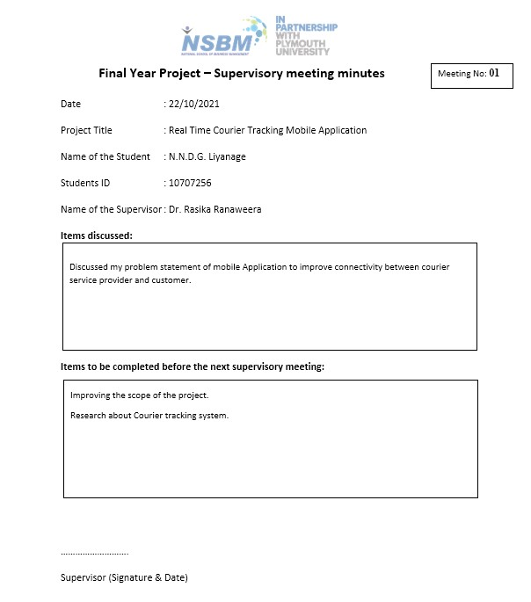

**Meeting Minute 2:**

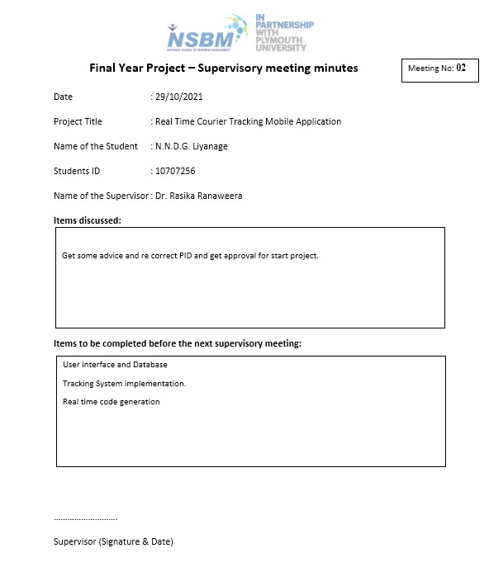

**07. Resources used**

**7.1 methodologies used in development**

In this chapter we will look at the research methods used in their sequence to achieve research objectives. This chapter will cover system analysis, system modeling and the method used in the system. The Prototyping method to be used will be to deliver the original model. In the prototyping model, the system simulation real program is provided by users and the real system is developed based on prototype or by improving it. So: users use the program in part and see if they get it good system. Giving users time to learn to use and interact with the system. Oral once written interviews or questions will be used to gather needs information in the area courts as other possible means such as observation require an existing system of learning in it.

Due to the modern collaborative business environment, manufacturing organizations are needed to track and track their own Logistics chains in the form of sharing. Due to the nature of many companies providing transportation networks processes, the different sides of the transport network need to communicate and cooperate in determining needs tracking and tracking systems. Before establishing the necessary cooperation between cooperating partners, see the need to follow a few consecutive steps such as unique asset identification technology to be used, coding traces, content and method of sharing tracking information, structural information to be used in tracking system and available access to tracking information.

The most important concern of the tracking system is the length and breadth of tracking collection information. There are two ways to track a transportation service provider that is independent working for one company and many run from where different companies are able to get theirs tracking information. Building knowledge is needed to build and achieve follow-up information. Two different types of structural information are available in the tracking and tracing system. first type, tracking system sends tracking information to each group in the transport network, and to the second type of tracking information is included in the central information system from the co-operative partners can get tracking information by hand request (email, phone, fax etc.). Another type of information tracking in the workspace is the automated system where centralized information tracking is done by Electronic Data Interchange (EDI) or XML message visual. In the automated tracking system, the basic pieces of track item information as a name object, object location and time zone of the object are provided. This program also provides access to information directly to online network partners using the World Wide Web. This tracking method confirms scheduled delivery dates and automatic delivery tracking. Information on the properties of auto-tracking system supports real-time tracking schedule technologies that help track networks working collaboratively in a variety of contexts and integration part of the partner strategy activities.

**7.1.1. Using the Agile Method**

In the case of uncertainty, at present most project life cycles are planned to follow an agile approach. At the beginning my scope was ordained to be constructed using Geo referencing. Due to the compatibility issue with my Operating System, I was not able to set up QGIS for mapping of tile sets, so I had to change my methods of design and implementation. As such, I turned to scene recognition, but its practicality was of naught. My scope changed and so additional functions were established while some were removed. Staying true, to the project objective using the agile methodology I am hopeful in my success of building a working product.

**7.1.2. Using phases of the Waterfalls Model**

Also known as an incremental approach to the development of a project, it is not in use due to its solid stance towards a project, but I used some of its architecture when breaking my system down to units.

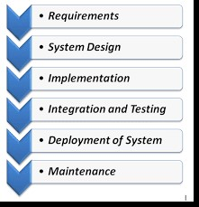

Figure n: Waterfall Model for Component Development

Using this structure to develop the units I’m able to then integrate the components together later

**7.2 Technologies**

* React Native – Frontend
* Node.js - Backend

* Firebase as the Centralized Database

* Tracking system as the Google API

* Mongodb

**7.3 External Resources**

* Google API
* Mongodb
* Mongoose
* React Local APM Package
* React number format
* Sweet alerts react
* Js package
* Nodemon package

**08. Learning Undertaken**

**User Interface Design**

The UI plays a major role in the success of any software. A simple, easy-to-use, and normal UI makes the visitor feel good and that means the software will succeed. Sometimes it is very smooth and has excellent data structure software that can make its presence in the market due to its UI. The Courier Management System solves all the problems of one integrated communication system. Each profile has a UI customized by our experienced team to make them feel special

**Tracking System**

The required delivery concept is a continuous trend popular among customers worldwide. In recent times business owners and entrepreneurs are expected to come up with new and better marketing strategies that provide better service delivery options. Customers are initially looking forward to successful delivery and if your business can supply you in the same way, you may have some loyal customers for the rest of your life. Organizations fighting for progress must come up with strategies that will improve the overall business performance of the business.

An effective tracking system helps an organization to reorganize its normal operation, improve customer experience, and remove additional steps while allowing them to operate faster and more efficiently. It is always important to have strong relationships with delivery managers, customers, and business operators. The technological advancement of tracking systems helps us to deliver professional delivery to our customers, improve performance management, and ultimately lead to customer satisfaction. This not only helps to give customers a better sense of delivery but also helps the growth and development of the organization.

Having an effective mission tracking system not only ensures business growth but also creates a strong customer base for the rest of your life. If you run a business in this digital age, you should be familiar with online trackers. In these years when everything is online, you should have an advanced delivery system that includes installing a tracker so customers can get real-time information and updates related to delivery.

As long as your business grows, you will need better resources and more effort to maintain current standards. As the number of orders grows, the demand for more skilled workers will increase, and in return, interest rates will increase exponentially. In business-driven delivery, success and continuity mean that includes a greater number of delivery vehicles, more delivery personnel, and unprecedented or complex races. Here the vehicle tracking system and service delivery staff must be the same. In this digital age, in order to maximize business efficiency, you need to keep your customers informed at all times.

These updates include a visual tracking system where customers can clearly track the shipping process from the place of order until the delivery is complete. This will understand the effective management of the organization and will keep your customers satisfied with your business at the same time. The tracking system plays a major role when it comes to doing business. A tracker is needed if your business is focused on delivery, and you want your customers to be fully satisfied with your business.

There is no need to create a messenger tracking software without using the same features on the side of the Management Panel. As you have already seen the order status presented on the order screen, the tracking function can be used as an in-app mapping method. Your managers will be able to see all the drivers as they travel in real time and update customers with this information. Alternatively, they should be able to set up an address-based delivery service address, long-term links, or postal codes and see them on the map.

**Route preparation**

A proper tracking system enables you to develop the best available routes for a particular delivery. This also enables the customer to track the exact location of the order and delivery staff, thus allowing them to estimate the exact time when the delivery will take place.

**Vehicle restrictions**

Customers can clearly see where the car is going, which route the delivery staff is following, how long it will take to get to the destination, etc. Customers get the full parameter of where the delivery staff are located exactly.

**Speed and downtime for vehicles**

The tracker will provide real-time information about the speed and waiting time of the vehicle, if provided for delivery.

**Reminders and warnings**

The tracker will provide any latest reminder or warning about delivery.

**Integration with different programs**

The tracking system helps integrate with other programs.

**Appearance**

The service delivery tracking system allows customers to be transparent about their transport workers and vehicles. They clearly see the place where the delivery person is. This not only helps the customer to limit delivery time but also increases the overall efficiency of the organization.

**Delivery status updates**

Customers receive the latest delivery update via the tracking system. If, for some reason, delivery is delayed, the customer may be more inclined to look at the situation than to wait for the delivery on time. The tracker provides real-time information.

**Maintenance features**

The tracker will update your system with any care features that need to be done immediately.

**Digital proof of all delivery**

The tracker will provide a digital receipt for delivery upon completion. This will help you and your business to keep proof that delivery is complete.

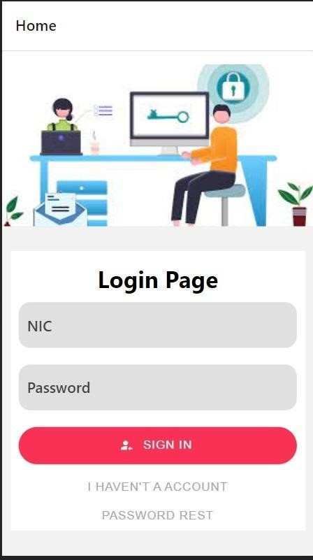

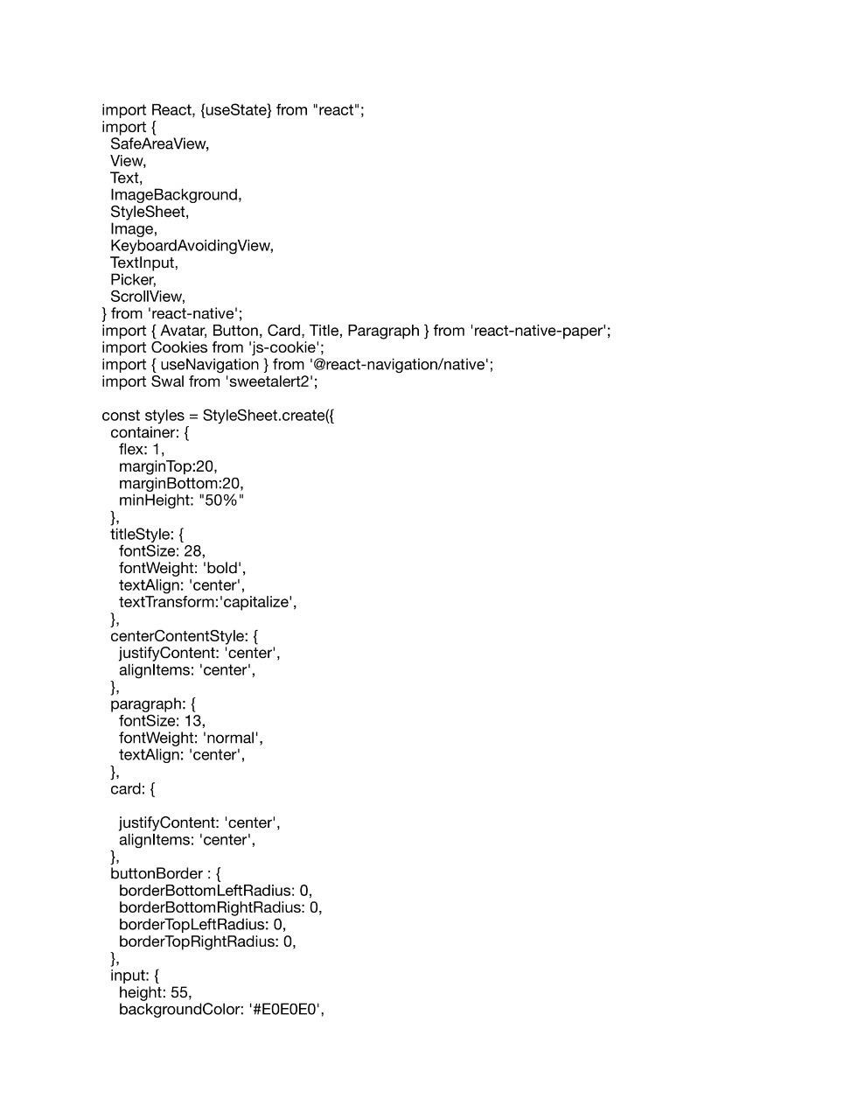

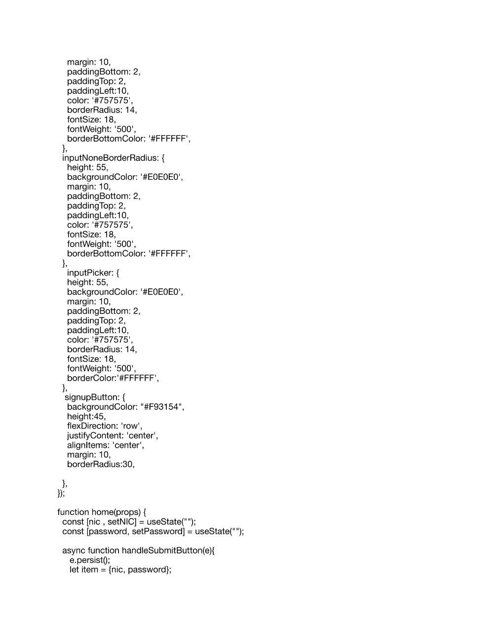

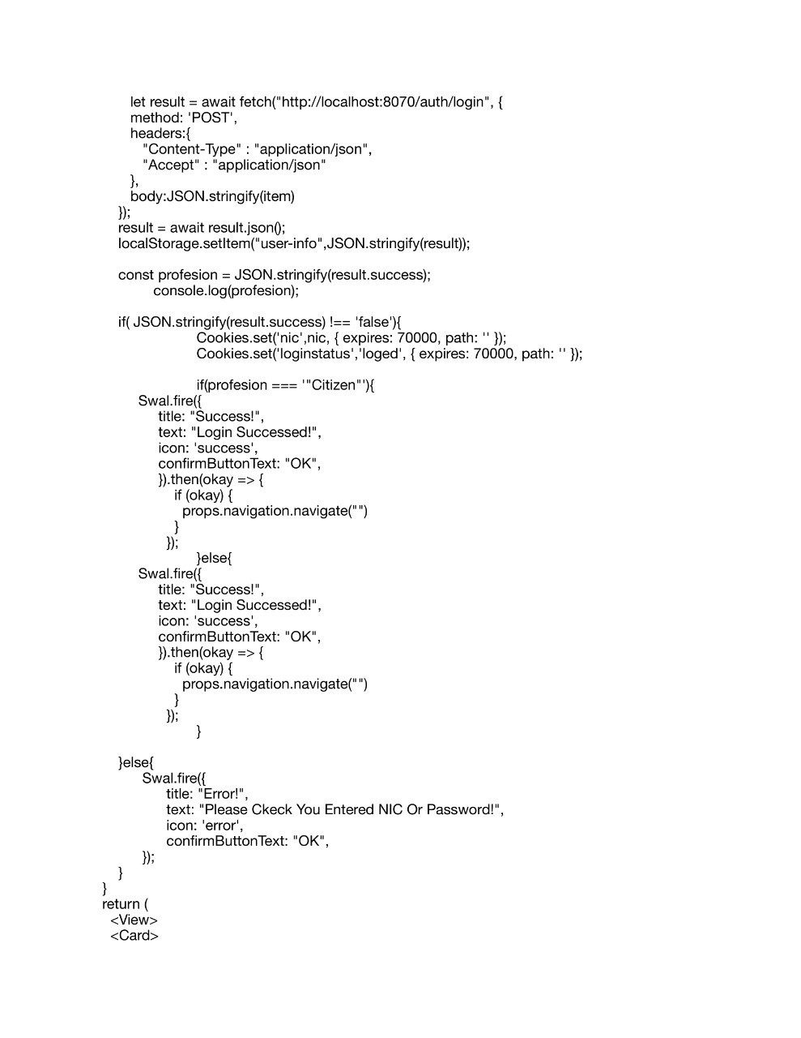

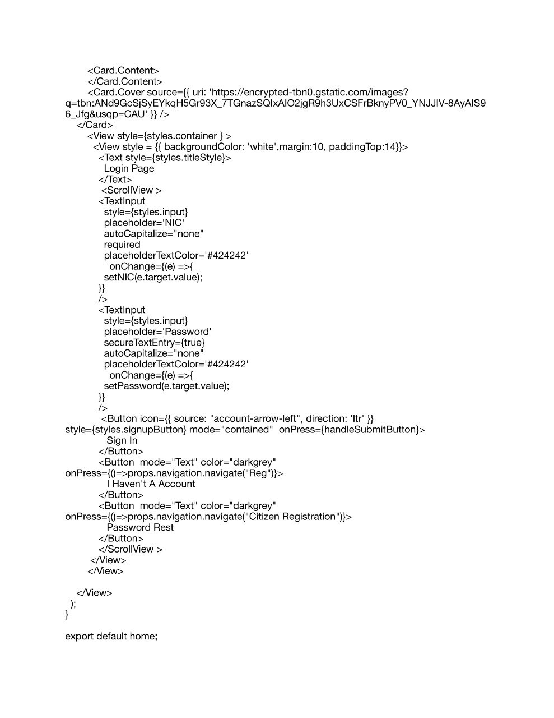

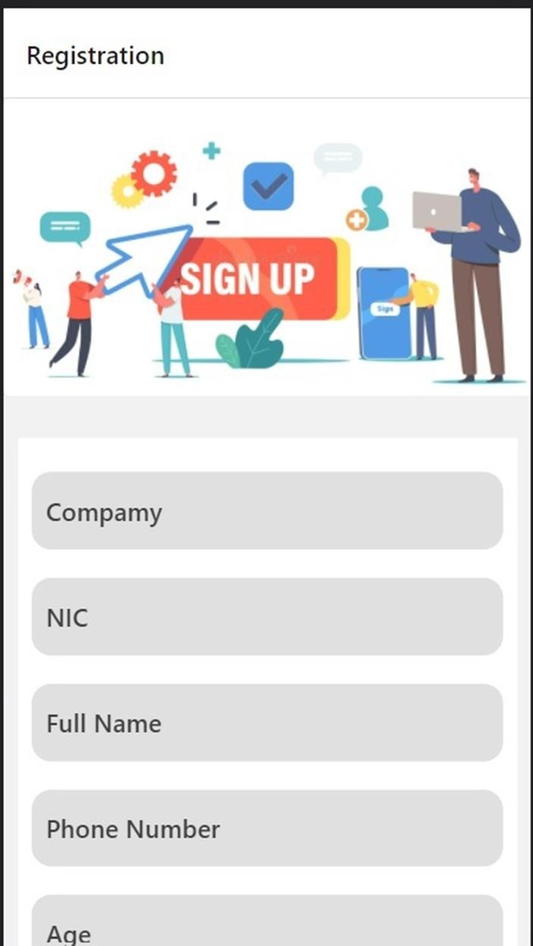

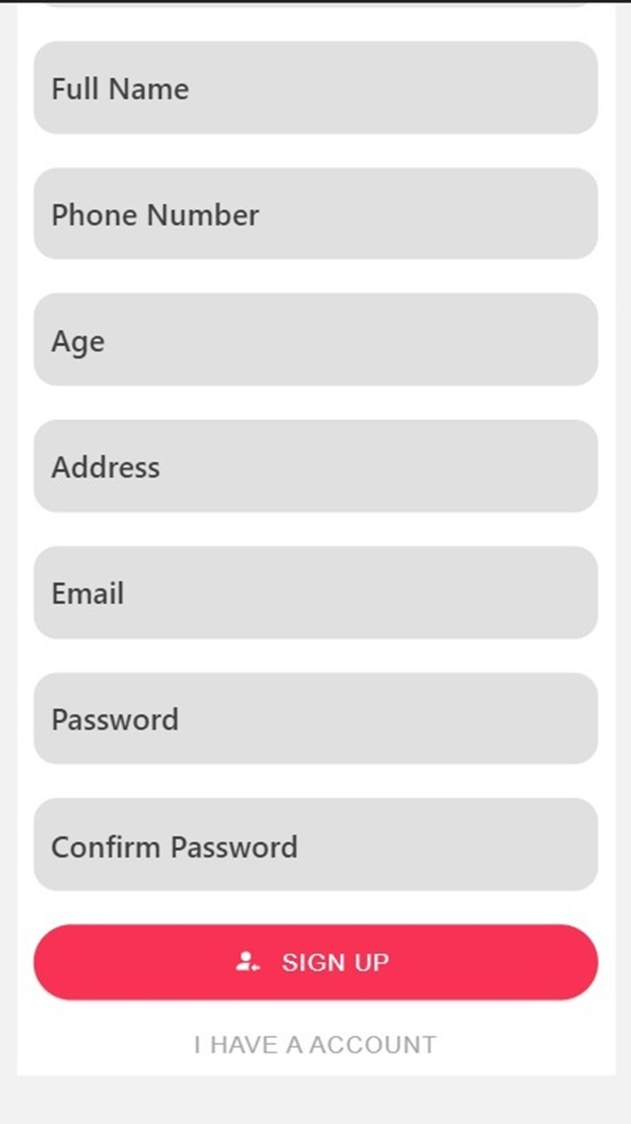

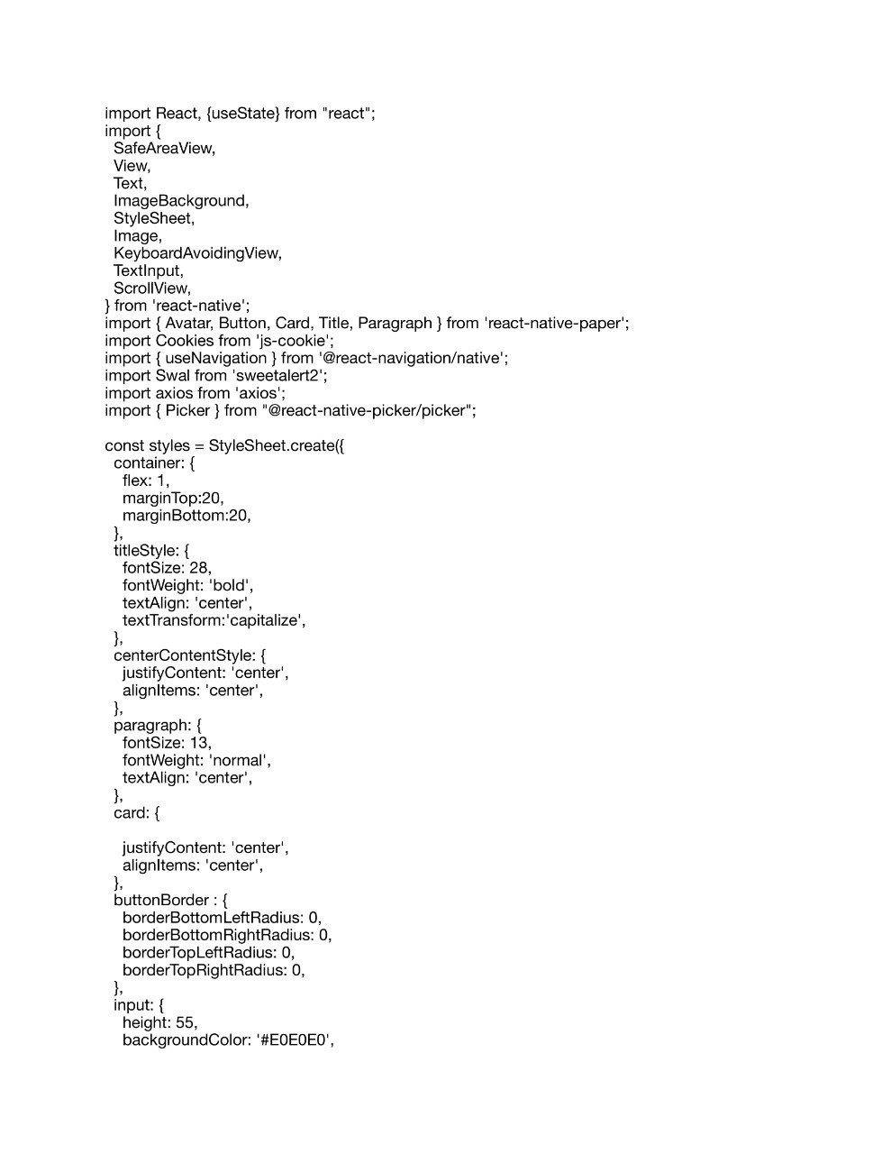

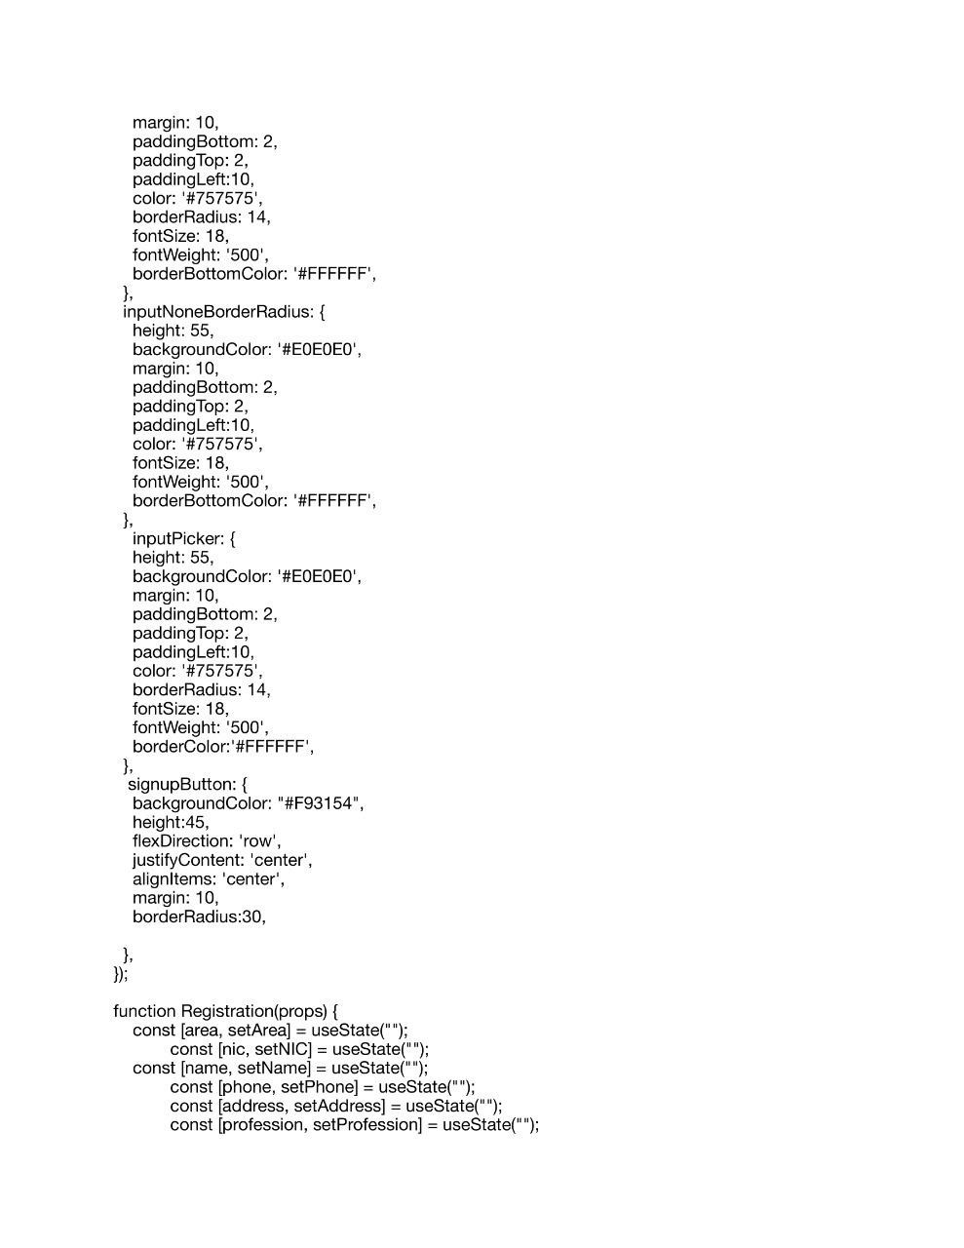

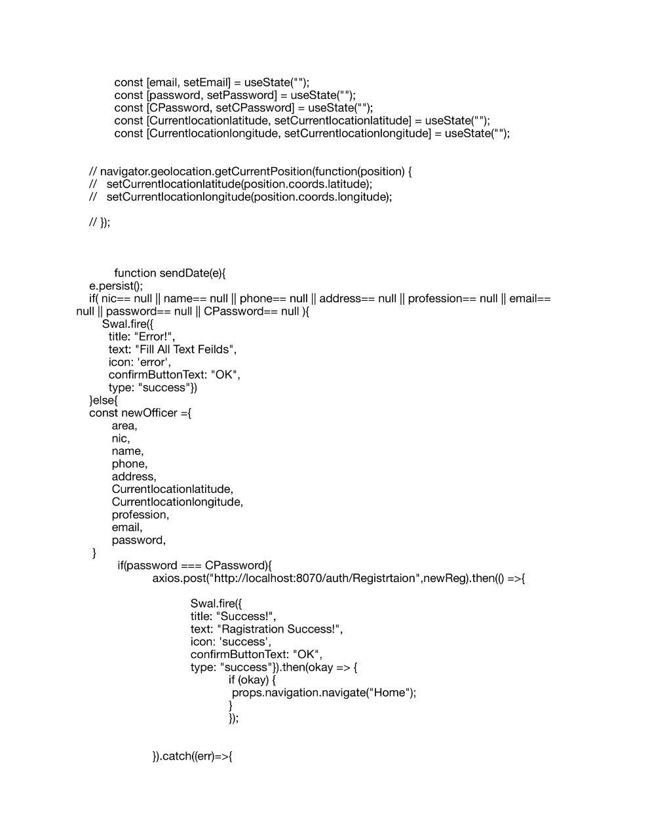

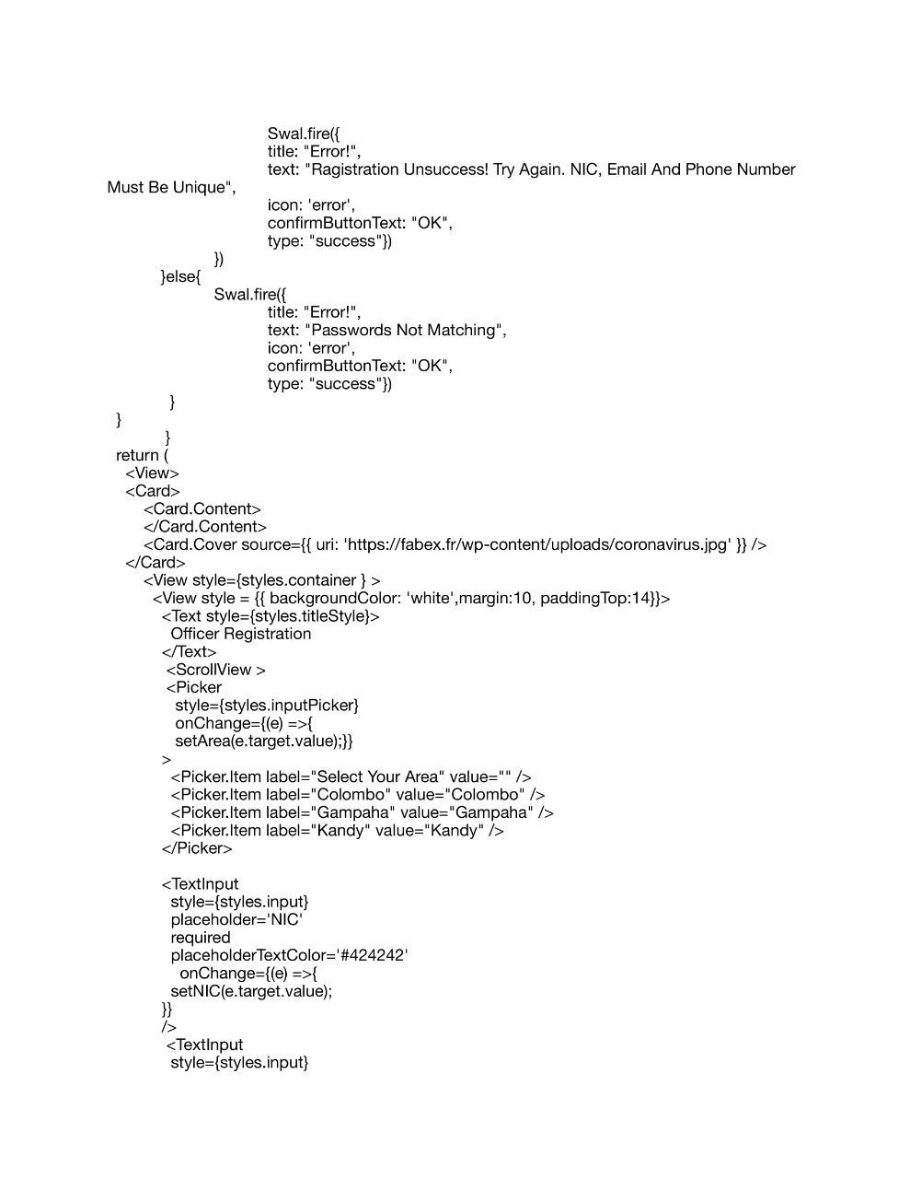

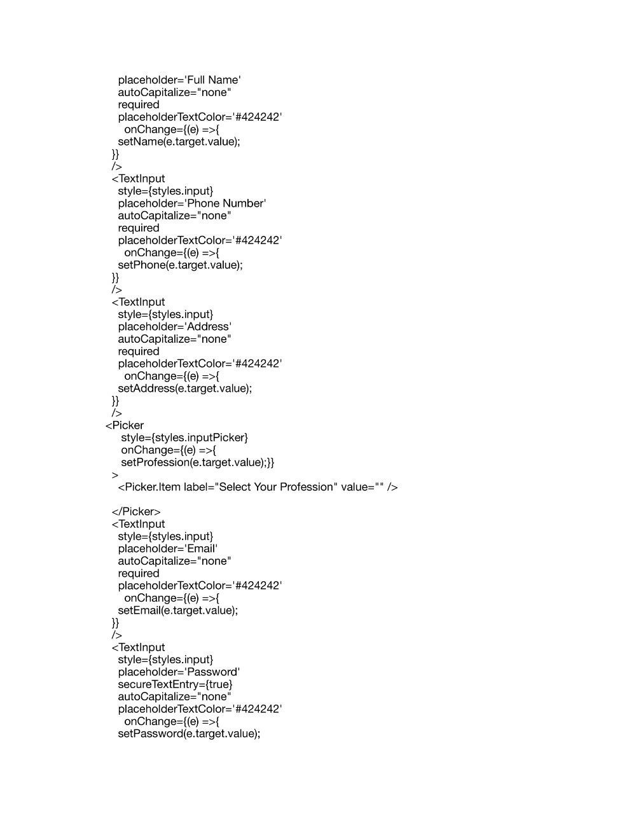

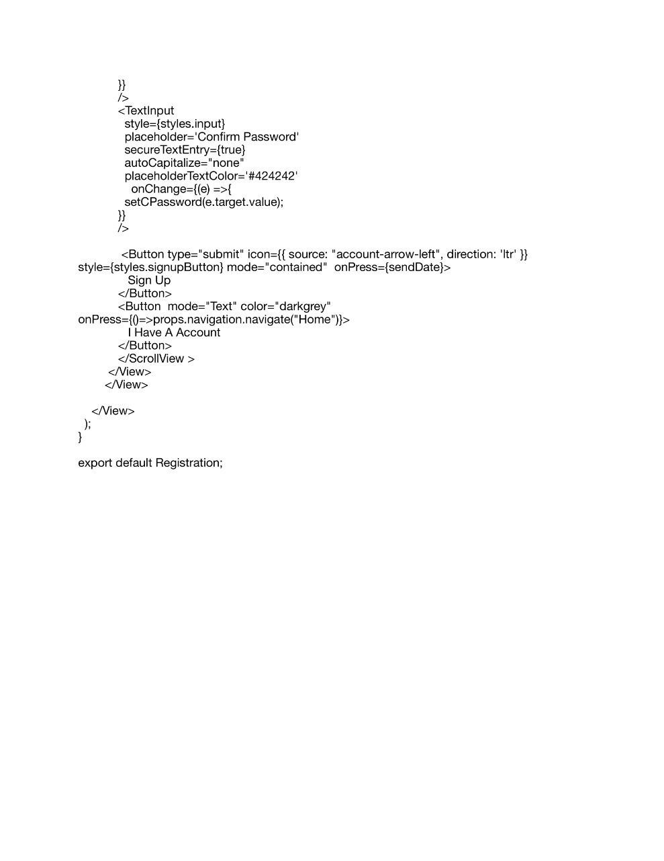

**09. Future Implementation**

It is still mature and fully energetic. Whatever the requirements, the project is complete but still, they want to update and fix some modules. We are constantly thinking of the needs of meeting them that are growing day by day. We always want to do something more. This project ends when you look at it, but we want to do more things.

* Online chat
* Overseas Service
* Application to Take on Conversation
* Extending local research

**10. Summary**

Having an effective delivery tracking system not only ensures business growth but also creates a strong customer base for life. It is a time when everything is online. People avoid going to the shops for their daily needs and instead opt for the same online system. This is a time for changing much-needed courier services and online shopping. With the rapid growth of online shopping, comes the need for an accurate and robust mail delivery system. In addition, a courier system without a proper tracker is useless. A tracking system is essential to achieve maximum customer satisfaction. It is very important to have a proper service delivery tracking system in order to develop a service delivery system in a competitive market. Proper tracking system will ensure the proper handling of parcels and vessels. The project entitled ‘Book Management Service’ was developed into delegation services and guidance. If you run a business in this digital age, you should be familiar with online trackers. In these years when everything is online, you should have an advanced delivery system that includes installing a tracker so customers can get real-time information and updates related to delivery. The system was tested, and system

performance was found to be acceptable. Built-in of all required output. The system was found to be easy to use with a customer help message.

**11. References**

CodeCanyon. (n.d.). *No results found*. [online] Available at: [https://codecanyon.net/category/mobile?term=courier%20delivery.](https://codecanyon.net/category/mobile?term=courier%20delivery)

ResearchGate. (n.d.). *(PDF) Development of android-based apps for courier service management*. [online] Available at: [https://www.researchgate.net/publication/339802344_Development_of_androidbased_apps_for_courier_service_management](https://www.researchgate.net/publication/339802344_Development_of_android-based_apps_for_courier_service_management) [Accessed 23 Jan. 2022].

Stormotion Blog. (2020). *How to Develop a Courier Management System: Top Things to Consider*. [online] Available at: <https://stormotion.io/blog/how-to-develop-courier-management-system/>[Accessed 23 Jan. 2022].

www.deliforce.io. (n.d.). *How Does A Courier And Package Tracking System Work? | Deliforce*. [online] Available at: <https://www.deliforce.io/blog/courier-parcel-package-tracking-system>[Accessed 23 Jan. 2022].

Bunger AC, Hanson RF, Doogan NJ, Powell BJ, Cao Y, Dunn J. Can learning collaboratives support implementation by rewiring professional networks? Adm Policy Ment Health. 2016

Neta G, Glasgow RE, Carpenter CR, Grimshaw JM, Rabin BA, Fernandez ME, Brownson RC. A framework for enhancing the value of research for dissemination and implementation. Am J Public Health. 2015.

Nadeem E, Olin S, Hoagwood KE, Horwitz SM. Understanding the components of quality improvement collaboratives: a systematic literature review. Milbank Q. 2013 Gulc, A. (2017). Courier service quality from the clients’ perspective. *Engineering Management in Production and Services*, *9*(1), 36–45. https://doi.org/10.1515/emj-2017-0004

Mohd, A., Rashid, R. A., Abdul Hamid, A. H. F., Sarijari, M. A., Rahim, M. R. B. A., Sayuti, H., & Abdul Rashid, M. R. (2019). Development of android-based apps for courier service management. *Indonesian Journal of Electrical Engineering and Computer Science*, *15*(2), 1027–1036. https://doi.org/10.11591/ijeecs.v15.i2.pp1027-1036

Okemiri, H., Henry, O., Nwogbaga, N. E., & Nwebonyi, F. N. (2017). Critical Review Of Courier Service

Management System With Empasis To Its Relevance If Adopted In Nigeria Queuing Theory View project Smart home control system View project Critical Review Of Courier Service Management System With

Empasis To Its Relevance If Adopted In Nigeria. In *Journal of Multidisciplinary Engineering Science and Technology (JMEST)* (Vol. 4). www.jmest.orgJMESTN423516887738

**12. Appendices**

**12.1 Questionnaire**

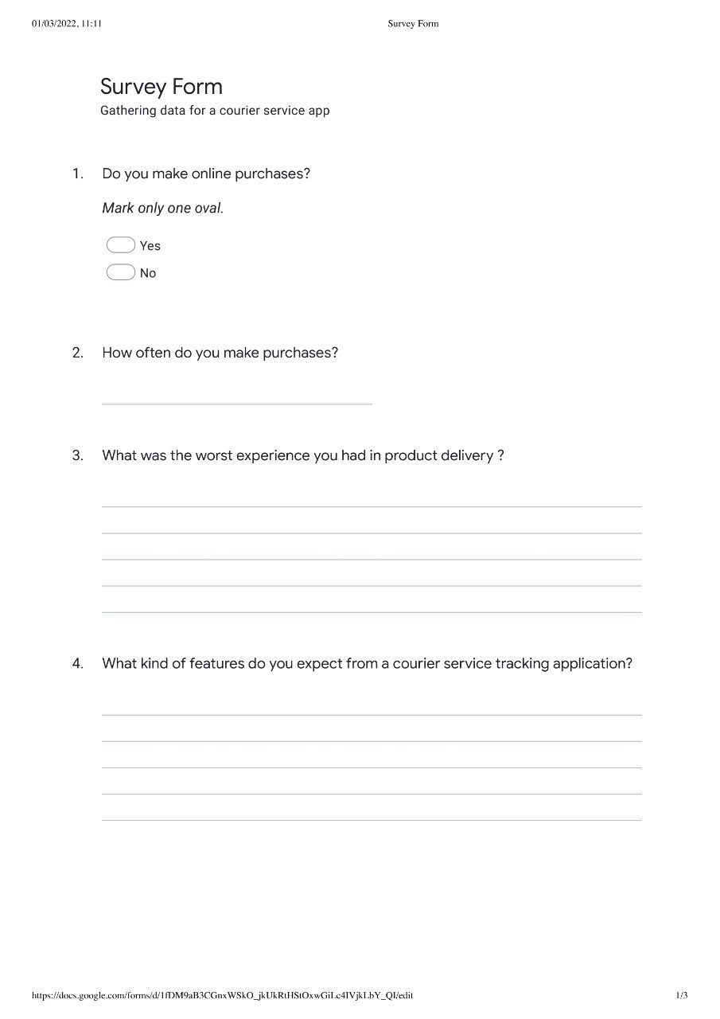

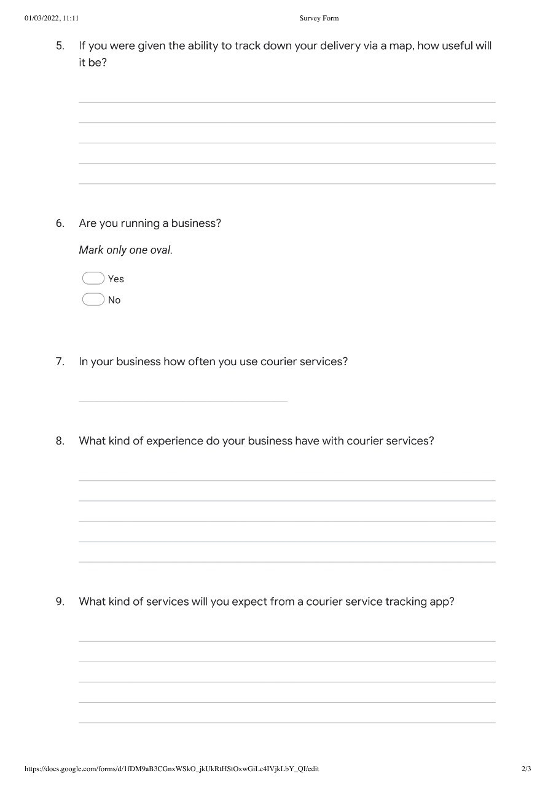

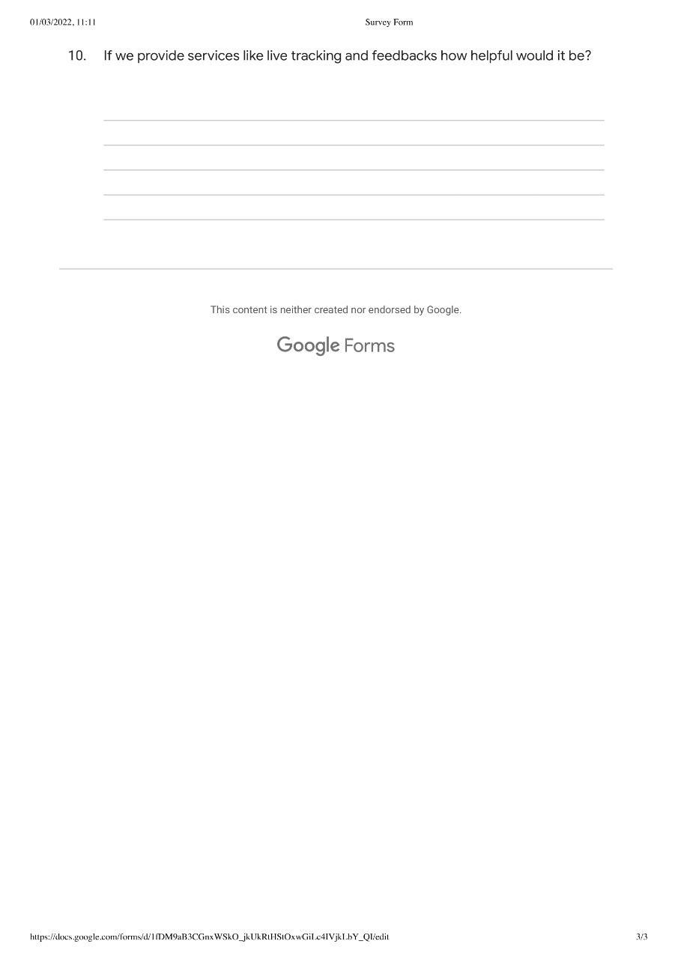

## **16.6 Stage Plan**

## **16.7 Supervisor Meetings**

